
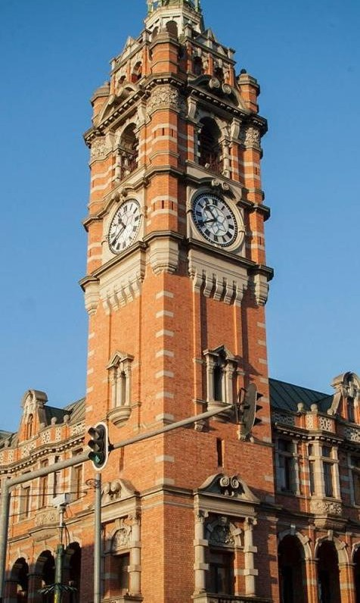


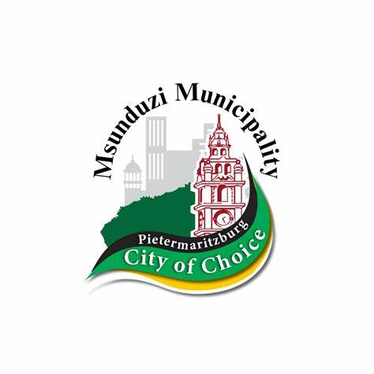
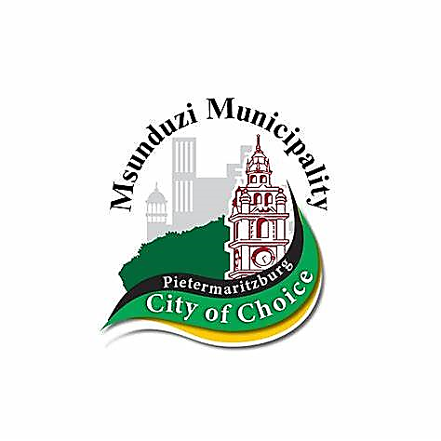

MSUNDUZI MUNICIPALITY
MSUNDUZI INDUSTRIAL DEVELOPMENT STRATEGY 2024 (DRAFT) FOR COMMENTS

Sustainable Development and City Enterprises
Development Services Sub-Unit
Key Contact:
Ms. Mandisa Gabuza Tel: 033 392 3757
Email: Mandisa.Gabuza@msunduzi.gov.za

TABLE OF CONTENTS

GLOSSARY OF ACRONYMS vi
EXECUTIVE SUMMARY viii
SECTION A: BACKGROUND AND CONTEXT
- INTRODUCTION 2
  - PROJECT PURPOSE 2
  - MUNICIPAL ROLE IN INDUSTRIAL DEVELOPMENT 2
  - OBJECTIVES 5
  - PROJECT SCOPE 5
    - Project phases 5
    - Methodology 6
  - CONTENTS OF THE INDUSTRIAL DEVELOPMENT STRATEGY 8
- THE PHASES OF THE PROJECT AND KEY FINDINGS 9
  - Phase 1: Status Quo Report 9
    - Contents 9
    - Summary: Key factors 9
    - Preliminary ideas towards an Industrial Strategy 12
  - Phase 2: Sectoral Analysis 13
    - Contents 13
    - Phase 2 summary – key factors 13
    - Summary and conclusions 19
  - Phase 3: Production Analysis 20
    - Contents 20
    - Key factors 21
    - Summary and conclusions 26
  - Land Supply and Demand Analysis 27
    - Contents 27
    - Key factors 28
SECTION B: MSUNDUZI INDUSTRIAL DEVELOPMENT STRATEGY
- VISION FOR INDUSTRIAL DEVELOPMENT 33
  - Local Economic Development Vision 33
  - Industrial development vision 33
  - Towards the 4th industrial revolution 33
  - International context 35
  - Contents of the strategy 37
- KEY INFORMANTS TO THE STRATEGIES 38
  - Spatial and Land Programme 38
    - Land Availability: Municipal land release strategy 38
    - SEZ and Industrial Park/ Hub Initiatives 40
    - Land zoning – Scheme provisions 40
    - Urban Network Strategy 42
    - Residential zoning linked to industrial / commercial opportunities 43
  - Bulk Infrastructure and Services Support Programme 45
  - Integrated Catalytic Projects Programme 46
  - Industrial Sectors Programme 48
    - The SMME sector 49
  - Protective Environmental and Social Measures Programme 50
  - Institutional Support Programme 51
  - Alignment of Plans and Policies 52
- STRATEGIES PER PROGRAMME 53
  - Spatial and Land 53
  - Bulk Infrastructure and Service Support 54
  - Integrated Catalytic Projects 56
  - Industrial Sectors 59
  - Protective environmental and social measures 63
  - Institutional Support 64
SECTION C: IMPLEMENTING THE STRATEGY
- iMPLEMENTATION: STRATEGIC ROLES AND RESPONSIBILITIES 67
  - Strategic Project Tables 67
    - Spatial and Land Support Programme 67
    - Bulk Infrastructure and Service Support Programme 70
    - Integrated Catalytic Projects Programme 74
    - Industrial Sectors Programme 80
    - Protective Environmental and Social Measures Programme 89
    - Institutional Support Programme 92
  - IDP 2016/17 – 2021/22 projects intersection 94
    - Alignment of Strategic Priorities 94
    - Alignment of projects 95
    - Industrial Strategy priority projects to be included in the IDP Review 2018/19 100
- Alignment of policies and plans 105
- PROJECT PRIORITISATION 107
  - Introduction 107
  - Prioritisation model 107
  - Results 109
  - Link with the Integrated Development Plan (IDP) 112
- Monitoring and Evaluation 113
  - Defining monitoring and evaluation 113
  - Key indicators for monitoring and evaluation 113
  - Evaluation tools 115
  - Institutional requirements 118
  - Industrial Health Dashboard 119
- CONCLUSION 121
- References 122
ANNEXURE A: DETAILED MAPS OF INDUSTRIAL AREAS 124
ANNEXURE B: AIRPORT PRECINCT AND TECHNO HUB IMPLEMENTATION SCHEDULE 132
ANNEXURE C: PROJECT PRIORITISATION TABLES 137
ANNEXURE C1: ASSIGNMENT OF PRIORITIES 139
ANNEXURE C2: RESULTS PER STRATEGIC PROGRAMME 153
ANNEXURE C3: RANKED PROJECTS PER STRATEGIC PROGRAMME 169

GLOSSARY OF ACRONYMS

AEO | : | African Economic Outlook
BEPP | : | Built Environment Performance Plan
BPO | : | Business Process Services and Offshoring
BRICS | : | Brazil, Russia, India, China, South Africa Trade Agreement
CBD | : | Central Business District
CCP | : | Climate Change Policy
CCTV | : | Closed circuit television
CRDP | : | Comprehensive Rural Development Plan
DFSG | : | Durban-Free State-Gauteng (corridor)
DMR | : | Department of Mineral Resources
DRDLR | : | Department of Rural Development and Land Reform
DTI | : | Department of Trade and Industry
EDTEA | : | Dept of Economic Development, Tourism and Environmental Affairs (KZN)
EGS | : | Ecosystem Goods and Services
EMF | : | Environmental Management Framework
EPWP | : | Expanded Public Works Programme
EU | : | European Union
GDP | : | Gross Domestic Product
GN / GNR | : | Government Gazette Notice / Regulation
GVA | : | Gross Value Added
HDI | : | Human Development Index
ICLEI | : | International Local Governments for Sustainability Programme
ICT | : | Information and Communication Technology
IDC | : | Industrial Development Corporation
IDP | : | Integrated Development Plan
IDS | : | Industrial Development Strategy
IDZ | : | Industrial Development Zone
IGR | : | Inter-governmental relations
IPAP | : | Industrial Policy Action Plan
IRPTN | : | Integrated Rapid Passenger Transport Network
KGFT | : | KwaZulu-Natal Growth Fund Trust
KZN | : | KwaZulu-Natal
LED | : | Local Economic Development

MDGs | : | Millenium Development Goals
MTREF | : | Medium Term Revenue Expenditure Framework
NDP | : | National Development Plan, 2011
NEMA | : | National Environmental Management Act
NEMA:AQA | : | NEMA Air Quality Act
NEPAD | : | New Partnership for African Development
NERSA | : | National Electricity Regulator of South Africa
NIP | : | National Infrastructure Plan
NIPF | : | National Industrial Policy Framework
NMT | : | Non-Motorised Transport
PACSA | : | Pietermaritzburg Agency for Christian Social Awareness
PGDS | : | Provincial Growth and Development Strategy
PMB | : | Pietermaritzburg
PPE | : | Personal Protective Equipment
PSEDS | : | Provincial Spatial Economic Development Strategy
SACN | : | South African Cities Network
SADC | : | Southern African Development Community
SAIIA | : | South African Institute of International Affairs
SALGA | : | South African Local Government Association
SANRAL | : | South African National Roads Agency Limited
SARS | : | South African Revenue Service
SDBIP | : | Service Delivery Budget Implementation Plan
SDF | : | Spatial Development Framework
SDGs | : | Sustainable Development Goals
SEA | : | Strategic Environmental Assessment
SEDA | : | Small Enterprise Development Agency
SEDis | : | South Eastern District (Area within Msunduzi Municipal area)
SEZ | : | Special Economic Zone
SIP | : | Strategic Integrated Projects
SMME | : | Small Medium and Micro Enterprises
SONA | : | State of the Nation Address
TRAINS | : | Trade Analysis and Information System

EXECUTIVE SUMMARY

PROJECT INTENTIONS
The fourth generation municipal IDP (2022- 2027) identifies “an economically prosperous city” as one of six strategic priorities. The intention of the Industrial Development Strategy, is to respond to this overarching strategy by unlocking latent industrial development potential, encouraging private sector investment and creating economic development and job opportunities for the poor with industries as the catalyst.
More particularly, the intention is to highlight the role of the municipality in unlocking this industrial potential.
The Industrial Development Strategy (IDS) report on its own only provides useful background and context, and through individual discussions and interviews with stakeholders as well as stakeholder workshops, sets out what industrialists themselves believe to be the most promising opportunities, as well as the main challenges that both existing and potential investors should take cognisance of.
The key to unlocking that potential is for an active and effective body or agency, with both public and private sector input, to drive the implementation of the projects identified in the strategy, many of which are also found in the IDP and in the Local Economic Development Strategy.

ISSUES IDENTIFIED FROM THE STATUS QUO ASSESSMENT
The status quo assessment that kicked off the project, set out the background and context within which the industrial sector operates in Msunduzi. The main issues identified were:
- The importance of the support at every sphere of government for industrial development; this is indicated in such plans and policies as the National Development Plan, the Industrial Action Policy Plan, the Provincial Growth and Development Strategy, the Provincial Spatial Economic Development Strategy and through various national and provincial incentive programmes through the Department of Trade and industry (DTI) and the KZN Department of Economic Development, Tourism and Environmental Affairs. At local level, the municipal IDP, SDF and the LED strategy.
- The physical character of the municipality imposes limitations on expanding beyond the current boundaries, particularly with respect to flat industrial land.
- A socio-economic analysis of the municipal area indicates that Msunduzi municipality contributes the lion’s share of GVA to the District – 71%. Unemployment stands officially at 18% of the economically active population; the total workforce at present is approximately 290 000 people.
- A profiling of current industries was undertaken and the following emerged: the need to identify industries where growth is imminent as it is supported by government initiatives e.g. the leather and automotive hubs; the importance of support for the agricultural and agri- processing sectors, including the involvement of youth in both processing of agricultural products as well as associated businesses, and support for the development of the ICT sector. The importance of retaining existing industries was raised as a major issue by industry stakeholders, and the need for developing local skills through training and capacity building programmes. The profiling assessed which industries were existing or stable; which were

unstable or threatened, which have high growth potential and which are the emerging industries; it drew on the District comparative advantages report to highlight those industries and businesses which favour Msunduzi.
The various industrial sectors were looked at in a fair amount of detail: mining and quarry, aluminium (metals industry); timber, leather, transport and communication and rural development (agri-processing).
- There are a wide range of incentives available at national, provincial and municipal level, to encourage industry to locate in the city, and that current and future industries can draw upon, for instance, those established through the Department of Trade and Industry.
- Considerable work was done on industrial land availability in order to ensure that there would be sufficient land to meet current and future needs. There is already a short term land release strategy in place as outlined in the Spatial Development Framework; this is intended to release
60.7 ha of land for industrial use. Altogether, there is 1 740 ha zoned for industrial purposes, from extractive industry to light industry and general business.
- There are a number of catalytic projects in the IDP which support industrial development such as the Pietermaritzburg airport upgrade, the Integrated Rapid Public Transport System (IRPTN), the electrical infrastructure upgrade and the installation of a fibre optic cable network.
- The Strategic Environmental Assessment and the Ecological Infrastructure Plan provide critical information on which would be no-go areas for development, and / or where sensitive environments require specific mitigation measures. In addition, the Climate Change Policy was summarised, looking at both mitigation and adaptation strategies. There is also an uMgungundlovu Climate Change Response Strategy (2014) which provide further information in the drive to minimise carbon emissions and the effects of climate change. The importance of all development applications being assessed in the light of these environmental plans was stressed. The city also has Water Services By-laws which are designed, among other things, to protect the water supply system for the city.
- The potential for “green industries” (such as renewable energy) and the greening of existing industry was examined. The Climate Change Policy set out the need for this very clearly.
- The potential opportunities available through the N3/SIP2 corridor was examined in some detail, emphasising the need for current and future industries to make the most of the opportunities that will be enhanced with the development of the corridor as per the National Infrastructure Plan.
- The assessment also found that there needs to be greater cooperation between public and private sector to help drive industrial development and manage its growth responsibly, in particular, there needs to be more regular liaison and cooperation between the municipality and the Pietermaritzburg Chamber of Business. Furthermore, the development of the Private-Public Partnership Framework adoption

OPPORTUNITIES FOR INDUSTRY
The strategy identifies the comparative advantages of locating industry in Pietermaritzburg and outlines the potential that exists – to both build on the opportunities generated by existing industries as well as to explore new opportunities. The incentives policy is in the process of being finalised; the

intention is that provides incentives for existing industries to remain in the City as well as to attract new industries.
The table below illustrates opportunities available across various industrial sectors.

Sector | Project Name | Project
Agriculture | Agri-processing | The Transnet premises next to the Old Prison site along Mayors walk road need to be refurnished into Agri Factory shops. Young entrepreneurs don’t have funding to start businesses, and these premises would allow them to be used as SMME incubation centre cubicles.
 | Agricultural extension | There are areas at Edendale and Vulindlela which are good for agricultural practice, but agricultural extension support would be required.
 | Aquaculture | There are also fish farming opportunities. There was an old reservoir in the Blackridge area that was used for trout farming, which can be re-commissioned. Support has already been expressed by the Department of Economic Development, Tourism and Environmental Affairs.
 | Compost from waste | There is interest in the support of a waste to compost generation operation. This could be of value in general in Pietermaritzburg, supporting not just the local and agricultural community, but also extending the lifespan of the Pietermaritzburg Waste Disposal Site, as the volume of waste to be managed would be reduced. Waste to energy has also been a potential
 | Feedlots and abattoirs | Feedlots can increase revenue for the farmer. The value chain can be further extended through the development of an abattoir in close proximity to the Feedlot. (The example of the Abattoir at Boston was used, providing for farmers in the Vulindlela and Boston/ Bulwer area).
Manufacturing | Aluminium Beneficiation Programme | ALU Products is a prodigy of the ABI programme. With a local example and a potential SEZ, a competitive advantage, with Hulamin within the city has been created which must be encouraged.
 | Establishment of SEZ | Establishment of a Virtual Special Economic Zone
Airport Precinct | Airport development | New N3 upgrades of the Mkondeni intersection to be undertaken by SANRAL
 | Hotel at Airport | Construction of Hotel/ Conference Centre at the Entrance to the Airport
 | Techno-Hub | Development of Phase 1 of the Techno-Hub
 |  | Development of Phase 2 of the Techno-Hub
Leather | Leather Hub | Establishment of a leather hub next to Leather from the Heart enterprise. The new facility will share the existing services used by Leather from the Heart, reducing the footprint.
Automotive | Automotive Hub | Establishment of an Automotive Hub, preferably close to the Leather Hub and potentially within the Edendale Centre precinct, which could assist with the development of the site. Funding is available for the feasibility study and structures.
Forestry / Timber | Manufacture of furniture  Housing and social infrastructure provision | Housing and social infrastructure provision could be used as a driver for timber industries. Currently, only about 1 % of local construction in South Africa uses timber structures as opposed to about 70 % in countries in the northern hemisphere. This combined with social infrastructure backlog in the public sector presents potential opportunities for timber industries to assist in developing social infrastructure such as schools, clinics, multipurpose centres, low-cost housing and others, using timber as a cost-efficient and quick method of building
In addition, there is serviced industrial land available as indicated in the table below:

Industrial Precinct | No of Ha | No of sites | Serviced | Access to N3 | Ownership
Ashburton | 256 | 78 | 75 | Yes | Info avail
CBD | 0.234 | 2 | 2 | Yes | Info avail
Mason's Mill | 79.4 | 50 | TBD | Yes | Info avail
Mkondeni | 88 | 110 | 110 | Yes | Info avail
Northern Area | 41.19 | 15 | 15 | Yes | Info avail
Edendale/  Shenstone | 24.7 | 10 | TBD | Yes | Info avail

CHALLENGES FACED BY INDUSTRY
There are a number of challenges faced by industry in Msunduzi; firstly, the challenge of making the most of the opportunities presented by the SIP2 /N3 corridor so that other industries locating along the corridor (e.g. at Cato Ridge or Durban) are not seen as competitors, but rather seen as opportunities to link into through the corridor.
The two of many challenges which caused a major set-back for industries in Msunduzi which also resulted to other industries having to shut down business is the Covid-19 lockdown in 2020 and the July 2021 unrest. Even through the government offered support to industries during this difficult time for business, other industries still did not manage to resume business and eventually shut down. Other industries are still under major debt due the disruption of the covid 19 lockdown and the July 2021 unrest.
Stakeholders showed particular concern over the current inability to rely on a stable and secure energy and water supply. These are considered top priorities for the majority of industries and is something that needs to be addressed urgently by the municipality. These are recognised and a number of projects in the IDP are addressing, and will continue to address shortcomings in key infrastructural services.
The issue of locally available skills, particularly for the ICT sector, was mentioned as a challenge to locating in the city. Clearly, there needs to be some focus on bringing in programmes, either publically funded or through private and public sector partnerships, to build skills levels, particularly among youth, so that the industries can better rely on there being the skills they require, and so that there are greater opportunities available for better paid jobs.
The lag time in processing development applications, business licences etc. was considered a real drawback for investors. The need for some kind of one-stop-shop which undertakes to process applications within reasonable timeframes was stressed by industry stakeholders.
There are some catalytic projects and major infrastructural projects which have been in the planning pipeline for many years; projects such as the N3 by-pass, the location of which has still not been decided. Uncertainty over the catalytic projects tends to create uncertainty throughout the system, which is a challenge for both existing industries and potential investors.

INTERSECTION OF INDUSTRIAL STRATEGY PROJECTS WITH IDP
Section 6.2 tables outlines the intersection of IDS projects with the IDP (2016/17 – 2021/22). Section
    - on page 99 provides a table indicating which of the priority projects within each of the IDS strategic programmes, already appear in the IDP (as a whole, or at least are partially addressed), and which projects need to be incorporated into the next IDP Review (2018/19).

RECOMMENDATIONS
The Strategy identified a range of projects within five main strategic programmes:
      - Spatial and land support program
      - Bulk infrastructure and service support programme
      - Integrated catalytic projects programme
      - Industrial sectors programme
      - Protective environmental and social measures programme
      - Institutional support programme.
These projects were then prioritised for each programme using a project prioritisation model which assessed the level of contribution to the overall Strategy; the implementation period, the contribution of the project to job creation, the financial requirements of the project and the implementation risks.
It is recommended that the municipality:
- Include those projects that are not already part of the IDP, in the next IDP review (2018/19)
- The municipality should establish the implementation structure

IMPLEMENTATION STRUCTURE
There was a specific request from one of the stakeholder workshops, that a project champion be identified, within the municipality, to drive the implementation of the Strategy.
It is proposed that a rapid delivery agency be established, under the auspices of the Business Development Manager, but overall falling under the General Manager: Sustainable Development and Municipal Entities. This agency should form a “one-stop-shop”, ensuring that the requisite departments within the municipality and relevant provincial and national departments or agencies, are brought in to comment on, and/or provide approvals for, the development application processes for the various approvals that industry and business require. This is not intended to shortcut much needed protective measures, but rather to streamline the process and make it more efficient. This is being done to a certain extent by some departments within the municipality where, for instance, planning applications come before a committee comprising all the relevant people who are needed to comment on or provide regulatory input on a development.
The proposed structure is illustrated below:

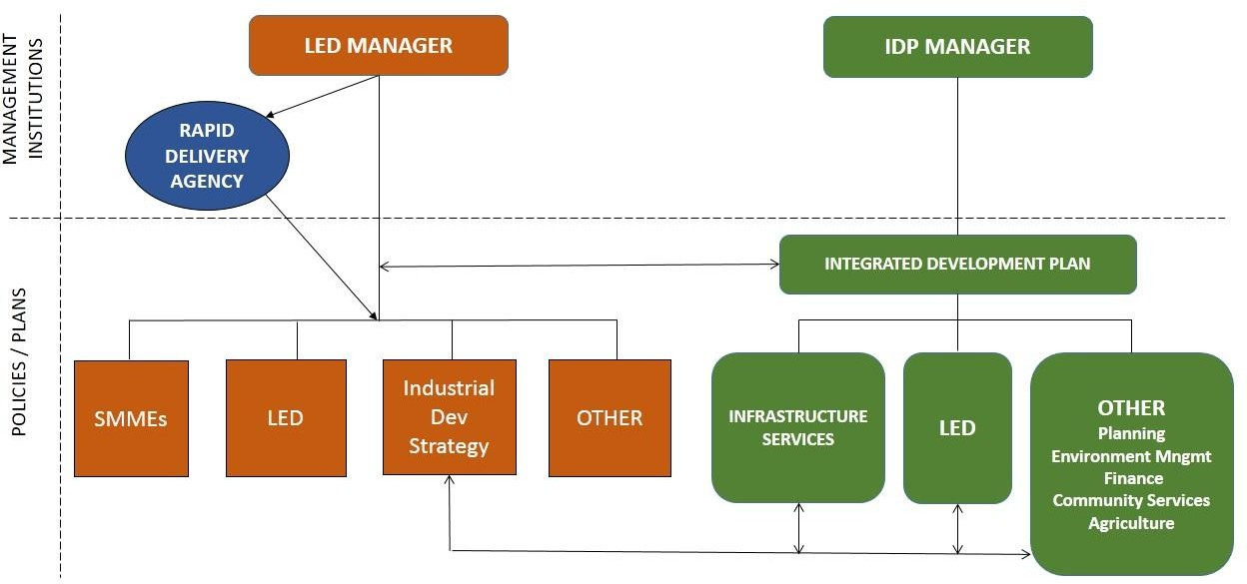

SECTION A

BACKGROUND AND CONTEXT

- INTRODUCTION

  - PROJECT PURPOSE

The purpose of this project is to formulate a Local Industrial Development Strategy based on identified development needs, opportunities, competitive and comparative advantages to inform and guide the Msunduzi Municipality to facilitate development, unlock latent industrial development potential, encourage private sector investment and create economic development and job opportunities for the poor.

  - MUNICIPAL ROLE IN INDUSTRIAL DEVELOPMENT

Industrial development is a function of private sector initiative. However, the private sector requires input from the public sector to create an enabling environment; municipalities in particular have a role in developmental local government as set out in the Constitution (Act No 108, 1996) and the White Paper on Local Government of 1998. Developmental local government means “local government that maximises social and economic growth, provides infrastructural services, creates liveable living areas and facilitates integration and partnerships” (Meyer, 2013:4). Essentially, there needs to be a balance between pro-poor development (social and welfare) and pro-growth development (market oriented) – i.e. economic development spending. This is supported by the global experience of the role of government where “partnerships with the private sector are important for development, support policies required for entrepreneurial developme nt, local economies need to be internationally competitive, and the creation of jobs is far more important than increasing dependence on welfare” (Meyer, 2013:10). Meyer also points to the linkage between development economics, developmental governance and strategic spatial planning initiatives (Meyer, 2013:12).
What does this mean for Msunduzi Municipality in its role vis a vis industrial development? The points below have been divided into individual aspects for which local government has some responsibility for (direct or indirect). However, they all link to each other in some way and collectively, set out the municipality’s (and general government) role in having an impact on industrial development. The integration of these factors will emerge in the strategies that are the focus of this report.
    - Public infrastructure and services: this is the core function of government which is mandated to provide public infrastructure to their citizens for their welfare. This includes not just the capital provision of infrastructure, but allocating sufficient resources for operations and maintenance.
    - Industrial infrastructure (industrial development zones): to attract industry, some areas should receive more specialist infrastructure and conditions.
    - Transportation and access: this is a critical factor for industry, encompassing the need for adequate road / rail access for their ingoing and outgoing goods and products, as well as good private and public transport access to enable their staff to get to and from work with relative ease and at reasonable cost.
    - Strategic spatial planning: from national to local level, particularly local government, have responsibility for vision based integrative planning. This includes area based development

plans, such as precinct plans for the regeneration of areas or to create special zones such as industrial parks. Spatial development frameworks set the broad direction for more detailed planning.
    - Zoning: the municipality maps out the detailed land use zones on a cadastral basis using the SDF as its guideline. At this level, industrial zoning can be broken down into different types of industrial use – e.g. heavy or light industry. This then guides the provision of bulk services.
    - Land availability: the municipality needs to be able to either make available municipal land or negotiate with other land owners regarding making land available for expansion or creation of, industrial areas.
    - Partnership formation: the municipality has an important role to play in partnering with private sector and / or other government agencies, to facilitate industrial development. By doing so, Msunduzi Muncicipality has adopted a Private-Public Partnership framework which the muncicipality is implementing by entering into partnerships/ memorandum of understanding with institutions for a collaborative vision for the city.
    - Policies and programmes: investors like certainty; the policies and programmes governing all aspects of industrial development from land acquisition to operation are clear, which also the municipality has developed the programme for incentives and reviewing of other strategies, important regulatory policies and by-laws,
    - Catalytic projects: Msunduzi Municipality has already identified a number of catalytic projects to jumpstart development in certain areas, such as the Airport precinct and Techno Hub, as well as an integrated rapid public transport network.
    - Decision-making processes: given the essential role of the private sector in industrial development, it is important that the municipality have an agile structure and decision-making processes that can respond timeously to the private sector on land applications, business and licensing applications etc. fortunately, Msunduzi Municipality has a turnaround on land applications, business licensing applications, SPLUMA applications, municipal building plan approvals, call centre complaints turnaround time etc in order to reduce o cut red tapes that hinder business growth and development.
    - Greening of industry and public infrastructure and services: the municipality, through policies and by-laws, needs to support and encourage industry to adopt green production practices. To some extent, many industries have already seen that it is in their best interest both economically and / or as responsible citizens, to lessen their carbon footprint. In turn, municipalities need to ensure that the way in which they supply support infrastructure and services follows a greener path. The municipality should consider using a different measure for success than that of GDP (the total value of final goods and services produced within a defined area) or GVA (monetary value of the amounts of goods and services produced less the cost of all inputs and raw materials that are directly attributable to that production); neither of these two metrics take into account the negative externalities that society often has to bear through, for example, pollution of natural resources. ¹
    - Incentives: the municipality is in the process of adopting an investment incentives scheme which is to empower the municipality with an additional tool for attracting, beautification and expanding investments into the municipality.

¹ To some extent, this has been covered through the calculation of the Human Development Index which has also been used in municipal reports, but only as a supplementary measure (see Phase 1 Status Quo report, Figure 40, p.70). The HDI measures average achievement in key dimensions of human development: a long and healthy life, levels of knowledge and a decent standard of living.

    - Marketing: the municipality does, and still continues to market the city as industry friendly, highlighting the comparative advantages of the sub-region.
    - Regulatory function: a critical role for municipalities in conjunction with other government agencies such as the Department of Environment Affairs and the Department of Water and Sanitation, is that of ensuring strong protective measures are in place to prevent ground, water and air pollution which not only has serious implications for the natural environment, climate change etc. but also greatly impacts upon the lives of neighbouring communities.
    - Good governance and political stability: again, investors like stability so it is important that not only existing businesses and industries, but also potential investors, perceive the municipality is actively eradicating corruption, and that it has strong local leadership and together with the private sector, has local champions driving an integrated agenda for industrial retention and growth.
    - Poverty alleviation and pro-poor initiatives: the project purpose talks about industrial development as being able to create jobs and alleviate poverty. The municipality has a role in providing, or encouraging other agencies, to develop pro-poor initiatives such as nutrition programmes, preventative health care, clean water, proper sanitation, shelter, education, skills, a sense of well-being and belonging, access to land and the ability to find work (Meyer, 2013:15).
    - Positive investment climate: aside from providing incentives to industrialists, the municipality also has a role in providing support to SMMEs and emerging businesses which in turn can provide input into, and benefit from, industrial development.
    - Lobbying provincial and national government: this is an important function of local government; its ability to act as an advocate to other government spheres on issues of importance to its citizens, including its business and industrial entrepreneurs.
    - Environmental and spatial development actions: this is linked strongly to the municipal and government regulatory function – that of sound environmental management. Municipalities must always be aware that neglecting this role will mean much greater financial and social cost in the medium to long term.
    - Human resource development: municipalities themselves have a role to play in terms of developmental local government, and in conjunction with the private and NGO sectors, in supporting and encouraging skills training, especially amongst unemployed youth, so that they can increase their chances for employment.
    - Entrepreneurship development: similar to human resource development, this targets those who aspire to be entrepreneurs and own their own businesses.
    - Agricultural development: two of the industries identified in this strategy, leather and timber, rely on the agricultural sector for inputs. In the face of growing urban sprawl, the city has a distinct role to play in both ensuring that high potential agricultural land is conserved for agricultural use in terms of zoning, as well as working with the Department of Agriculture to ensure that farmer support programmes are accessible to both commercial and emerging and small-scale farmers within the municipal area.

    - Safety and security: the municipality has a role in providing a safe and secure environment, with zero tolerance for crime. The city cannot afford to have deteriorating neighbourhoods, including industrial precincts, which will drive investors away.
None of these points are new; most, if not all are part of current municipal operations. It is just important to look at each of these through the lens of an industrialist – those already conducting business in the City and those who are looking for a place to locate their business.

  - OBJECTIVES

The project essentially seeks to:
- Identify and quantify the Industrial Development opportunities in the main economic priority sectors, including the main economic sectors in Msunduzi, i.e., Aluminium, Forestry, Agriculture, Leather processing, Information Technology and other possible sectors;
- consider methods to encourage business growth and capitalising on the location of Msunduzi on the N3 Durban – Johannesburg corridor; and,
- develop a framework plan to strengthen Foreign Direct Investment opportunities in the Msunduzi municipal area.

  - PROJECT SCOPE

The scope of the project is illustrated below in Figure 1.





Figure 1: Scope of project

Research and analysis:
Development opportunities
In-depth interviews with key role players/ experts

Creation of an enabling environment conducive for economic development
Emphasise local job creation, alleviation of
poverty and redistribution of opportunities and wealth

Implementation actions: prioritisation, innovation, strategies
Identification of pro-active economic development initiatives and seeking opportunities for SMME development

    - Project phases
The project phases outlined below each produced a report which provides the information and background to this Strategy document.
- Phase 0 was the project inception, confirming the scope of work and that the project process met with municipal approval.
- Phase 1: covered the situational analysis where the various fields of enquiry outlined below were followed, the resultant information assessed and a preliminary analysis undertaken.

- Phase 2: through stakeholder interviews, a deeper assessment of each of the sectors was undertaken, keeping in mind the issues from the situational analysis that needed to be considered in relation to the sectors and to particular industries such as those highlighted in the Terms of Reference: aluminium, timber and leather manufacturing and agro-processing.
- Phase 3: This phase looked at the potential of each of the sectors outlined in the analysis in the previous phase.
- Phase 4 entailed an analysis of supply and demand in terms of land required for industrial development.
- Phase 5: this phase is the drawing up of a Strategic Framework which will take into account national imperatives such as the Constitution and the NDP, and the development of the Local Industrial Development Strategy, including project implementation guidelines.
- Phase 6: will provide a project prioritisation model which will help feed into Phase 8.
- Phase 7: will provide a framework for the monitoring and evaluation of the Strategy.
- Phase 8: this involves the preparation of a practical guideline for the implementation of the Strategy.
- Phase 9: Close out report.
In each of these phases various fields of enquiry were pursued, depending on the focus of the phase. This report pulls all of these together into an integrated analysis out of which this industrial development strategy has been produced.
Figure 2: Fields of enquiry for the development of a local industrial development strategy
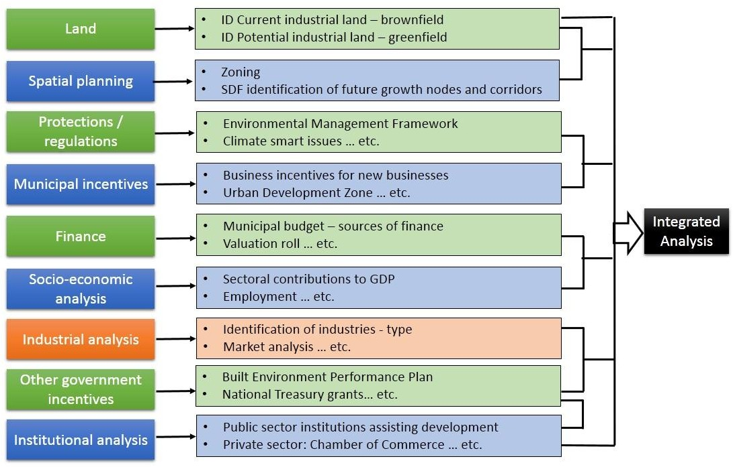

    - Methodology
The methodology essentially involved the activities shown below.

Historical and current industrial trends | In order to plan for the future, it is important to understand the past and the extent to which it can help inform future trends or future direction for industrial development. This will be done through accessing: municipal records, historical records concerning city development, discussions with members of the Chamber, and other key stakeholders. Issues such as investor confidence, macro-economic conditions, local land and infrastructure costs, ageing infrastructure, urban management of industrial land-crime and grime, investor aftercare, municipal rates and incentives, how those have changed over time and what effect they have had on investment in the City will be researched.
Consultation with key role- players and experts | A list of important role-players (those that have defined roles within the commercial / industrial sector and the decision-makers in terms of approvals for development), stakeholders (those that have some kind of stake in industrial development, including current firms/ business owners, small business sector who rely on industries for downstream work etc.), and experts (industrial specialists etc.) who can provide insight from work they have done or are doing in this field. These people and organisations should be identified during the inception phase, starting with information provided by the client, and then building on this through links and referrals.
Literature review | This will cover any available literature specific to historical, current and future trends in industrial development related to Msunduzi; it will also look at KZN and national industrial trends. Of critical importance are the various national and provincial initiatives as set out in the NDP, the SIPs, the National Infrastructure programme, and the provincial and district Growth and Development Strategies among others. Obviously, all relevant legislation, national, provincial and local by-laws and regulations, will be reviewed. Again, this will be discussed with the client and the Steering Committee members to ensure that all relevant sources are reviewed.
Spatial analysis | Spatial analysis is a key aspect threading throughout this investigation. Primarily, this relates to mapping of existing industries (including industrial type) land availability and suitability for industrial development (supply and demand); it also needs to assess locational advantages for specific sectors wherever relevant. The mapping should enable all stakeholders, but particularly the potential investors and decision-makers, to see at a glance what is currently in place and what land is available. Such spatial analysis must include risk factors such as environmental, climate, pollution (water, air and ground), safety and security (crime); flooding potential etc.
Sectoral analysis | This is a focus on an analysis of the industrial stock of the City: which are the lead industries in the city and how do these link internally with downstream activities as well as with external markets. It will look at performance of the sectors, employment analysis within each sector and a comparative or competitive advantage assessment to determine where the focus of marketing and investment should be going forward. The sectoral analysis will also need to look closely at declining sectors and provide a view on cause-effect factors and whether there is a case to revive some sectors.
Carvalho Classification | This analysis considers a combination of three values: provincial and local sector relative growth as well as the location quotient. This will assist in determining whether  the sectors are leading or lagging, and whether they are for example, ‘driver’ sectors,

 | ‘promising’ sectors or ‘vulnerable’ or ‘marginal’ sectors. This helps in providing a quick overview of comparative advantage.
Project prioritisation model | Key variables will be identified and discussed to seek agreement on which are the most important in establishing priorities for project implementation in terms of the strategy. Issues such as job creation, poverty alleviation, income generation, spatial location, redistribution of opportunities and overall benefit for municipality will be considered and applied in a structured manner in order to develop a logic for prioritising key projects which should act as catalysts for growing the industrial sector and greater economic, social and environmental sustainability.

  - CONTENTS OF THE INDUSTRIAL DEVELOPMENT STRATEGY

This strategy report is structured as follows:
Figure 3: Structure of Industrial Strategy Report
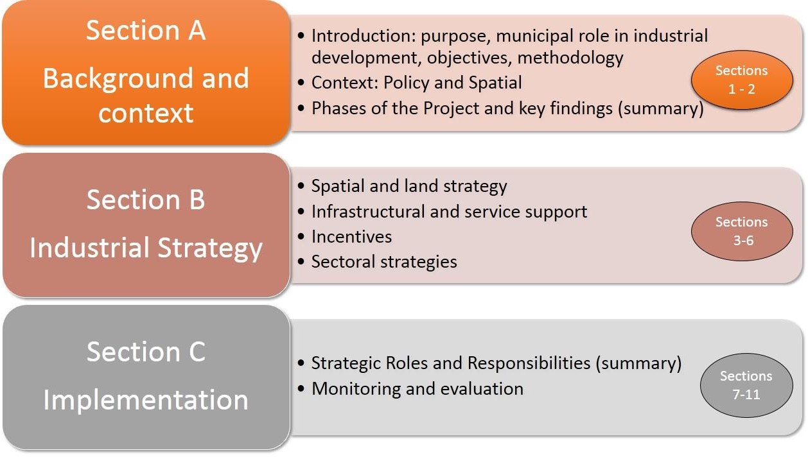

.

- THE PHASES OF THE PROJECT AND KEY FINDINGS

  - Phase 1: Status Quo Report

    - Contents
Phase 1 provided the background to the project and a description of the current status quo regarding industrial development within the Msunduzi Municipal area.. A summary of the contents of the Phase 1 report is illustrated below.
Figure 4: Contents of Phase 1 Situational Analysis Report
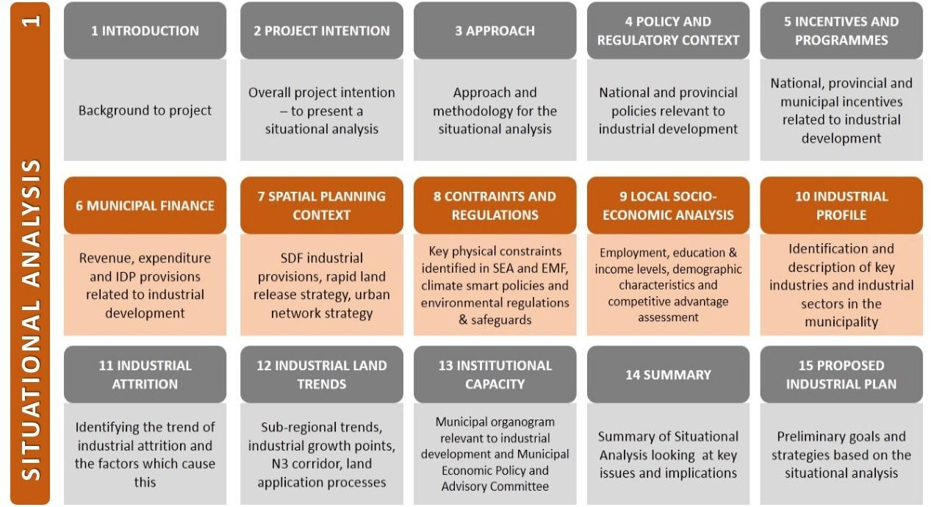

    - Summary: Key factors
In summary, the situational analysis highlighted the following main issues:
- National and Provincial Policy
The National Development Plan, State of the Nation Address (2017), the Industrial Policy Action Plan and the Provincial Growth and Development and Spatial Economic Development Strategies all indicate support for industrial development. The strategic role of the N3 Durban- Gauteng Logistics Corridor was highlighted as well as specific national action plans for industrial development. The importance of rural development was also a feature of the NDP. Msunduzi’s role as a secondary provincial node was acknowledged with specific catalytic developments mentioned.
- National, provincial and municipal incentives and programmes
The various incentives at all three spheres of government were highlighted, indicating general measures, spatial and sectorally targeted measures, financial and non-financial incentives offered, as well as rebates, subsidies and exemptions from application fees, among others.

- Msunduzi Industrial Spatial Planning context
The strategic framework set by the municipal SDF and how this is realised through the IDP is highlighted, as well as the role of the SIP2 corridor. The intention is to develop an agricultural and logistical platform as part of a supply chain, as well as enhancing the role of the N3 corridor (industry, transport, logistics) and the additional catalytic project of the Pietermaritzburg airport and Techno Hub.
- Msunduzi physical and infrastructural status
Innovative thinking will be required to overcome the physical constraints and limitations on land suitable for industrial development.
- Local socio-economic analysis
The analysis looked at sectoral contributions to GDP within Msunduzi municipal area, with manufacturing contributing 15.4% in 2014 (IDP, 2016-17 – 2020/21, p.141). With the official unemployment rate at 33%, there is recognition of the importance of retaining, and growing the current industries in Pietermaritzburg as well as promoting the city for new industrial investment. Apart from GDP and GVA, this analysis also looks at the HDI or Human Development Index as a measure of the key dimensions of human achievement (a long and healthy life, being knowledgeable and having a decent standard of living). There has been a sustained (albeit slight) increase in the HDI from 2008 to date (see Figure 5).
Table 1: Overall assessment of sectors in Msunduzi municipal area including GVA contribution as a percentage

Sector | GVA  R million | % per sector  *1 | Employment 2016 *2
Mining and quarrying | R471 | 2% | 187
Construction | R568 | 3% | 8970
Electricity, gas & water | R628 | 3% | 604
Agriculture (incl. Forestry) | R633 | 3% | 7577
Community, social and personal services | R1, 400 | 6% | 9802
Wholesale and retail trade, catering and accommodation | R2, 305 | 10% | 14 630
Transport, storage and communication | R3, 255 | 14% | 1113
General Government | R4, 218 | 19% | 11606
Finance, insurance, real estate and business services | R4, 422 | 19% | 3 544
Manufacturing | R4, 804 | 22% | 5 214
TOTALs | R 2 300 000 000 | 100% | 63 247
Sources: 1. Msunduzi Local Economic Development Strategy, 2014. 2. IHS Marki

Figure 5: Human development index 1996 - 2016

- Profiling of industries
The main industries that have been identified as having a comparative advantage in the Pietermaritzburg area are: aluminium (metal industry), leather and footwear, agri-processing, forestry/timber (wood and wood products), logistics (due to location on the N3 and SIP2 corridor), ICT, electronics and engineering, clothing and textiles (important because this is more labour intensive).
- Industrial land demand
The current and potential demand for land needs to be analysed; in addition, the land development application and approval processes need to be reviewed and streamlined where possible.
- Institutional analysis
This covers the public and private sector institutions which help coordinate all the elements required to facilitate industrial development, as well as set up partnerships between the public and private sectors.
- Catalytic projects
The uMgungundlovu District Comparative Advantage Report (UDM, 2012 ) identified various catalytic projects which, related to industrial development, included: establishing dedicated large scale truck stops; development of a logistics platform, train coach manufacturing at Mason’s Mill, a Special Economic Zone for leather and footwear companies, further expansion of airport, encourage location of aircraft manufacturer and an Msunduzi ICT incubator.

In conclusion, based on the assessment within the Status Quo report, industries were divided into two main categories: the industries which need to be maintained and supported and the industries which need to be grown or initiated, as detailed below.
Figure 6: Industries to grow and maintain

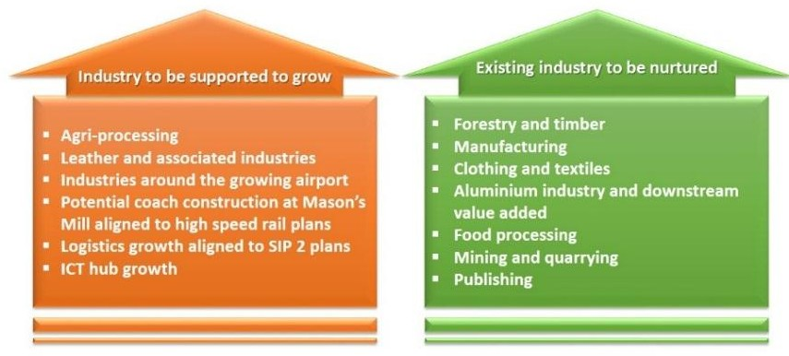

    - Preliminary ideas towards an Industrial Strategy
The situational analysis identified six broad themes required to improve the current industrial climate in Msunduzi. These themes are:
Figure 7: Broad themes and preliminary ideas on strategies
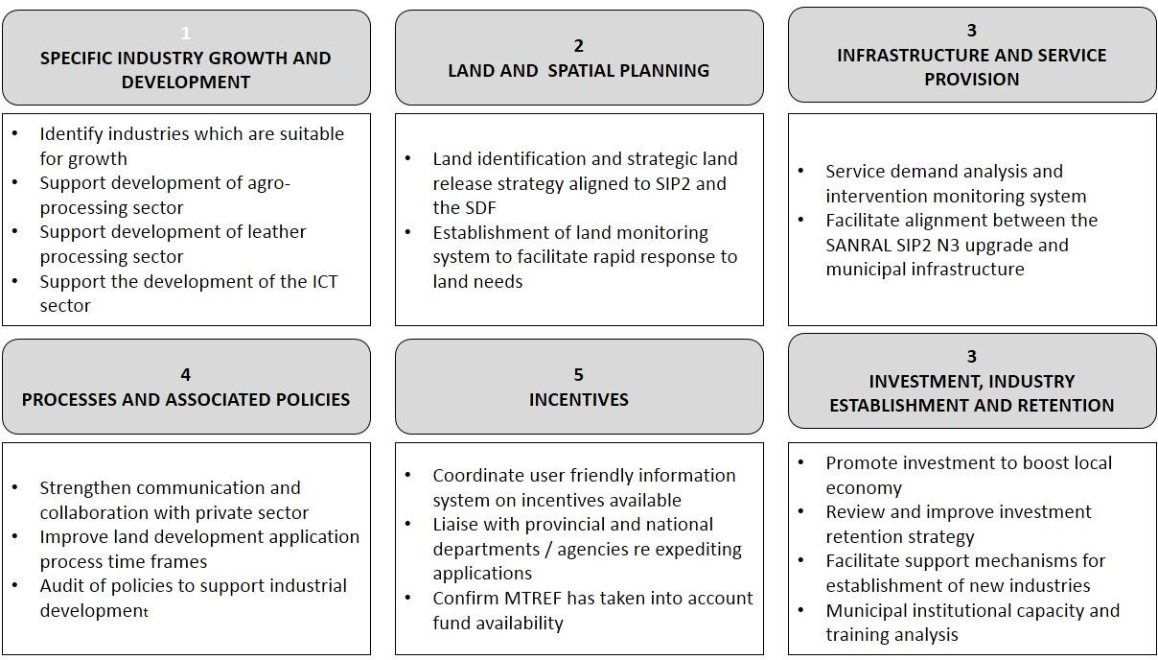

  - Phase 2: Sectoral Analysis

Phase 2 delved deeper into each of the sectors, both through desktop analysis using various analytical tools, as well as through a stakeholder workshop and individual interviews, accompanied by a questionnaire, with various industrial roleplayers. The contents of the Sectoral Analysis report is shown below.
    - Contents
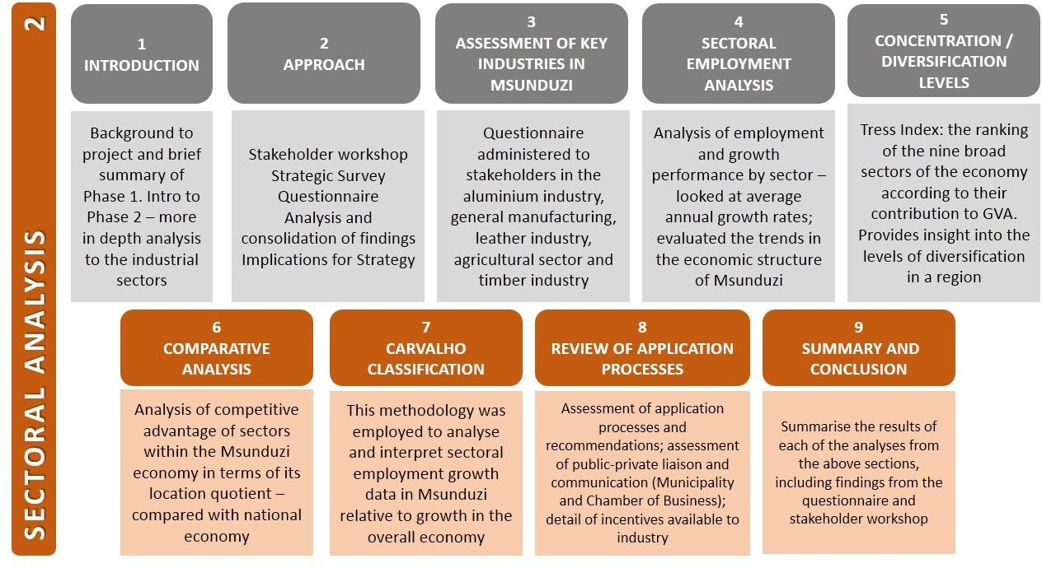

    - Phase 2 summary – key factors
      - Interviews: consultation
The questionnaire asked the following questions:
        - How are you organised – clusters, forums, other?
        - Do you have a growth strategy and can you provide a vision for your industry?
        - How can the Msunduzi Municipality enable and support growth in your (existing) industry?
        - How can the Msunduzi assist and promote new entrants?
        - Can you provide sector employment data? And is there a custodian of this data?
        - Can you provide data on growth within your sector? And is there a custodian of this data?
        - What are the estimated multipliers per industry (e.g. number of jobs per tonne produced)
        - Would an interactive industrial health dashboard be useful? And what form should this take?
        - What external resources do you know of that are available to support industry?
        - Are there any obstacles hampering the use of such resources?
        - Do you have any specific parameters regarding spatial location for your industry?
        - Is the environment you operate in conducive and inviting for business growth?
        - What are you doing towards the greening of your industry and climate change mitigation?
        - Are there forums for you to meet and discuss matters of mutual interest?

The key factors that arose out of these interviews are:
          - Apart from the Chamber of Business, there are no other institutional structures – like clusters, where industry is organised across the industrial sectors.
          - Industrial growth strategies: all industries identified a reliable water supply and a stable and secure electricity supply as fundamentals, particularly electricity supply which at present is operating at capacity. Each sector then listed additional aspects which they saw as important for their growth, such as, for the agricultural sector, the development of agri-processing plants in Mkondeni and improved agricultural extension support for small and emerging farmers.
          - Enable and support existing industry through the following interventions which were identified during the interviews:

Services and infrastructure  Improved service infrastructure Cleaner operational environment  Better road and transport access (internal and external) |  | Land and spatial issues  Access to flat land  Provision of land by the municipality through the SDF Access to high value agricultural land close to agri- businesses
Human resources  Attract skilled labour Attract scientists Funding for research and development | Fundamental issues  Stable electricity supply Reliable water supply |  | Institutional Issues  Re-establish working relationship with municipality  Streamline application processes Industrial health dashboard

          - Promoting and supporting new industrial investors: this focused on similar issues such as electricity supply, water and road access. It was also recommended that an SEZ be created, and that alternatives sources of energy such as gas, be looked at.
          - Refining and growing industry by creating hubs for specific industries, focusing on skills development, seeking innovation through further research and development within each sector, liaising with the Department of Agriculture to ensure improved agricultural extension support for those farmers supplying Msunduzi agri-industry; establishing an SEZ and providing suitable land.
          - Multipliers per industry cluster: the aluminium industry sector provided an indication of multipliers with an estimate of 3 new jobs created per each tonne of downstream beneficiation, with a vision to create and support over 300 new entrepreneurs over the next six years. The other industries, such as agriculture, have varying estimates of job potentials, dependent on the product (sugar cane, for example, provides approximately 20 jobs per ha during planting season). Looking as SA stats as a whole, the agricultural and manufacturing sectors have the highest multiplier effects in terms of job creation per amount of investment.
          - Industrial health dashboard: the stakeholders agreed that setting up an industrial health dashboard as a means of monitoring would be useful for both themselves and the municipality to gauge on an ongoing basis, what issues needed intervention and what is working well. The dashboard should monitor issues such as: status of municipal services, climate change

mitigation measures, upstream and downstream opportunities and progress with strategic planning and implementation.
          - Financial or other assistance: accessing funding is subject to very strict conditions and requirements. The applicant must be able to demonstrate commitment and co-funding.
          - Spatial location / spatial parameters: this looked at various input resources and, on a sliding scale, whether they were critical to not important across the range of industrial sectors. This provided a snapshot of which issues were most critical for specific industrial sectors. The issue most critical across most industrial sectors (aluminium, leather, agriculture, manufacturing, electronics and forestry) was that of the locational aspects of markets.
Figure 8: Spatial criteria per industry
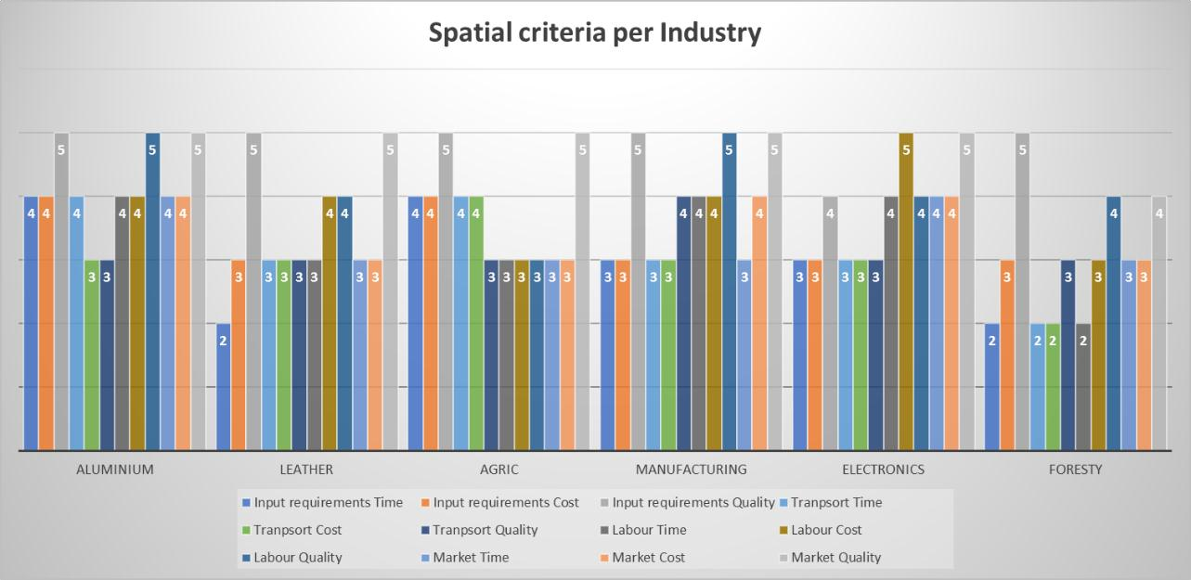

          - Industrial locational requirements: this question sought to determine which issues were most important to each industrial sector such as position in relation to N3, proximity to labour force, access to large amounts of water, access to large tracts of flat land, proximity to a port for imports and exports, proximity to high quality agricultural land and proximity to end-product clients. Based on the questions posed to the respondents, the data lent itself to further analysis, again allocated values from 1 (not important) to 5 (critical consideration). These assessment are captured in Table 2 below.
Table 2: Industry location criteria

Industry Locational Requirements | Alumin- ium | Leather | Agric | Manu- facturing | Elec- tronics | Forestry
Position to N3 and main routes | 4 | 3 | 2 | 3 | 2 | 2
Locality iro labour force | 4 | 4 | 5 | 4 | 3 | 5
Quality energy source | 5 | 4 | 3 | 5 | 4 | 3
Large amounts of water | 5 | 5 | 4 | 3 | 2 | 3
Large tracts of flat land | 5 | 5 | 3 | 4 | 2 | 2
Close to a port for import and exports | 4 | 3 | 3 | 3 | 3 | 3
Fertile high quality agricultural land | 1 | 1 | 5 | 1 | 1 | 1
Close proximity to end-product clients | 3 | 3 | 4 | 3 | 2 | 2

          - The operational environment: this related to the quality of the environment in the city in general and surrounding the industries and industrial areas in particular. There was a feeling that this was deteriorating with streets not being kept as clean as they should be and that general services and maintenance were not being kept up. The common response was that this issue was important to industry, to the extent to which some felt they had to move to locations where they were not embarrassed to bring clients to.
          - The greening of industry: the graphic below summarises as to how industries are responding to this issue
Figure 9: The greening of industry
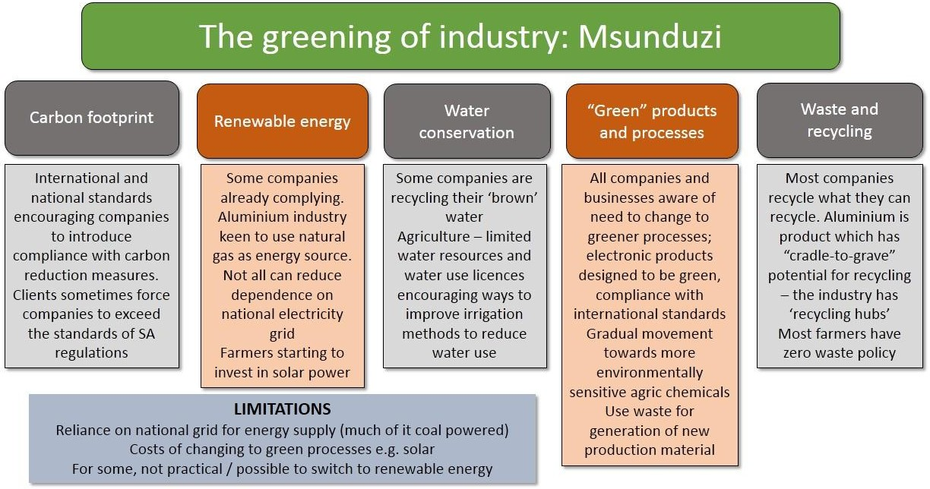

          - Public and private sector relationships: generally it was agreed that the relationship with the municipality could be improved as there had been a decline in the number of regular meetings that were once held. Different industries had varying levels of interaction with relevant provincial or national departments, often depending on their own industrial organisations (e.g. national forums or federations linked to their sector)
          - Links to LED Strategy: this looked at the extent to which the issues of concern in this industrial strategy linked to similar issues, concerns and recommendations in the Msunduzi LED Strategy. For example, the LED Strategy recommends a Business Retention and Expansion Programme; it also looks at skills development and the need for information sharing and coordination in investment promotion for the City; the need to establish more business and industrial ‘hives’ to provide opportunities for small and emerging manufacturers; the need to monitor the release of municipal land for industrial development; the support of small-scale farmers and the protection of high value agricultural land within the Vulindlela area and to look at ways to intensify agricultural opportunities for agri-processing / beneficiation.

      - Comparative Analysis / Carvalho Classification and Tress Index
Various analytical tools were employed to gauge how industry in general or specific sectors are performing either within Msunduzi itself or how industry fares locally in comparison with national trends.
The Tress index provides insight into the level of concentration (or diversification) within an economic region. A Tress index value of 0 shows that all economic sectors contribute equally to GVA – i.e. a high level of diversity, which is healthy. A value of 100 means that only one economic sector makes up the whole GVA of the region – in other words, there is no diversity and a high level of dependence on one sector. For Msunduzi, the Tress index in 1996 was 45.5 and in 2016 this rose to 47, indicating a decrease in diversity and therefore increasing risk to jobs and the local economy. However, in 2002 to 2004, the index rose to 49 and between 2008 to 2010 the graph spiked up to 48, so there has been an improvement since then, but not yet to 1996 levels of diversity.
Figure 10: Tress Index for Msunduzi 1996-2016

49
48
48
47
47
46
46
45
45
44
44
Tress index

47
45.5

1996 1998 2000 2002 2004 2006 2008 2010 2012 2014 2016
Source: IHS Markit Regional eXplorer version 1160

The comparative analysis or location quotient demonstrates the relatively more competitive production for a product or service in a specific economy compared to the whole economy. This shows, for instance, where a product or service might be rendered more efficiently in Msunduzi than in the rest of South Africa. If the location quotient is larger than 1 then it has a comparative advantage in relation to the wider economy; if less than one, then that industry is at a comparative disadvantage. Location quotients were provided for Msunduzi for various sectors (agriculture, mining, manufacturing, electricity, construction, trade and transport) from 1996 to 2000 and in 2016. The graphic below shows the 2016 location quotient which indicates that the electricity sector has the strongest comparative advantage with mining having no advantage (less than 1).

Figure 11: Location quotient for Msunduzi, 2016

Location quotient
Msunduzi, 2016
1.6

1.4
1.2 1.0
.
0.8

0.6

0.4

0.2

0.0

- Agriculture

- Mining

- Manufacturing

- Electricity

- Construction

- Trade

- Transport

- Finance

Source: IHS Markit Regional eXplorer version 1160

The Carvalho Classification analyses and interprets employment growth data, examining employment growth in Msunduzi relative to growth in the overall economy or regional level. In this case, the benchmark for sectoral employment against which Msunduzi was measured was that of KwaZulu- Natal. Essentially, it shows whether each sector is in a driving, accelerating, rising, evolving or transitional phase as well as whether there are challenges or vulnerabilities, and which sectors are marginal or under-represented in the community.
Table 3 below shows, using the Carvalho Classification modelling, how Msunduzi compared with KZN performance across various sectors over a ten year period from 2006 to 2016.

Table 3: Carvalho Classification showing Msunduzi performance compared with KZN 2006 - 2016

 |  |  | Average Annual Growth Rate KZN (2006-16) | Average Annual  growth rate Msunduzi (2006-  16) | Difference
 | KZN | Msunduzi
11 Agriculture and hunting | 110,170 | 5,971 | -6% | -6% | 0%
12 Forestry and logging | 26,906 | 1,606 | -1% | -2% | -1%
13 Fishing, operation of fish farms | 65 | 12 | -19% | -17% | 2%
21 Mining of coal and lignite | 6,775 | 182 | 2% | 8% | 6%
23 Mining of gold and uranium ore | 0 | 0 | -100% | -100% | 0%  1%
24 Mining of metal ores | 35 | 5 | -32% | -31%
25-29 Other mining and quarrying (incl 22) | 3,683 | 148 | 7% | 7% | 0%  0%
30 Food, beverages and tobacco products | 48,997 | 3,714 | 3% | 3%
31 Textiles, clothing and leather goods | 76,197 | 3,805 | 1% | -1% | -1%
32 Wood and wood products | 37,206 | 2,480 | -1% | -1% | 0%
33 Fuel, petroleum, chemical and rubber products | 30,974 | 1,985 | -2% | -2% | 0%
34 Other non-metallic mineral products | 13,139 | 871 | 1% | 1% | 1%  1%
35 Metal products, machinery and household appliance | 44,926 | 5,214 | -1% | 0%
36 Electrical machinery and apparatus | 1,037 | 99 | -11% | -11% | -1%
37 Electronic, sound/vision, medical & other appliances | 2,349 | 131 | -1% | -3% | -2%
38 Transport equipment | 15,181 | 1,113 | -6% | -4% | 2%
39 Furniture and other items NEC and recycling | 14,126 | 786 | -1% | -2% | -1%
41 Electricity, gas, steam and hot water supply | 4,831 | 604 | -3% | -2% | 1%
42 Collection, purification and distribution of water | 5,083 | 447 | 8% | 6% | -1%
50 Construction | 139,113 | 8,970 | 4% | 3% | -1%
61 Wholesale and commission trade | 23,572 | 1,929 | -11% | -10% | 1%
62 Retail trade and repairs of goods | 197,661 | 14,630 | 3% | 3% | 0%
63 Sale and repairs of motor vehicles, sale of fuel | 67,815 | 5,144 | 1% | 1% | 0%
64 Hotels and restaurants | 74,383 | 5,234 | 4% | 5% | 1%  1%  1%
71-72 Land and Water transport | 80,787 | 5,156 | 2% | 3%
73-74 Air transport and transport supporting activities | 21,429 | 992 | 4% | 5%
75 Post and telecommunication | 8,497 | 641 | -4% | -4% | 0%
81-83 Finance and Insurance | 41,178 | 3,243 | -4% | -4% | 0%
84 Real estate activities | 5,024 | 301 | -9% | -9% | -1%
85-88 Other business activities | 253,482 | 20,551 | 2% | 2% | 0%
91 Public administration and defence activities | 108,009 | 11,606 | 3% | 4% | 1%  1%  0%
92 Education | 175,351 | 15,948 | 2% | 3%
93 Health and social work | 147,099 | 16,505 | 4% | 4%
94-99 Other service activities | 113,538 | 10,119 | 11% | 11% | 0%
Households | 235,056 | 20,407 | 1% | 3% | 2%
Total | 2,133,675 | 170,551 | 1% | 2% | 1%

    - Summary and conclusions
This sectoral analysis showed that Msunduzi needs to look at trying to diversify the economy more; mining, trade and finance are at a comparative disadvantage while agriculture, electricity and transport are at a comparative advantage.
The series of interviews which were conducted helped gain a more personalised understanding of the daily practicalities of maintaining business as well as more strategic structural, service and institutional issues. Key issues emerging from these interviews was a sense of stagnation and the need to encourage business retention before trying to attract new industries when there are very real challenges for existing industries, challenges which make it difficult for them to stay in the City. On a practical level, the stability of electricity supply was a major issue, as was the deterioration in communication between the Chamber and the city, with what were once regular monthly meetings, to virtually no liaison meetings in 2017. This is recognised as by both parties as something that needs to be remedied.

The survey included an analysis of the spatial requirements for industry considering reliance on proximity to the N3 and major transport networks, the importance of input material, the importance of labour and different types of transportation and concluding with the importance of markets for end products. The study was of value, exposing differing needs, with more technical manufacturing being more dependant of higher skilled labour. This is of particular importance for the electronics, manufacturing and aluminium industries. Some industries, such as Hulamin have initiated their own skilling and attraction programmes through bursaries and liaison with universities
Some interesting new ideas which came to the fore included the establishment of an Aluminium Hub, the possible extension of the Special Economic Zone, an extension of the agricultural sector, establishing youth agri-processing facilities and aqua-culture enterprises.

  - Phase 3: Production Analysis

Phases 1 provided a broad status quo on industrial development, with Phase 2 beginning to focus down on particular sectors, identifying the following industries that have growth potential in Msunduzi: agri-processing, manufacturing (particularly aluminium), leather, a techno-hub, an automotive hub and the rubber industry. A wide range of projects were identified in respect of the above these industries, which would support the growth of the Msunduzi Industrial Development Strategy. This includes more than 50 projects within the Techno-Hub with a combined total value of more than R2,6 Billion rand, admittedly with a number of projects being infrastructure related. This together with the new Leather Hub, the Automotive Hub and the potential designation of a Special Economic Zone, creates an exciting environment for economic and industrial development.
This phase looked in greater depths at the growth path for key sectors (see graphic below which provides a brief summary of the contents of the report.
    - Contents
Figure 12: Contents of Phase 3 report
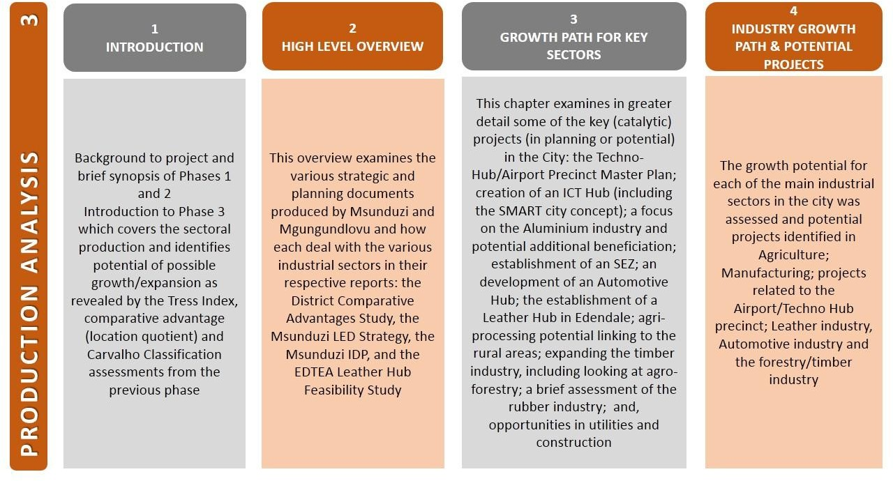

    - Key factors
The key factors for each of the identified growth sectors are summarised below.
      - Airport precinct and Techno-Hub
The establishment of the Technology Hub and the extension of the airport is of critical importance for Msunduzi and will provide the Municipality with a number of competitive advantages. This includes the following:
        - Creation of an area of aeronautical excellence through establishing a specialist aviation centre. The Techno-Hub is intended to include flight training and postgraduate aviation courses. This will also include pilot training as well as aviation engineer training.
        - The Durban University of Technology has already indicated its willingness to support and initiate this process of aviation curriculum development.
        - It is the intention to offer high tech developments in this Techno-Hub.
        - Pietermaritzburg is considered to be the bike mecca of Africa and as a consequence the Techno-Hub is considering the inclusion of a velodrome as well as training and research and road testing. This would need a feasibility study to determine viability.
        - It is the intention of the Techno-Hub to provide laboratories for testing of high tech equipment. It would be important to see if prototype testing could be included in the Techno- Hub.
        - In addition to the above additional industrial land will be unlocked adjoining the Techno-Hub and along Gladys Manzi Road.
It is however important that the strategy is realistic and recognises that the actual development my occur only from 2022 onwards.
The KZN Treasury initiative of provincial Techno-Hubs does however provide an important short and medium term investment opportunity to the Hub. The fact that various feasibility and operational studies have been completed in this regard suggests that the various implementation strategies and projects should be considered as part of the current industrial development strategy.
Furthermore, various technology investors have already shown interest in this regard, and together with key partnerships such as the Technology Innovation Agency, could unlock the initial capital investment required to establish the Techno-Hub in the medium term.
      - Information and Communication Technology (ICT)
The original ICT HUB strategy proposed a largely development oriented ICT HUB i.e. providing ICT Services to the developmental sectors of a disadvantaged community such learners, community organizations, job seekers, micro to small business, etc. The revised approach now includes some of these development services, but is enhanced by the drive to be commercial and competitive within the ICT industry. The primary services area is the Msunduzi municipal area but the intention is to spread its services to industries beyond the municipal boundary. The key drivers of the ICT HUB Strategy are still pertinent, these being:
- Mechanisms to enhance the municipal area as a “Smart City”
- Bridging the digital divide and promotion of ICTs uptake by all citizens

- ICT skills development
- Empowerment of communities and business through ICT
- Entrepreneurship
- Local and provincial competency development
In discussions with the Economic Development unit of the Msunduzi Municipality high level requirements for ICT enabled business solutions to support economic development within the Msunduzi area were identified. The underlying success of these business solutions lies within the ICT Infrastructure and Technology space. Each business requirement identified by Msunduzi Municipality prompts for robust and professional approaches to design and implement these business solutions, enabled by Smart Information and Communication Technology.
      - Aluminium production
The Aluminium Industry has an important influence on the Msunduzi economy. Hulamin has head offices in Pietermaritzburg and Midrand and are responsible for R8 Billion turn-over annually, and employs 2000 staff members. The importance of the aluminium industry is further supported by the number of employees in the manufacturing sector in Msunduzi which has increased from 3 945 in 1996 to 5 214 in 2016 (IHS Markit, 2016). During this period the financial contribution of this sector grew from R627 918 to R790 724.
An overview of the operations in respect of Hulamin, revealed that in 2014, it had sold 200 000 tonnes of processed aluminium, with a turnover of R8 billion, to more than 40 Counties, confirming a well- diversified market.
The Aluminium Beneficiation Initiative has a vision to identify and support 100 entrepreneurs in the aluminium fabrication sector. It is the intention to guide these entrepreneurs into sustainable businesses within a period of 3 years. It is intended for each of these businesses to consume at least 100 tonnes of aluminium. The programme includes the identification of entrepreneurs, to provide training and support, including linkages with the right partners. Using the global benchmark of three jobs for every tonne of downstream aluminium beneficiation, the support of 100 entrepreneurs with 100 tonnes of aluminium each in a 3 year cycle, has the potential to create 30 000 new jobs. Over a 9 year period, 90 000 new jobs can be created.
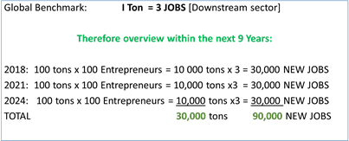
In addition, Hulamin would like to see an SEZ created for industry, even on a virtual basis, which would allow industries to qualify for the same benefits associated with a land-based SEZ.
      - The Automotive Hub
The Auto Service Hub will take the form of a formal mini industrial park/hub focusing on providing automotive related services. It is intended to include the following components: a management body,

shared facilities, training & incubation, consumables store room, tool room, canteen, carwash, controlled & secured holding yard, recycling collection area, and security services.
The intended area for the automotive hub is aligned to the Masons Mill, Leather Hub and Hulamin area. With the intended development of the Edendale Hub and the IRPTN and the intended growth of the Mason’s Mill Industrial area, the Automotive Hub could be well situated in the area under consideration, but subject to land availability.
      - The Leather Hub
The leather industry in Pietermartizburg has experienced fluctuating fortunes, with the number of tanneries declining from 13 to 5 and shoe production in the city declining from 80 million in 1990 to just over 22 million in 2001, with employment decreasing from 12 000 to 2 000. EDTEA has, however, acknowledged that there is an existing infrastructure for the leather industry in Pietermaritzburg, with the potential for revival, with the right support. To this end, it has identified two potential sites in Edendale for a Leather Hub. The optimism for the revitalisation of the leather industry in Pietermaritzburg is clear. Nationally, in the 1980s, the industry employed 40 000 people; this dropped to 6 000 by the 2010s but has now increased steadily to 17 000.² The Eddels shoe factory has doubled its employment figures in the past 5 years to 1 500 which is part of this steady growth.
Downstream beneficiation of the tanned leather hides includes:

Footwear | Leather clothing
Leather upholstered furniture | Leather art / decoration
Leather bags and wallets | Leather book covers etc.

The optimism surrounding the proposed Leather Hub is predicated on the following key market opportunities:
- African tanning capacity has reduced over time allowing for opportunity to fill the gaps
- Leather production is labour intensive and should therefore attract government support
- Value added through the manufacturing process by the four leading producers is close to 25%
- Leather lends itself to high end niche products such as shoes, garments and bags that can be sold on the international market.³ The intention, therefore, is to make a firmer commitment to export markets.
- There is huge opportunity in the sheepskin market with around 5 million sheep slaughtered annually of which 97% of the skins are exported raw or semi-processed. Bringing beneficiation back to South Africa makes sense. There are about 2 million goats slaughtered annually in South Africa but there is no beneficiation of their skins. This would require a feasibility study

² Mr John Comley, pers comm. October 2017
³ EDTEA, 2014, p.78

which takes into account farm security issues; there has apparently been a reduction in livestock farming in the area due to theft of animals. A 2016 news report⁴ stated that the Red Meat Producers Organisation (RPO) singled livestock theft as one of the main threats to farming in the province.
The Department (EDTEA) is looking to the example set by Turkey which started its first leather cluster 20 years ago and now has 13 clusters which generate exports of $1.5 billion a year. It is important, however, to develop the skin production value chain which is weak at the moment resulting in underutilised potential of the skin/leather industry. DTI has given the sheep and goat skin tannery national pilot status and has included it in IPAP 6 as part of a targeted initiative in the leather industry.
The establishment of the Hub should be facilitated by re-purposing existing buildings; essential to its operation is the provision of sufficient water and electricity. In addition, the Hub is anticipating support from the DTI and IDC in providing funding to assist with the purchase of additional equipment. The input of investment from the state will, it is anticipated, be more than doubled within a year, with the added benefit of the creation of 750 direct job opportunities.
      - Agri-processing
While the value of agriculture’s contribution to the total SA GDP has been in decline, it is acknowledged that primary agriculture is an important sector in the South African economy. “Agriculture remains a significant provider of employment, especially in the rural areas, and a major earner of foreign exchange”, (Department of Agriculture. Forestry and Fisheries, Economic Review of the South African Agriculture (2016, iv). In fact, in a report from StatsSA, it credits the agriculture and finance sectors for lifting SA out of a recession in 2017 (STATISTICS South Africa, 21/10/2017). A key factor for the agricultural industry relates to its potential for job creation as shown in the graph below:
Figure 13: Number of jobs created per R 1 million (multiplier)
Number of jobs created for R 1 million investment Multiplier
No. of jobs
Electricity
Transport & communication
Mining Finance Construction Manufacturing Wholesale and retail
Agriculture
0.1
0.1
0.5
1
2.5
3
3.3
10.5
0 2 4 6 8 10 12
Source: Adapted from Abedian et al. (2011, p. 15)

⁴⁴ IOL ANA Reporter, 2016, Livestock theft a blow to KZN farmers, 15 April 2016, https://www.iol.co.za/news/crime-courts/livestock-theft-a-blow-to-kzn-farmers-2010341

The Msunduzi agricultural production and beneficiation analysis identified that agriculture has a small, but important part of the Msunduzi GVA. The analyses identified a number of potential projects as detailed below:
- Agri-processing, particularly employing the youth and using unused buildings
- Agricultural extension in the Edendale and Vulindlela area
- Aquaculture
- Hydroponics
- Compost from waste
- Feedlots and abattoirs
These projects, offer real opportunities to secure further development and employment opportunities in Msunduzi, particularly when considering the multiplier affects associated with agriculture. With the new leather hub being implemented in Msunduzi, the growth and support of the leather hub through feedlots and an abattoir could be very useful.
      - Forestry and timber
The South African forestry sector contributes 1.6 % to GDP and 6 % to manufacturing GDP nationally. In terms of regional GDP, forestry in KwaZulu-Natal contributes 4.4 %; in Mpumalanga 3.7 %; in the Eastern Cape 0.6 %; and in Limpopo about 0.6 %.
Although the availability of input timber and associated afforestation is a vital component for the growth of the timber industry and would need to systematically be addressed, the following opportunities exist for the further development and industrialisation of the timber sector within Msunduzi:
- Furniture manufacturing: there is potential for furniture manufacture with the proviso that a skills development programme should be initiated for this sector within Msunduzi
- Construction (poles): there appears to be a growing demand for timber poles in the electrification and ICT sectors which could serve not only South Africa, but also a number of other African countries who are all promoting the expansion of electricity and ICT networks. Pole production would require sufficient treatment facilities and storage yards and might be well suited in proximity to rail infrastructure
- Dissolving pulp industries: The previously reported growth in the pulp and paper industries is an indication of this this growing sub sector and these products often get used in furniture manufacturing as well. The processes involved within this sub-sector would require similar land and infrastructure as mentioned above for furniture and construction industries.
- Establishment of outgrowers: Supply is a vital factor within timber industries and the systematic promotion of more localised afforestation would thus be important in the growth and development in such industries. Apart from the promotion of the expansion of commercial forests, there exists an opportunity for the development of out-growers as a method of ensuring further localised benefits to smaller producers and possibly communities. The industrial development strategy could thus establish a programme of support to such out-growers. The availability of water and associated licenses are important starting points in that process and the municipality could engage with other spheres of government to assist in the co-ordination and possible fast-tracking of those processes.

      - The rubber industry
The rubber Industry forms part of the Petroleum, Chemical, Rubber and Plastic category. This category has shown a gradual growth in South Africa from 2004 to 2013 from R 59 329 million in 2004 to R 93 695 million in 2013 (Statistics South Africa, 2014). In Msunduzi, there has been a growth in this sector from 1996 to 2016, almost doubling in value. The largest manufacturer is Dunlop in the neighbouring municipality of Umngeni (Howick).
      - Utilities and construction
The Msunduzi construction sector has been remarkably resilient since 2006 and has continued to grow over-time. Public spending on infrastructure programmes and major new commercial and residential developments including social housing have been among the contributory factors to this pattern. There is thus a window of opportunity to build on this momentum and create more opportunities for the municipality and the populace. The value of approved building plans in 2015/16 was R 1.469 billion with further R 860 million value of plans sent for rating. It should be added that in places such as Edendale and Vulindlela, much of the residential growth value has not been measured because often building occurs without municipal knowledge or approval.
    - Summary and conclusions
The table below provides a summary of potential projects arising out of this production analysis and growth assessment phase.

Sector | Project Name | Project
Agriculture | Agri-processing | The Transnet premises next to the Old Prison site along Mayors walk road need to be refurnished into Agri Factory shops. Young entrepreneurs don’t have funding to start businesses, and these premises would allow them to be used as SMME incubation centre cubicles.
 | Agricultural extension | There are areas at Edendale and Vulindlela which are good for agricultural practice, but agricultural extension support would be required.
 | Aquaculture | There are also fish farming opportunities. There was an old reservoir in the Blackridge area that was used for trout farming, which can be re-commissioned. Support has already been expressed by the Department of Economic Development, Tourism and Environmental Affairs.
 | Compost from waste | There is interest in the support of a waste to compost generation operation. This could be of value in general in Pietermaritzburg, supporting not just the local and agricultural community, but also extending the lifespan of the Pietermaritzburg Waste Disposal Site, as the volume of waste to be managed would be reduced.
 | Feedlots and abattoirs | Feedlots can increase revenue for the farmer. The value chain can be further extended through the development of an abattoir in close proximity to the Feedlot. (The example of the Abattoir at Boston was used, providing for farmers in the Vulindlela and Boston/ Bulwer area).
Manufacturing | Aluminium Beneficiation Programme | ALU Products is a prodigy of the ABI programme. With a local example and a potential SEZ, a competitive advantage, with Hulamin within the city has been created which must be encouraged.
 | Establishment of SEZ | Establishment of a Virtual Special Economic Zone

Sector | Project Name | Project
Airport Precinct | Airport development | New N3 upgrades of the Mkondeni intersection to be undertaken by SANRAL
 | Hotel at Airport | Construction of Hotel/ Conference Centre at the Entrance to the Airport
 | Techno-Hub | Development of Phase 1 of the Techno-Hub
 |  | Development of Phase 2 of the Techno-Hub
Leather | Leather Hub | Establishment of a leather hub next to Leather from the Heart enterprise. The new facility will share the existing services used by Leather from the Heart, reducing the footprint.
Automotive | Automotive Hub | Establishment of an Automotive Hub, preferably close to the Leather Hub and potentially within the Edendale Centre precinct, which could assist with the development of the site. Funding is available for the feasibility study and structures.
Forestry / Timber | Manufacture of furniture  Housing and social infrastructure provision | Housing and social infrastructure provision could be used as a driver for timber industries. Currently, only about 1 % of local construction in South Africa uses timber structures as opposed to about 70 % in countries in the northern hemisphere. This combined with social infrastructure backlog in the public sector presents potential opportunities for timber industries to assist in developing social infrastructure such as schools, clinics, multipurpose centres, low-cost housing and others, using timber as a cost-efficient and quick method of building

  - Land Supply and Demand Analysis

This phase of the industrial strategy focuses on land availability and the current and potential demand for industrial land.
    - Contents
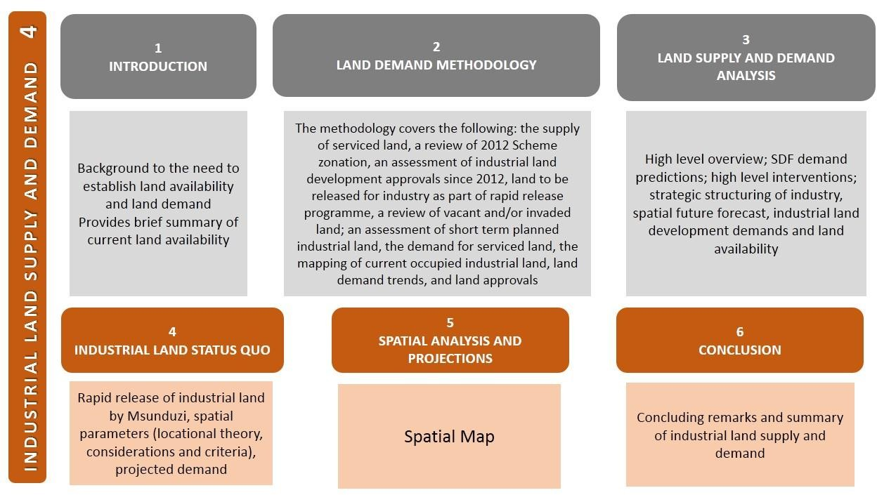

    - Key factors
The key points that arose from this industrial land analysis phase are summarised below.
      - Land Supply and Demand Analysis
The demand and supply of industrial land must be linked to the SDF modelling exercise; this model established that, in order to accommodate moderate growth in the manufacturing sector, the land area available for industry should be at least doubled over the next 30 to 40 years. Based on this, there is an urgent need to develop a programme for the release of at least 50ha to 100ha of industrial land per annum. The demand for industrial space depends on the demand for, and production of, goods within Msunduzi and also regionally and nationally.
In terms of the Msunduzi SDF, General Industrial and Light Industrial land accounts for 1 476, 59ha. The SDF suggests that the industrial land allocation might grow by an optimistic 400% over the next 30 to 40 years to 8 909 ha. Finding and allocating a further 7 400 ha over the next 30 to 40 years will be challenging.
In order to try and meet this challenge, the need for high level interventions was recognised. These have been identified as follows:

Land release along the N3 corridor
Consolidate and revive the CBD
Strengthening centres of economic activity
Introducing new economic zones and centers
Incorporate productive agricultural land
Focus on township economies by establishing and prioritizing industrial zone for small manufacturers
Linking primary hub (city centre, N3) with secondary hub and township through main active economic spines, corridors and sectors alignment
Support the development of the mix use precinct between the N3 and R56 targeted for mixed use industrial zone

These interventions and land release programmes must take into account the strategic structuring of industry with the need to provide space for light, medium and heavy industrial manufacturing enterprises. The different industries will have different service requirements and the recognition of their important locational criteria. This also ties in with the creation of industrial parks and hubs which need to look carefully at economic- and access-structuring elements such as the location of agricultural production areas in relation to agri-processing facilities and location in relation to the N3 for those industries relying on, for example, access to the Durban port facilities.
The spatial forecast for Msunduzi is inseparably linked to regional economies of scale and to the policy environment shaping South Africa. The most pivotal role for Msunduzi is to take stock of the regional

trends and ensure that land with infrastructure is available for future investment - both greenfield and brownfield development. The Msunduzi Municipality has already adopted an approach of pro- actively identifying municipal land for development; and through the 2014 SDF process, land for future large scale urban expansion. These processes will be continued with a focus on specific land development opportunities. There are a number of spatial industrial programmes that were identified in the 2014 Msunduzi LED Strategy such as the municipal land release programme, land development programme, a lease management strategy, revitalization of the manufacturing sector and upgrading infrastructure across all industrial space.
The industrial land demand is partially assessed through the number of land development applications to Msunduzi which shows a relatively low level of demand, with the exception of the creation of the Ibhubesi Industrial Park which, in one application, requested 75 sites (the application was made in 2012 with the development only commencing in 2016. However, uptake of sites has been limited. One of the reasons given for the low level of demand is the uncertainty of the Eskom power supply post 2008. The current status of industrial land use is shown in the table below:
Table 4: Current status of industrial land

STATUS | PROPERTIES | Properties  % | TOTAL AREA (HA) | Area Ha  %
(TO BE REZONED) | 51 | 2.8% | 341.9548 | 14.8%
AIRPORT | 1 | 0.1% | 120.0361 | 5.2%
DEVELOPED | 1447 | 80.7% | 1046.4841 | 45.3%
FUTURE | 5 | 0.3% | 279.3726 | 12.1%
INVADED | 23 | 1.3% | 32.1313 | 1.4%
VACANT | 265 | 14.8% | 491.3873 | 21.3%
VACANT BUILDING | 1 | 0.1% | 0.3756 | 0
Grand Total | 1793 | 100 | 2311.7417 | 100

Detailed maps have been included Annexure A for the following industrial areas which reflect land availability in terms of the categories set out in the table above:
- Ashburton
- the CBD
- Edendale
- Mkondeni
- Northern industrial area
      - Industrial land status quo
Msunduzi Municipality, as part of the 2015 IDP, initiated a rapid land release strategy, in respect of general industrial and business development. Through a land audit process, 30, 589 ha has been identified for this purpose and is being made available through public tender for land development. Whilst 30, 589 ha has been identified, not all the land is in the high demand areas in Msunduzi. It does

however addresses 50% of the 60ha short term growth in Industrial land demand as recommended in the 2015 IDP.
In this section, it was also considered important to look at spatial parameters, essentially this is linked to industrial location theory as applied to Msunduzi. Locational factors represent savings in costs that a business can gain from producing in one place over another and this is then applied to various factors, but mostly related to labour and transport cost factors and the consideration of agglomeration effects(clustering of businesses and industries). These theories highlight various approaches, but essentially indicate the sensitivity of industry to the indicated locational factors in terms of the supply, cost and quality of material, labour, transport, agglomeration, markets, land, energy and water and this then formed the basis of identifying the suitability of various industrial locations within Msunduzi. Location and access to markets is the most critical requirement across all the industrial sectors. Obviously some industries – such as agriculture and forestry – are particularly sensitive to the availability of labour. These locational factors also point to the need to improve public transport and transport infrastructure. Spatial access to reliable energy and sufficient water are major factors, particularly for large manufacturing industries such as the aluminium and leather industries. Access to sufficient flat industrial land is also critical for large production plants.
From the findings to date, the mentioned four locational factors appear to be the most crucial for industrial location. While it was found that the aluminium industry would prefer a location in close proximity to the N3 (as key transport mode to its offset markets), the agri-processing industries would prefer a locality in closer proximity to the raw input material. The various industry sectors within Msunduzi further presented different dependencies on skilled / specialised labour and the general locational variances between the industry sectors could be conceptualised as follows in this graph that shows locational preferences in Msunduzi.
Figure 14: Locational preferences of industry types in Msunduzi
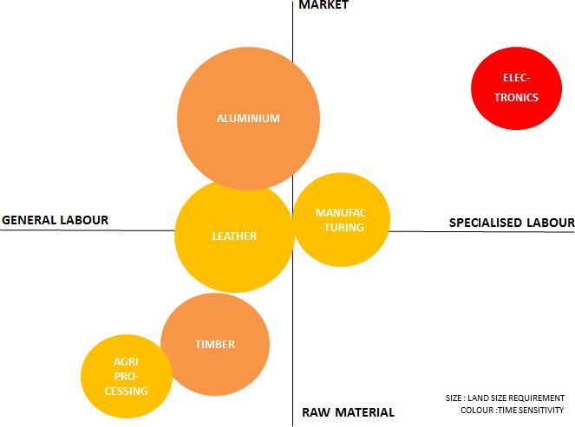

      - Spatial analysis and projections
Based on the preceding analysis and spatial parameters, it is evident that the overall spatial strategy for Msunduzi would ideally be focused on the existing and already identified industrial areas as illustrated by the series of maps contained in Annexure A. There are a few distinct focus areas, namely:
        - The Mkondeni complex which would remain a major industrial development node due to it being established and located in close proximity to the N3. It is also envisaged that the proposed Techno Hub anticipated around the airport and towards Mkondeni, the area would be a strategic locality for electronics and research facilities. The area would however need consistent electrical supply and improved public transport between the area and Edendale. The N3 upgrade planned at the Market Road interchange will contribute to the development potential of this area as well as improved linkages with Masons Mill and Edendale.
        - Similarly, the Mason’s Mill area appears to be well suited for further industrial development associated with the established aluminium industry. There are further opportunities to accommodate a leather hub and automotive hub in this area as indicated. Collectively, the proposed Special Economic Zone within this node would be able to supply a diversity of industrial opportunities. In addition, it is located in close proximity to the labour market and provides a unique opportunity for various beneficiation and value adding initiatives as the area is planned to be integrated in to the wider city public transport system.
        - The Msunduzi SDF’s proposed new industrial extension area located east of Lynnfield Park and along the N3 is expected to provide an opportunity for agri-processing and timber related industries. Although this area would require proper development authorisation, infrastructure provision and access routes, it could contribute to new industrial investment in the medium term. It is however suggested that the proposed development is in future further extended towards Edendale and integrated within the city’s Integrated Rapid Public Transport Network.

SECTION B

MSUNDUZI INDUSTRIAL DEVELOPMENT STRATEGY

- VISION FOR INDUSTRIAL DEVELOPMENT

  - Local Economic Development Vision

The vision that has been adopted as part of Msunduzi’s LED strategy is as follows:
“The vision of Msunduzi Municipality is of a globally competitive metropolitan city of choice which capitalizes on its strategic location, environment, cultural heritage and educational facilities in creating a choice quality of life for all, whilst actively creating an enabling environment for local economic development directed towards economic growth, prosperity, alleviation of poverty and job creation.”

  - Industrial development vision

The normal process of developing a vision involves extensive consultation with stakeholders. However, as there is sufficient material from both the IDP and the LED vision, it is recommended that the Council adopt the following vision which is specific to this industrial development strategy:
Msunduzi aims to see its industrial sector grow so that it remains the engine that powers the local economy, and that it does so with particular regard to providing dignified and safe work for its residents, and that it does so without harming the environment - the people, the flora and fauna that make up the local ecosystems for a truly sustainable future. The industrial and business sector stakeholders will partner with the municipality in striving for a carbon neutral industrial future which takes into account the critical need to ensure that industrial processes do not add further fuel to the drivers of climate change, and that they employ measures to mitigate against the current and future negative effects of climate change.

  - Towards the 4th industrial revolution

The next wave of industrial innovation and growth is going to be based on the ability of a region to harness the Internet of Things (IoT), cloud computing and Big Data analysis towards more intelligent production. In practical terms this would meant that any production run as well as daily operations would be based on almost all systems (from vehicle monitoring, electricity dips, worker hours, market pricing, traffic, etc) will be integrated into a network to produce real-time dashboards towards better decision making, increased productivity and profits as well as improved R&D for that industry / region.
The industrial success of a region / city will depend on the ability to attract, accommodate and support those industries which are constantly moving towards Industry 4.0. (see Figure 15). Although one might automatically think that this implies very technically advanced industries, the concept includes any and all industries (even the most primary), but focuses on how they integrate information from various systems toward better management and increased production.

Figure 15: The 4th industrial revolution
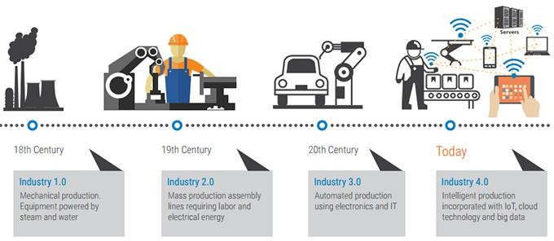

Thus for a region to promote industrial growth and investment it would typically need to have a combination of the following elements (apart from the standard elements of land, accessibility, water etc.):
    - Constant and affordable electricity supply not only for production purposes, but also for servers and communication between systems.
    - High quality connectivity, being it fibre or a WAN capability. This would probably take the form of a partnership between the municipality and a service provider, but needs to be a distinguishable offering to industrial parks / industrial areas.
    - Data support servers for data storage and cloud computing. Although this more of a long term requirement when Industry 4.0 becomes the norm rather than the exception, the sooner the service is introduced to industrial parks, the better. Many companies now use cloud computing on external servers from third parties to avoid costs associated with internal systems.
    - Associated support services such as System Integrators (analog to digital), general IT support, generators etc. This therefore helps attract those types of services in close proximity to the industrial park(s).
Some of these requirements have been mooted within the Techno-Hub business plan suggesting the same philosophy. However, a branding toward Industry 4.0⁵ and an indication that the strategy should move toward the next industrial revolution, in line with global standards, explains the critical need for the technological infrastructure to attract industrial investment. This may also assist in differentiating Pietermaritzburg’s industrial attraction from other areas.

⁵ For further information, see https://www.i-scoop.eu/industry-4-0/

If this Industry 4.0 forms part of the vision for Msunduzi’s industrial future, it ties in with the Smart City concept as well as providing a platform for innovation towards greener production processes.

  - International context

While this strategy is focused strongly on local conditions and potential for industrial development, the very nature of business and industrialization depends to a greater or lesser degree on international trends.
African Growth Path
A useful source of information for the African continent as a whole, and what opportunities for Msunduzi industrialists and entrepreneurs may exist, is in the African Economic Outlook, (AEO) a collaborative annual report which documents the monitoring of the continent’s social and economic situation. The AEO 2017 examines entrepreneurship and industrialization in Africa, put together by a partnership between the African Development Bank, the OECD Development Centre and the United Nations Development Programme. It includes a statistical annexure which contains tables comparing social, political and economic indicators across all 54 African countries. It examines macro-economic prospects, external financial flows and tax revenues, trade policies and regional integration, improving entrepreneurship for industrialization in Africa, design, operation and assessment of Africa’s industrialisation strategies, and policies to promote industry in Africa.
NEPAD
There is also the NEPAD programme (New Partnerships for Africa’s Development) which is intended to be a blueprint for socio-economic transformation. There is a NEPAD 2014-17 Strategic Plan produced by the NEPA Planning and Coordinating Agency which set out challenges to Africa’s transformation, achievements and failures of the previous strategy and the strategic orientation for the future.
BRICS Trade Agreement
Manufacturing and production is dependent on domestic and Foreign Trade. When considering Foreign trade, it is important to consider the implications of South Africa being part of the BRICS trade agreement.
BRICS consists of Brazil, Russia, India, China, and South Africa. This trade and investment agreement now represents represent 3 billion people and a combined GDP of 16 trillion dollars. The BRICS group is the third largest grouping after the European Union and the United States of America (World Economic Forum, 2015).
This positive sentiment is however tempered by the differences between the member countries. Movchan (2015), points out that the member nations are too different, and have too few synergies to represent a solid economic political power. Reference is made to the following:
- The Chinese economy has a clear dominance in respect of the partnership.
- Trade between the union member countries is now less than 320 billion dollars a year and declining. In contrast the BRICS Country trade with the US and EU is 6.5 times higher, and China’s trade with the rest of the world is 12.5 times higher.

- BRICS countries compete with each and therefore the sharing of research and development between member countries is limited.
Manzombi (2015) in considering trade flows in respect of BRICS countries, inter alia, reflect on exports from South Africa to other BRICS countries. Figure 16 below reflects that India and China are the largest importers of South African goods.
Figure 16: Exports from South Africa to the rest of BRICS
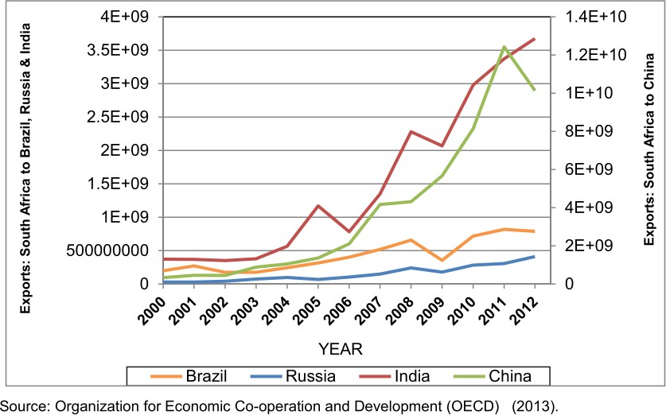

On the import side, South Africa’s growth has been driven by China, which is the most dominant source of the country’s imports. In 2012, South Africa’s imports from other BRICS countries was estimated at about⁶:
- US dollars 14643.87 million from China,
- US dollars 4597.53 million from India,
- US dollars 1671.50 million from Brazil, and
- US dollars 203.531 million from Russia
In terms of specific exports, the Department of Trade and Industry in their 2014 Trade Report – Export opportunities for South Africa in other Bricks Countries, identify the following export opportunities.

6 Manzombi (2015: 26)

Table 5: South Africa's leading export categories to other BRICS countries in 2012 (order of importance)
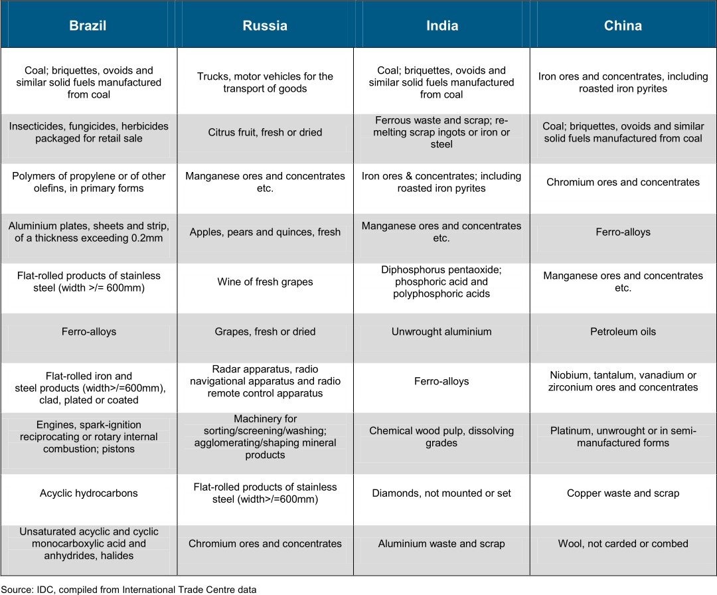
Source: South Africa Trade and Industry Department, 2014: Trade Report – Export opportunities for South Africa in other Bricks Countries, p12
Based on the above, Industry in Msunduzi must consider relevant market or export opportunities in respect of the BRICS Countries.

  - Contents of the strategy

Broadly speaking, this industrial strategy needs to recommend ways of ensuring:
- Retention of existing industries (Enable and support existing industry)
- Attraction of new industries – promote new entrants
- Support growth of industries – existing and new entrants
The development of the strategy has been a thorough process with four stand – alone reports produced. Appropriate information (summarised) from these reports have been brought forward into this section as informants to each strategy. Thereafter, the strategies will be set out.

- KEY INFORMANTS TO THE STRATEGIES

Six broad strategic programmes are discussed in detail in this section:
- Spatial and land
- Infrastructural and service support
- Integrated catalytic projects
- Industrial sectors
- Protective environmental and social measures
- Institutional Support
In addition, the alignment of plans and policies is briefly examined.

  - Spatial and Land Programme

In order to develop a sound spatial and land strategy, it is important to understand the key issues, including current initiatives that will inform the strategy. These key informants are:
- Land availability (including any strategies or policies the municipality may have regarding making land available). This includes Identification of already planned industrial development areas as laid out in the SDF
- Initiatives to create a Special Economic Zone (SEZ) and land for industrial parks / hubs
- Planning Scheme provisions – zoning of industrial land
- Urban Network Strategy – linking strategic transport and passenger routes through City, linking key nodes
- Supporting initiatives to identify land for affordable and low cost housing in areas which have easy accessibility to industrial and other job opportunities.
    - Land Availability: Municipal land release strategy
Within the short, medium and long term horizons the SDF identifies associated land release and transformation requirements as indicated by the maps below. It is evident that a number of areas are identified for commercial and industrial expansion within the short and medium term horizons and that these areas should in turn influence the municipal IDP and budgeting processes.

Figure 17: Short term land release areas – Msunduzi SDF
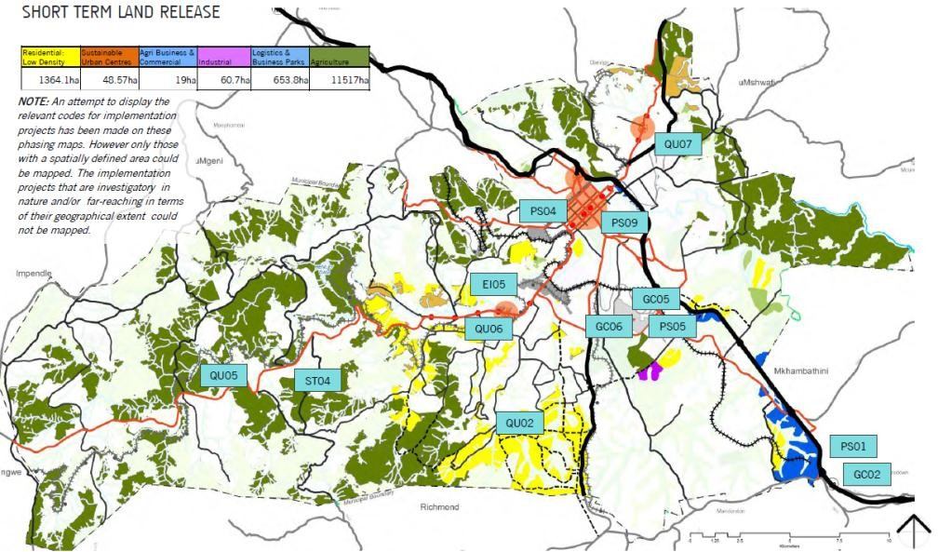

The table below provides a summary of the various envisaged landuse extensions illustrated on the SDF maps.
Table 6: Envisaged land use extensions (releases) on SDF map

 |  | TIMEFRAME
LAND USE | Short term | Medium  Term | Long Term | TOTAL AREA
Residential low density | 1 364 ha | 810.4 ha | 959.5 ha | 3 134 ha
Residential high density |  | 5 860.4 ha |  | 5 860.4 ha
Sustainable urban centres | 48.6 ha | 461.9 ha |  | 510.5 ha
Agri-business and commercial | 19 ha | 845.4 ha |  | 864.4 ha
Industrial | 60.7 ha |  |  | 60.7 ha
Logistics and business parks | 653.8 ha |  |  | 653.8 ha
Tourism |  | 1 279.5 ha |  | 1 279.5 ha
Agriculture | 11 517 ha |  |  | 11 517 ha
Recreational parks |  |  | 2.4 ha | 2.4 ha
Environmental corridors |  | 1 625 ha |  | 1 625 ha

Msunduzi Municipality, as part of the 2015 IDP, initiated a rapid land release strategy, in respect of general industrial and business development. Through a land audit process, 30, 589 ha has been identified for this purpose and is being made available through public tender for land development. Whilst 30, 589 ha has been identified, not all the land is in the high demand areas in Msunduzi. It does

however address 30ha of the 60 ha short term growth in industrial land demand as recommended in the 2015 IDP.
Table 7: Industrial and business land being made available for development in Msunduzi

NO | ADDRESS | PROPERTY  DESCRIPTION | EXTENT (m²) | ZONING
1 | Mkhondeni | Rem of Erf 10 000 of Murray Road, Mkhondeni | 102 336 m² | General industrial  This lot can be subdivided into 34 industrial portions of 3 000 m² each
2 | 40 Haworth Road | Erf 188 of Shorts Retreat | 28 015 m² | General industrial  This lot can be subdivided into 9 industrial portions
3 | Bulman Road | Portion 12 of Erf 441 Shorts Retreat | 38 623 m² | General industrial  This lot can be subdivided into 12 industrial portions
4 | Imbali Unit CC | Portion of Erf 23295 Edendale CC | - | General Business  The minimum site area for all industrial uses is 3000 m² as per the Pmb Town Planning Scheme
5 | Skhumbuzo  Ngwenya | Erf 456, portions 1, 2 and  3 Pmb | 136 900 m² | General industrial

    - SEZ and Industrial Park/ Hub Initiatives
This is similar to the land availability information for industries; however, it is more than just making land available, albeit that is a foundational component. This involves specific incentives and infrastructural provisions, as well as the deliberate establishment and promotion of downstream beneficiation associated with a recognisable, marketable zone or industrial park.
The Ibubhesi Industrial Park is one project that is already being implemented. There has been a call from industry for the creation of an SEZ (aluminium industry) in the city. There are also plans for the creation of a Leather Hub
    - Land zoning – Scheme provisions
The SDF’s proposed logistics, industrial and commercial development towards Camperdown is not currently within a planning scheme or zoned and it is therefore anticipated that the MIDS Implementation strategy would propose processes which systematically provide for such areas. The image below (Figure 18) illustrates the current business and industrial zonings within the Pietermaritzburg, Edendale and Ashburton Schemes.

Figure 18: Industrial land zones in Msunduzi

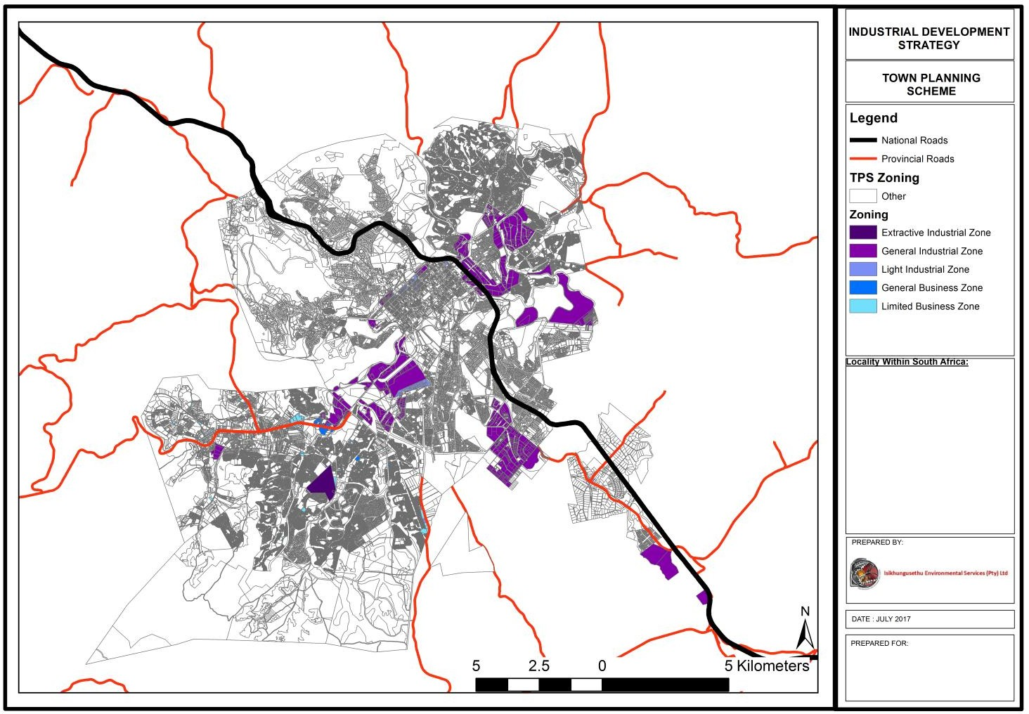

More specifically, the current land areas zoned for potential manufacturing and /or industrial purposes area summarised in the table below:
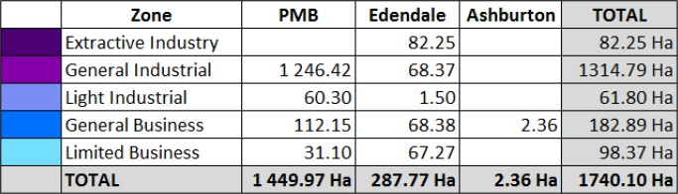

A suite of maps has been developed for the various industrial precincts; these are provided in Annexure A. Figure 19 (following section 4.1.5) shows the composite Industrial Development Strategy for Msunduzi.
    - Urban Network Strategy
The Msunduzi Urban Network Strategy (UNS), in addition to addressing the spatial restructuring of the post-apartheid city, also seeks to link the apartheid isolated socio-economic islands through transport and activity corridors. Whilst the main focus of the strategy is industrial development, the socio- economic integration of the industrial development activities with the Edendale complex is a critical consideration of the overall strategy. A strategy of this nature cannot be considered in isolation from an internal urban transport network plan and associated land use provisions (where people live, work, move and play). The table below indicates support for this strategy from province.
Table 8: Acceptance of Urban Network Strategy

NETWORK ELEMENT | MUNICIPAL SUBMISSION | NDP REVIEW
CBD | Pietermaritzburg CBD | Pietermaritzburg CBD accepted
HUBS | Edendale Hospital Node | Urban Hub accepted
PRIMARY PUBLIC TRANSPORT ROUTES | Edendale Hospital Node to the CBD Moses Mabida, Church Street, Rail | Edendale Hospital Node to CBD – Moses Mabida, Church Street, Rail  accepted as primary link
ACTIVITY CORRIDORS | Edendale Hospital node towards the CBD | Edendale Hospital Node to CBD –  Moses Mabida, Church Street, Rail accepted as primary link
SECONDARY NODES | All secondary nodes | The secondary nodes and network need to be clearly indicated on one map and should be prioritised using the population size of the township clusters within a 7.5km  radius
SECONDARY TRANSPORT NODES | All secondary linkages
EXISTING NODES | - Scottsville  - Liberty Mall  - Hayfields | These are three existing established nodes within the identified functional area
Source: Msunduzi Municipality, 2014: 2-3

    - Residential zoning linked to industrial / commercial opportunities
The Shenstone City Report, prepared by the Markewicz Redman Partnership in association with Royal HaskoningDHV (Pty) Ltd on behalf of Msunduzi Municipality in 2016, highlights the importance of the Edendale Complex via Shenstone into the city’s southern industrial areas and into the N3 (SIP2) Corridor. The area is settled by families and communities from a wide spectrum of income levels. In terms of the report, the need to develop this area in a formal manner was highlighted, particularly in respect of the housing and social facilities. Higher density development is proposed to provide for urban life at the level of the pedestrian. It is the intention to develop residential neighbourhoods at densities that can support the provision of a mix of diverse commercial activities and social facilities within walking distances of them (minimum of 50 units per hectare).
Based on the above and the linkage via the R56 to the N3/ SIP Corridor along the N3/ Thornville corridor and linking with the SDF Agri-business planning on the Thornville corridor, the strategy will also consider the development of industrial-related activities and land uses along the R56 activity spine.

Figure 19: Msunduzi Industrial Strategy - composite map
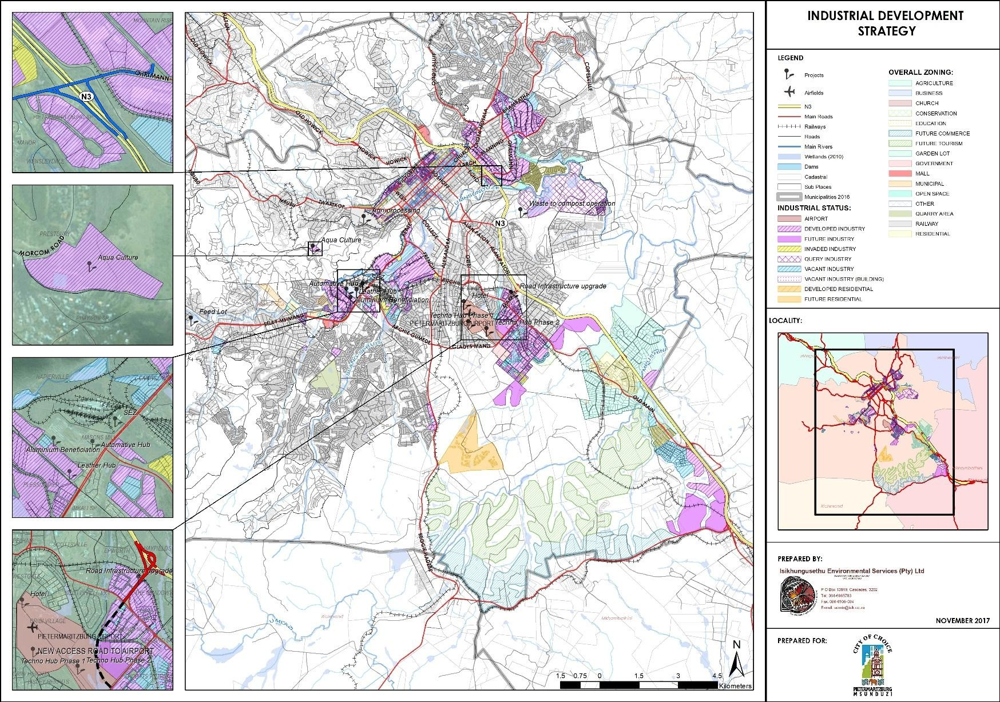

  - Bulk Infrastructure and Services Support Programme

The key informants to this strategy are:
- Location and status of bulk infrastructure (capital)
- Evaluation of operation and maintenance of bulk infrastructure
- Industrial infrastructure: industrial development zones
- Transportation and access: status and identification of problem areas
- Service support for industries (direct) (e.g. hazardous waste removal and treatment)
- Service support for communities (NB that neighbouring communities and workers have adequate service support – health and welfare)
- Ensuring a conducive environment for industry – clean streets, maintenance of infrastructure, safety and security etc.
Of particular importance to all industries is the need for an upgrade of electrical infrastructure which is a major constraint given that there is general agreement that the supply is unstable; indeed, unexpected power outages have cost some industries dearly. The system is also operating at capacity. The possibility of a gas pipeline to the city has been mooted and should be supported as an alternative energy supply.
In addition, South Africa as a whole is experiencing a crisis in water supply. A key factor in this is water loss through poorly maintained bulk and reticulated infrastructure and illegal connections. It is estimated that South Africa loses 37% of its water supply through leaks in municipal water supply systems⁷.
Table 9: Vacant industrial land and availability of bulk services

Industrial Precinct | No of Ha | No of sites | Serviced | Access to N3 | Ownership
Ashburton | 256 | 78 | 75 | Yes | Info avail
CBD | 0.234 | 2 | 2 | Yes | Info avail
Mason's Mill | 79.4 | 50 | TBD | Yes | Info avail
Mkondeni | 88 | 110 | 110 | Yes | Info avail
Northern Area | 41.19 | 15 | 15 | Yes | Info avail
Edendale/ Shenstone | 24.7 | 10 | TBD | Yes | Info avail

⁷ McKenzie, R., Siqalaba, ZN, and Wegelin, WA, 2013, The State of Non-Revenue Water in South Africa (2012) in,
The Water Wheel, Vol 12, No.1, January/February 2013

  - Integrated Catalytic Projects Programme

There has been much said and planned about catalytic projects from national and provincial plans and policies to local plans. The integrated catalytic projects are those that combine a number of elements with the intention that they will act as an “anchor tenant” in an area, attracting additional investment to the area as well as to the city as a whole.
These projects, already recommended or in planning / implementation stage are:
- Airport precinct and Techno Hub
- Integrated Rapid Transport Network
- SIP2 Corridor with associated upgrade of interchanges
- ICT Hub and Smart City concept
For some of these catalytic projects, planning is far advanced and in some cases, implementation has begun. For the Airport Precinct and Techno Hub – see map (Figure 20) below, there has been detailed planning which is reflected in the table under section 7: Implementation.

Figure 20: Airport precinct master plan – including Techno Hub
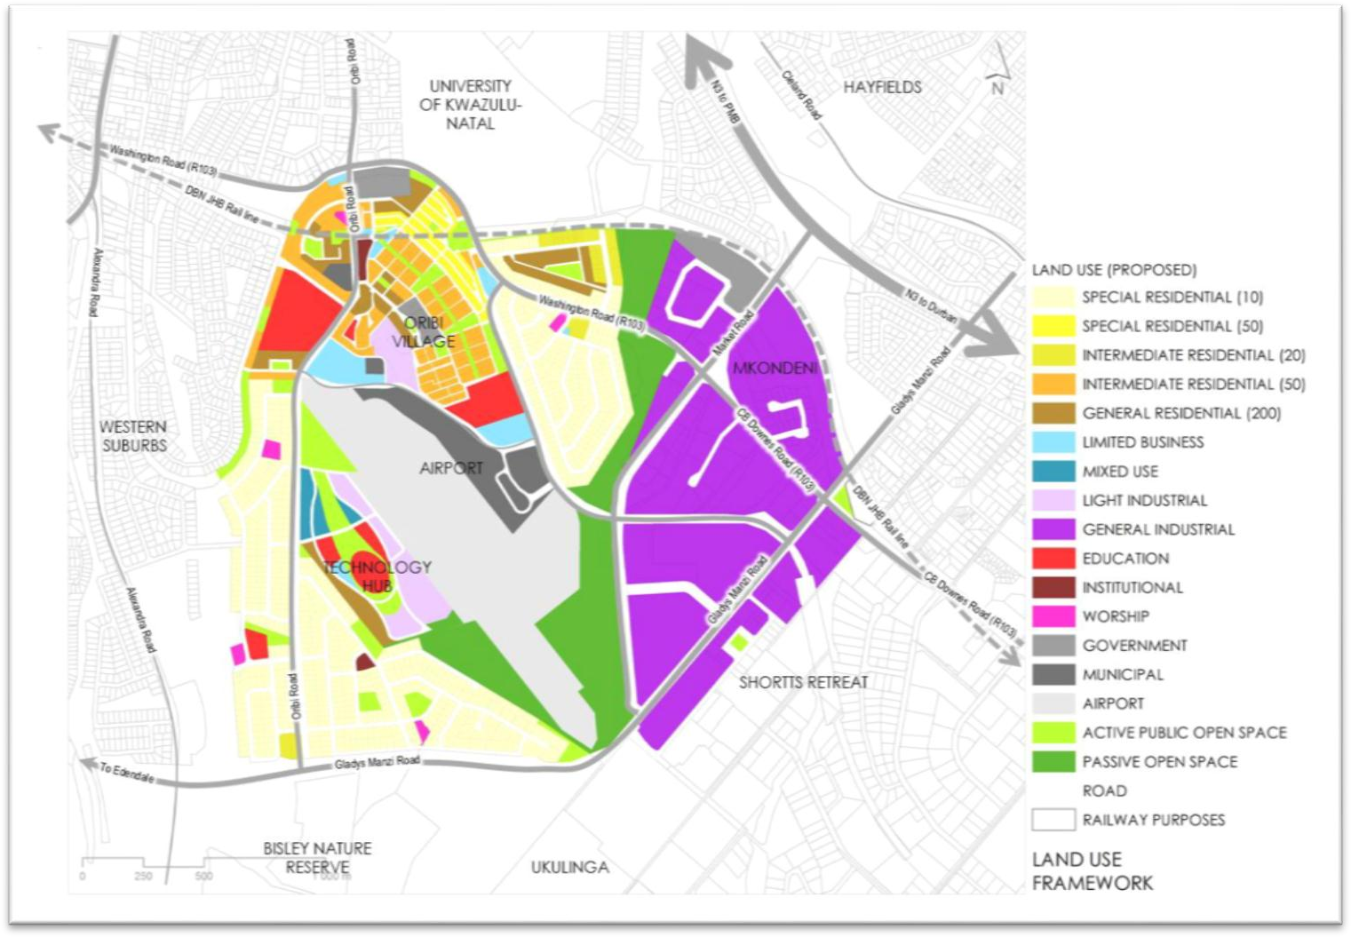

  - Industrial Sectors Programme

The key issues for sector specific industries are set out in the graphics below. Fundamental to all industry is that of a stable and secure energy supply and a reliable water supply.

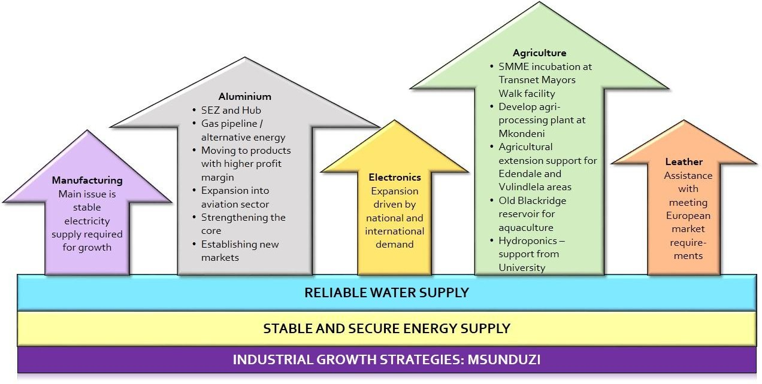

There are a number of other issues in addition to that which are common to more than one sector.

Fundamental
issues
Stable electricity supply
Reliable water supply
Institutional issues
Re-establish working relatonship with municipality
Application processes streamline
Industrial health dashboard

Human resources
Attract skilled labour
Attract
scientists
Funding research & development

Services and
infrastructure
Improved service infrastructure
Cleaner operational environment
Better road and transport access (internal and external)
Land and spatial issues
Access to flat land
Provision of land by the municipality through the SDF
Access to high value agric land close to agri- businesses
From the work done on the LED strategy and from the interactions with industry through the interview process and workshop, there are certain industries which should be supported to grow, namely: agri- processing, leather and associated industries, potential train coach construction at Masons Mill, the growth of the logistics sector allied to the SIP2 corridor and the proposed ICT hub.

4.4.1 The SMME sector⁸
The industrial value chain already includes SMMEs but it is imperative that these emerging and small businesses receive more support. The State of the Nation Address emphasised the importance of analysing the value chain to there is equitable access to the economic activities to assist SMMEs to grow.
Table 10: Comparative analysis of small business contribution - South Africa and other countries, 2016
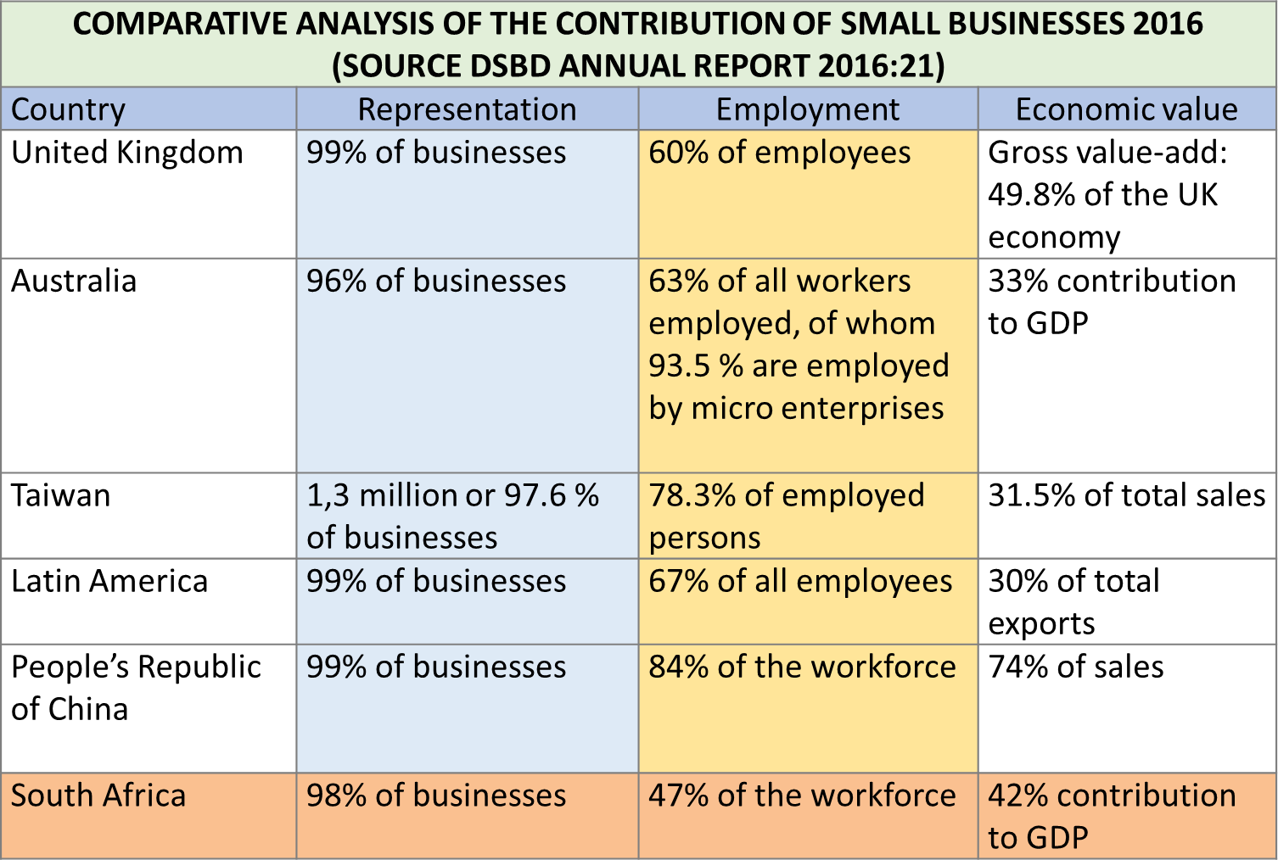

Ideally, both public and private sector should assist in establishing or supporting incubators which focus on various sectors. A study by M. Masutha and C.M. Rogerson in 2014⁹ found a total of 51 functioning incubators by 2013, up from only 4 in 2004. 43 of these incubators were established by the public sector and 8 by the private sector, covering agri-processing, construction, ICT, chemicals, jewellery, small scale mining, bio and life science, renewable energy and automotive sectors.
SMMEs help to provide greater diversity within a local economy:
“Some cities haven’t realised how important local small businesses are for an economically resilient city” (Olivia LaVecchia, Institute for Local Self-Reliance)¹⁰

⁸ The information in this section on SMMEs is drawn from work undertaken by Pat Luckin from a 25 July 2017 presentation
9 As quoted in presentation by Pat Luckin, 2015
- Vande Panne, V., 2018, There’s a much smarter way for cities to plan their Futures, Local Peace Economy, https://www.alternet.org/local-peace-economy/theres-much-smarter-way-cities-plan-their-futures

In India small businesses contribute significantly to the economy and account for a “huge chunk”¹¹ of the workforce. The Indian government provides a substantial range of opportunities for small businesses through various programmes. These include: public sector banks, a national bank for agriculture and rural development, a National Small Industries Corporation Ltd (NSIC); and the Small Industries Development Bank of India.
Figure 21: Indian government support for SMMEs¹²
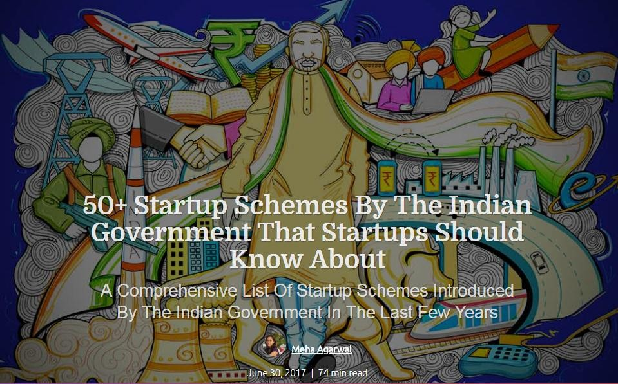
One example of the success of this support for SMMEs is that close to 4 400 technology startups exist in India with the number expected to triple by 2020.¹³ The many start up schemes range from IT and technology to health care and life sciences as well as biotechnology.

  - Protective Environmental and Social Measures Programme

The key informants leading to the strategies for the protection of the environment and communities to counter any negative impacts from industries are:
- The topography of the area – the city ‘bowl” – which exacerbates the effect and the length of time that air pollutants remain in the lower atmosphere
- Transportation: the very real problems posed by air pollution due to topography point not only to industry needing to change to cleaner technologies, but also that the transportation

- https://quickbooks.intuit.com/in/resources/funding/government-support-for-small-businesses/
- https://inc42.com/startup-101/startup-scheme-indian-government-startups/
¹³ Op cit

system needs an increase in the frequency, reliability and affordability of public transport to minimise the number of individual vehicles coming into the CBD, but also the switching to busses / taxis / tram systems/ electric cars
  - The vital river systems feeding the city – both business and residential – where water quality is a critical factor
  - Climate change which is happening now, and is only going to get worse with potentially dire consequences for the environment and therefore, for everyone, unless there is a substantial change in the way we ‘do business’. This requires industry, and the authorities, to work closely together to find a new, greener and carbon neutral path to follow.
  - Agricultural practices, including the use of chemicals for herbicides and pesticides, need to move towards more ecologically sustainable methods, increasing organic agriculture over ‘industrial’ agriculture.

  - Institutional Support Programme

The key informants for the strategies relating to institutional issues are:
- The decline in liaison and communication between the municipality and the Pmb Chamber of Business which both sides acknowledge needs to be addressed
- The need to expedite application processes within the municipality and other government agencies responsible for various approvals; in some cases, applications have been stalled for over five years. This does not create an investor-friendly climate.
- The need to receive more timely information on a range of issues of common interest to the municipality, current industrial stakeholders and potential investors. To this end, it was agreed that an interactive industrial health dashboard should be established Figure 22Industrial stakeholders also felt that they needed easily accessible information on available incentives, particularly with respect to start-up costs.
- There was concern that existing industries were struggling and that there is risk that some will close or relocate. The need for industrial retention strategies was identified to actively encourage industries to remain in the city.
Figure 22: Industrial Health Dashboard - what should be tracked
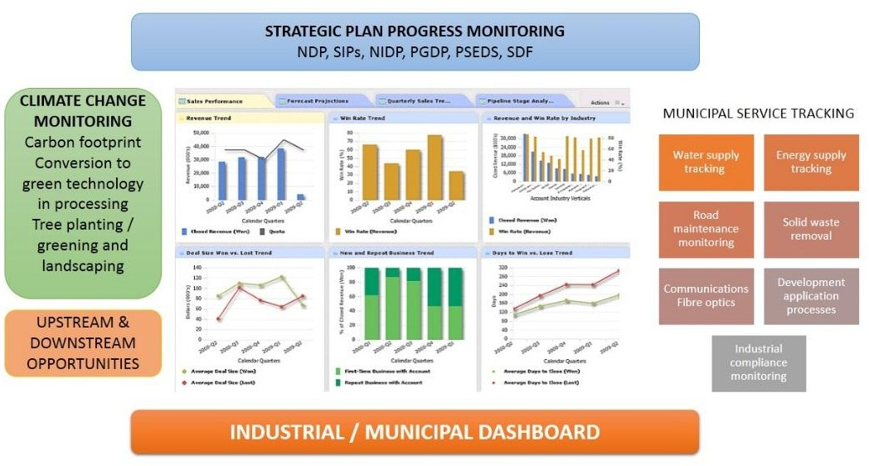

  - Alignment of Plans and Policies

The key informants for this cluster of strategies derive from the suite of plans, policies and strategies that have been developed nationally and provincially, as well as those that have been developed locally. Many of these have already set a clear direction and it is up to Msunduzi to align its plans with these.
The most important of these are:
- The National Development Plan
- The National Strategic Infrastructure Plan
- IPAP
- KZN PGDS / PGDP
- KZN PSEDS
- Msunduzi LED Strategy)
- uMgundundlovu Comparative Advantages Study
- Msunduzi Climate Smart Policy

- STRATEGIES PER PROGRAMME

The following tables provide the broad strategies that have been developed. They indicate a combination of strategies recommended in other sector plans (e.g. the LED Strategy) and from the IDP, as well as those that have arisen from this report.

  - Spatial and Land

 |  | STRATEGY | DETAILS
SPATIAL AND LAND SUPPORT | 1 | Principal Goal | To ensure that there is sufficient land for industrial growth in Msunduzi in the short- medium and long term
 | 1.1 | Land release for industrial development | - Short term release of 60.7 ha of land  - Identification, preparation, servicing and zoning of additional municipal land suited to industry and aligned to industry needs  - Identify subsequent land parcels to make up the remainder of the land identified in the SDF as required for industry in the medium to long term (the recommendation is 50 ha per year although current growth is 5 – 7 ha per year)
 | 1.2 | Zone land appropriately for industrial land use | - Amend the current Town Planning Scheme to reflect the new integrated zones proposed in the SDF, namely:  - Industrial zone (cumulative industrial zone)  - Logistics and business parks  - Agri-business and commercial
 | 1.3 | Resolve issue of currently zoned industrial land which is not being used for industrial purposes | - Investigate why some already zoned industrial land is not being used; this includes land which has been invaded or is vacant  - Determine strategy, with relevant municipal departments, for the freeing up industrial land where it has been invaded, particularly if it has good potential for industry, and/or may present problems to communities due to industrial impacts (pollution, noise, heavy traffic, poor access to schools etc)  - Rezone land which is vacant because it has no attraction for industry and seek alternatives elsewhere

 |  | STRATEGY | DETAILS
 | 1.4 | Identify possible land for industrial parks / SEZ / industrial Hubs | - Monitor progress on planned industrial hubs / parks  - Ibhubesi Light Industrial Park: promote the Park to achieve full capacity in terms of sale of land  - Camperdown logistics, industrial and commercial development to be zoned  - Business and industrial development opportunities along the R56 logistics, industrial and commercial development corridor to be encouraged and properly zoned as per the 2015 SDF

  - Bulk Infrastructure and Service Support

 |  | STRATEGY | DETAILS
BULK INFRASTRUCTURAL | 2 | Principal Goal | Ensure that there is sufficient capacity in terms of bulk infrastructure to meet both current and future demands: energy, water, road access, waste removal
 | 2.1 | Stabilise and secure energy supply | To ensure retention of existing industries and capacity to attract new industry to undertake the following:  - Electrical infrastructure upgrade  - Resolve staffing and capacity issues in the electricity department to ensure sufficient capacity to manage and operate electricity grid  - Ensure appropriate and timely maintenance and repair on electrical facilities and networks – sub-stations etc  - Where possible, partner with industry to ensure key electrical installations are maintained and upgraded
 | 2.2 | Secure sufficient water storage for existing and potential industrial bulk water users | - Determine water demands in order to liaise with DWAS to secure sufficient water supply for current and future needs (dams)  - Ensure city has sufficient storage capacity (water towers and bulk reticulation)  - Protection of water sources from pollutants through planning and environmental controls  - Non-revenue water reduction projects: ensure regular monitoring and maintenance prevents water loss
 | 2.3 | Implementation of Urban Network Strategy | - Upgrading of routes – rail and road, to ensure that proposed corridor linkages in the Urban Network Strategy are maintained and can meet transport demand

 |  | STRATEGY | DETAILS
 | 2.4 | Pietermaritzburg bypass route to be decided and put into planning phase | - Liaise with SANRAL to expedite the decision on location of by-pass route (following due EIA process); establish a standing forum to meet quarterly to monitor progress and address obstacles  - Msunduzi should establish a Task team to investigate and undertake the relevant studies to determine the impact of the intended by-pass on business and establish innovative strategies to mitigate the impact on business and develop new opportunities due to the new transport configuration
 | 2.5 | Upgrade of entry routes into Pmb | - Central: upgrade of the existing interchanges;  - Northeast: upgraded of the Northdale / Greytown Road, plus additional access to the Willowton industrial area;  - Southwest: upgrade of the Richmond Road and Edendale Road, plus additional access to Mason’s Mill area and further extend the small industrial node of Thornville. The current N3 can then turn into a Metropolitan trunk road, with higher local capacity, collecting traffic and bring this to the N3 at Umlaas Road and near Howick respectively.  - Funding is to be secured to improve the road connection between the N3 (Market Road) and the Airport, and further  towards the Mason’s Mill area, in unison with N3 market road interchange upgrade by SANRAL.. Progress to be reported to Council on a quarterly basis..
 | 2.6 | Solid waste / landfill upgrade | - Continued support of current initiative to investigate green energy options at landfill site
 | 2.7 | Stormwater upgrades | - This is critical in order to be able to cope with the likelihood of increasing, and higher intensity storm events due to climate change, as well as to prevent damage to transport infrastructure through inadequate stormwater management.
 | 2.8 | Technology Hub Infrastructure (IDP capital projects) | - Upgrade of infrastructure to facilitate Technology Hub as per the Airport Precinct Plan

  - Integrated Catalytic Projects

 |  | STRATEGY | DETAILS
INTEGRATED CATALYTIC PROJECTS | 3 | Principal Goal | Implement catalytic projects that are currently planned or, if in the process of being implemented, monitor progress
 | 3.1 | Launch the Agricultural and logistics platform | - Develop logistics platform (packaging, loading, transport) (envisioned)  - Dedicated large scale truck stops (envisioned)  - High speed train between Durban and Johannesburg (planned)  - Further expansion of Pietermaritzburg airport (planned)
 | 3.2 | Expedite the proposed N3 upgrades | - Actively support and encourage the 8 interchanges related to the city from the N3 – liaise with SANRAL, provide input and monitor progress; secure funding from the national agencies for the upgrade of roads linking to the new intersections, based on a municipal priority model  - The SIP 2 corridor plans must be integrated into the Municipal IDP and Precinct Plans with detailed implementation plans
 | 3.3 | Develop the Airport Precinct and Techno-Hub | - Airport precinct and Management Plan: continue with planning and implementation  - Refer to implementation table under section 7 for further details which are set out under the following headings:  - Airport infrastructure  - Regional road infrastructure  - City transportation infrastructure  - Local infrastructure  - Water/sanitation/stormwater/energy / ICT infrastructure  - Regulatory improvements  - Operation and management issues – e.g. a City Improvement District  - Techno Hub-development  - Airport development
 | 3.4 | Upgrade of the Oribi Airport as part of the | Improving and extending scheduled passenger parking, hangers, fuel storage, car hire and improved retail (5 – 10 of Schedule – see Annexure B)

 |  | STRATEGY | DETAILS
 |  | Airport Precinct development
 | 3.5 | Development of Phase 1 of the Techno Hub: Infrastructure and Aeronautical excellence phase development in joint curriculum programme with DUT | Access from the N3, via the Market Road intersection, bulk service extension and upgrading, phase 1 of the Industrial Hub internal infrastructure development and construction of Phase 1 development (5 to 10 years). Link with Msunduzi ICT plan. This phase is to consist of a research zone, student zone, testing and development zones, data zones, business support and start-up zones and convention centre.
 | 3.6 | Development of Phase 2 of the Techno Hub: Infrastructure and Aeronautical excellence phase development in joint curriculum programme with DUT | Improving bulk services and associated infrastructure. Development of single and multi-tenanted buildings, the remainder of the parking and landscaping.
 | 3.7 | Develop the mixed use industrial zone between the N3 and the R56 | - Develop mixed use industrial zone with logistical ties, along the new industrial extension along Gladys Manzi Road to both airport and N3
 | 3.8 | Launch the ICT Hub and Smart City concept | - Appoint service provide for 5 year programme to implement the ICT Hub and Msunduzi Smart City requirements  - Develop a fibre optic cable network for the city – communications upgrade  - This would form part of the Smart City Initiative – assess the efforts of other cities to establish Smart Cities and share lessons learned  - Identify specific industrial park(s) or new areas for a Hub  - Msunduzi can assist in this process through partnerships with ICT providers and ensuring a dedicated programme to facilitate and fast track ICT provision by streamlining approval and implementation processes under its control.  - Encourage, support and expand the development of broadband connectivity (as per the related projects in the IDP)

 |  | STRATEGY | DETAILS
- Investigate the use of existing municipal infrastructure (e.g. communication poles) or municipal servitudes for the provision of additional wireless networks by external providers and draw up service agreements with those providers in order to reduce authorisation times
- Assess the benefit to the municipality’s own internal communication and processes with improved city-wide ICT
- Link upgrading the ICT network through the Hub to increased preventative / public security systems – assisting in improving investor confidence (Safe City initiative)
- The systematic development of improved ICT infrastructure provide an opportunity for the establishment of associated ICT industries in itself.
- Link this ICT Hub initiative to education and providing ICT services to the developmental sectors of a disadvantaged community such learners, community organizations, job seekers, micro to small business, etc. (e.g. youth development and capacity building through municipal funding programmes)
 | 3.9 | Integrated Rapid Public Transport Network – implement | - Continue with the implementation of the IRPTN  - Monitor progress on the IRPTN project; IRPTN important to enable staff for industries to travel between work and home efficiently and at reasonable cost
 | 3.10 | SIP2 Durban-Free State- Gauteng Logistics and industrial Corridor | - Integrate the currently geographically separate industrial and logistics activities as well as peripheral rural production centres in the vicinity of the corridor and that are currently isolated from the main logistics system  - Create capacity ahead of demand  - Develop a programme to align stakeholders behind a common plan for the corridor  - Accelerate and synchronise infrastructure development associated with the corridor: this ties in with the alignment of stakeholders behind a common plan for the corridor, effectively recommending an implementation strategy for that plan  - Focus on upgrading and developing the main industrial areas linked to the SIP2 corridor: Mkondeni, Willowton, Pentrich and Masons Mill.

  - Industrial Sectors

 |  | STRATEGY | DETAILS
INDUSTRY SECTORAL STRATEGIES | 4 | Principal Goal | Provide support to industrial sectors
 | 4.1 | Retention of existing industries | - Upgrade operating environment in industrial areas (streets, street cleaning, aesthetics)  - Have Urban Management Zone teams across security, street cleaning, looking after the roads and fixing potholes  - Report bad buildings, by-law contraventions, land use issues, ageing infrastructure such as bursting of old pipes, electricity supply failures etc. to the municipality  - Strengthening of Urban Management Zone within industrial areas  - Have urban management teams reporting on a quarterly basis to an industrial clusters about progress.  - Stabilise electricity supply and secure water supply (Bulk infrastructure projects)  - Install CCTV cameras for additional security in industrial areas  - Re-establish regular communication and working relationship between industry representatives and the municipality (see also under institutional)  - Establish industrial health dashboard (see also under Institutional)  - Review incentives provided for new entrants vs existing industries and ensure that the incentives policy are fair to both  - Implement IRPTN to enable staff for industries to travel between work and home efficiently and at reasonable cost
 | 4.2 | Promotion / attraction of new entrants into the industrial sector | - As above for retention of existing industries  - Make land available for new industry – either through general zoning or through establishment of industrial parks or hubs  - Market the city for industries with comparative advantage and promote possible downstream / value-added industries  - Implement the 2017 incentives policy of the municipality to ensure that the incentives are fair to both existing industries as well as new entrants. The policy lists:  - Industrial incentives  - Broadening participation incentives  - Technology and human resources for industry  - Trade, export and investment incentives  - Produce marketing booklet with listing of all incentives and other types of support available for existing and new industries from national and provincial departments (e.g. DTI and KZN EDTEA), as well as from the municipality

 |  | STRATEGY | DETAILS
- Link Msunduzi to TIKZN investment initiatives so that Msunduzi has a platform to interact with investors coming to the province - both international and domestic
- Develop a business aftercare programme for new and existing businesses that have been established for less than 3 years
 | 4.3 | Provide support to the proposed Leather Hub | - Secure sites in Edendale for the proposed Leather Hub  - Municipality become part of the existing liaison between EDTEA, DTI and IDC and the leather cluster industries so that it has a better understanding of the industry and its municipal services and support requirements  - Municipality to liaise with the Department of Agriculture over support to small farmers regarding their livestock and the storing and transport of hides for processing  - Where the LED section has funding for apprenticeships or youth study grants, encourage them to consider a career in the agricultural / leather / shoe-making and high-end leather goods sector.
 | 4.4 | Provide support to the aluminium industry | - Liaise with the Aluminium Beneficiation Initiative (Hulamin and South32) to determine where it may be possible for the municipality to assist with their industrial growth plans and identify specific interventions that the municipality or other government agencies should undertake  - Consider establishment of an SEZ with a focus on the aluminium / metal industry – this may be in the form of designating a physical SEZ, or a virtual SEZ. Work with EDTEA and /or DTI on this initiative  - Aluminum/metal industry agglomeration to be marketed and be linked to existing Dube Tradeport SEZ as it is adjacent to King Shaka Airport  - Provide marketing support to the ABI initiative through the municipal / Chamber advertising and marketing initiatives.  - Explore possibility of bringing in natural gas as an energy source to the city, particularly for the aluminium industry as Hulamin has been considering this as a supplementary energy source.  - Linking to the above point: continue engagements with Transnet on the alternative use of the old Durban-Johannesburg Pipeline (DJP) to transport natural gas to the city. A Feasibility study was initiated by Hulamin and PMB Chamber of Business.
 | 4.5 | Provide support to the Automotive Hub | - Locate suitable land for an automotive service hub, in consultation with the industry representatives and/or the Chamber – preferably in the Masons Mill area  - Liaise with EDTEA to expedite the development of an automotive hub in terms of land / location  - Provide support to youth through municipal capacity building programmes to train them in the automotive industry  - Municipality, in conjunction with the Chamber, assist in marketing the proposed Hub to the automotive industry  - Liaise with metal and other recycling plants to link into the automotive service hub

 |  | STRATEGY | DETAILS
 | 4.6 | Agri –industry / processing development | - Review the forward and backward linkages and determine all areas for possible beneficiation or value-add that can be viably developed in Msunduzi; liaise with ADA and KZN Dept of Agric as well as Chamber to market these potential linkages  - Establish a programme of social engagement with the surrounding rural communities to determine what they need and the extent to which they can contribute ideas to, or are interested in ideas around the increase in agricultural production and beneficiation in the area. This should be done in conjunction with eh Agricultural Development Agency (ADA)  - Promote Climate Smart Agriculture in conjunction with the Department and the ADA as a critical component to reducing the carbon footprint of the production of agricultural goods  - Ensure that the Department’s Land Care programme is being implemented in Msunduzi  - Draw up information booklet on agricultural opportunities and agric-related application processes in conjunction with the ADA  - Development of an agri-processing plant at Mkondeni Market (revival of previous youth project)  - Protection of high potential land from urban, peri-urban and rural settlement sprawl to secure sufficient land for agricultural enterprises that can feed into agri-processing industries in the City  - Explore aquaculture opportunities - revival of project at the old Blackridge Reservoir. Liaise with EDTEA over this project  - Assess potential for hydroponics  - Continue current exploration of making compost from garden waste delivered to garden waste depots and the landfill site  - Explore possibility of establishing a feedlot and abattoir  - Explore alternative for energy production from agricultural products - Biofuels
 | 4.7 | Establish manufacturing hives for emerging and small-scale manufacturers in Msunduzi | - Identify land for hives  - Establish hive (buildings, infrastructure)  - Identify and promote opportunities for SMMES in existing manufacturing activities  - Potential projects including making use of abandoned buildings, refurbishing them and working with youth on refurbishment as well as potential SMME occupancy
 | 4.8 | Forestry and timber industry to be enhanced | - Draw up information pamphlet on opportunities available for the forestry and timber sectors for SMMEs, as well as the development of climate smart agriculture  - Link into DAFFs programme of promoting of agro-forestry to increase food security whilst also providing for cash crops  - Explore opportunities in the following sectors:

 |  | STRATEGY | DETAILS
- Biofuels from the high volumes of waste in plantations and sawmills
- Dissolving pulp industry – a green alternative to non-renewables. This is a key programme in the IPAP.
- Furniture production – from exotic plantation and use of timber from clearing invasive trees (e.g. water hyacinth can be used to produce a type of cane furniture)
- Housing construction (moving away from bricks and mortar which require building sand which is becoming a major ecological / environmental problem for our rivers in KZN)
- Promote the increase in the number of ‘outgrowers”
- Take into account environmental constraints of exotic timber plantations and their effect on water supply
 | 4.9 | Train coach manufacturing at Masons Mill | - Encourage the manufacture of coaches and rail components at Mason’s Mill and link this to Prasa’s refurbishment plan

  - Protective environmental and social measures

 |  | STRATEGY | DETAILS
PROTECTIVE ENVIRONMENTAL AND SOCIAL MEASURES | 5 | Principal Goal | To ensure that there are sufficient environmental and social protections in place to minimise, preferably prevent, negative impacts on surrounding natural environment and neighbouring communities; and to mitigate the negative effects of climate change
 | 5.1 | Implementation of the SEA and the EMF | - Measure industrial development applications against provisions of the SEA and the adopted EMF  - All development applications to take into consideration the EMF management zones
 | 5.2 | Establish, through zoning (management areas) buffer zones around sensitive areas | - Zoning (management area overlay) of 30m precautionary buffer areas around protected areas and sensitive environmental zones identified in the EMF and Ecological infrastructure Plan to ensure that industrial zones do not cause environmental harm
 | 5.3 | Climate Change Policy | - Implementation of Climate Change Policy where industry and municipality take cognisance of mitigation strategies and adaptation strategies  - Develop partnerships with industry to strive towards carbon neutral city  - Industrialists to install mitigating technologies to prevent pollution and become carbon neutral
 | 5.4 | Review municipal tariff structures to help ensure environmental compliance | - Review municipal tariff structures w.r.t penalties as well as incentives to help ensure environmental compliance and the costing of externalities  - This should be based on the principle of “polluter pays”  - Intention is to encourage industries to mitigate all emissions and effluent from their production processes
 | 5.5 | Explore green energy options for Msunduzi | - Biomass (energy from waste, forestry biomass)  - Biogas (anaerobic, methane, abattoirs)  - Solar or wind farms (renewable energy generation)
 | 5.6 | Mining and quarry – sandwinning operations to be monitored | - Work with the DEA and DMR in controlling illegal sand mining and quarrying

 |  | STRATEGY | DETAILS
 | 5.7 | Compliance with National and provincial legislation and local by-laws and policy | - Ensure, as part of the development application processes, that all laws and regulations, especially pertaining to the EIA process, are considered in the decision making process and complied with thereafter, particularly where approvals are given based on conditions.

  - Institutional Support

 |  | STRATEGY | DETAILS
INSTITUTIONAL SUPPORT | 6 | Principal Goal | Provide institutional support and improve communication between public and private sector with respect to industrial development
 | 6.1 | Liaison and communication with the Pmb Chamber of Business | - Re-establish regular monthly or bi-monthly meetings between the Chamber and the municipality
 | 6.2 | Rapid delivery agency | - Establishment of a rapid delivery agency within appropriate business unit to assist potential investors (links in with SDF and LED strategy)  - Recommend that this Rapid Delivery Agency become the champion for the implementation of the Strategy.
 | 6.3 | Work with Economic Policy and Advisory committee | - Work with municipal Economic Policy and Advisory Committee to review various aspects of industrial development, including incentives, municipal tariff structures for industry,
 | 6.4 | Organise industrial clusters | - Organise into sectoral clusters so that the clusters can more effectively lobby and interact with municipality and with provincial EDTEA. Note is taken that there are emerging clusters forming around the leather industry and the automotive industry in the City.  - Host industrial cluster quarterly engagements so that the industry take their stumbling blocks to the city as this must be implemented across industrial management areas

 |  | STRATEGY | DETAILS
 | 6.5 | Establishment of Industrial Health Dashboard | Appoint service provider to assist with the design and establishment of an industrial health dashboard for the city; this will include the tracking of industrial land (capacity and demand), monitoring key requirements for industrial applicants, monitoring progress on planned industrial hubs/parks etc.
 | 6.6 | Streamline application process for industrial land applicants | - Identify key requirements for industrial applicants  - Build capacity in Business Unit to be able to streamline applications  - Ensure key environmental and social protective measures are taken into consideration in the application / decision- making process
 | 6.7 | Develop booklet  /pamphlet with relevant information to attract / assist / inform investors and current industries | - Develop pamphlet - Include incentives available for existing and potential industries  - This effort must be linked to the TIKZN investment initiatives so that Msunduzi is well represented and gets a share of investors for Msunduzi

SECTION C

IMPLEMENTING THE STRATEGY

- IMPLEMENTATION: STRATEGIC ROLES AND RESPONSIBILITIES

  - Strategic Project Tables

This section takes the strategy tables from the previous section and assigns, responsibility, some indication of time frames, and where available, the cost. This is at a broad scale only: the more detailed implementation plan is still to be developed in the next phase. There are some gaps in the strategy tables; at this stage it is not possible to, for instance, quantify all the cost implications. Any figures given are those that are derived directly from specific reports; but such figures were not always available. Greater detail and prioritisation will be undertaken in the next two phases of this project. This implementation table should therefore be viewed as a preliminary setting out of possible projects and actions. In addition, the tables are cross referenced with IDP projects.
    - Spatial and Land Support Programme

STRATEGY |  |  | DETAILS | RESPONSIBILITY | TIMEFRAME | COST IMPLICATIONS | CURRENT STATUS
SPATIAL AND LAND SUPPORT | 1 | Principal Goal | To ensure that there is sufficient land for industrial growth in Msunduzi in the short- medium and long
 |  |  | term
 | 1.1 | Land release for | - Short term release of 60.7 ha of land  - Identification, preparation, servicing and zoning of additional municipal land suited to industry and aligned to industry needs  - Identify subsequent land parcels to make up the remainder of the land required for industry, according to the SDF, for the medium to long term (the recommendation is 50 ha per year, although current growth is 5 – 7 ha per year) | Municipality | Short term – | No cost | Being implemented
 |  | industrial |  |  | to meet | implications | 30.589 ha being
 |  | development |  |  | current |  | released through
 |  |  |  |  | demand. |  | public tender in
 |  |  |  |  |  |  | Mkondeni, Shorts
 |  |  |  |  |  |  | Retreat, Imbali and
 |  |  |  |  |  |  | Skhumbuzo Ngwenya
 | 1.2 | Zone land | - Amend the current Town Planning Scheme to reflect the new integrated zones  proposed in the SDF, namely: | Municipality | Short term | Operational | Envisioned: although
 |  | appropriately for |  |  |  | costs (rezoning | the Scheme is always
 |  |  |  |  |  | advertising and

STRATEGY |  |  | DETAILS | RESPONSIBILITY | TIMEFRAME | COST IMPLICATIONS | CURRENT STATUS
 |  | industrial land use | - Industrial zone (cumulative industrial zone)  - Logistics and business parks  - Agri-business and commercial |  |  | comments process) | under preparation as dynamic document
 | 1.3 | Include spatial component in industrial health dashboard | - Develop interactive system for tracking industrial land – current land, land demand and potential supply as well as land use applications  - Include this system as part of the proposed industrial health dashboard | Municipality | Short term | Cost implications of establishing a Dashboard (see under Institutional) | Envisioned
 | 1.4 | Streamline application process for industrial land applicants | - Identify key requirements for industrial applicants  - Build capacity in Business Unit to be able to streamline applications  - Ensure key environmental and social protective measures are taken into consideration in the application / decision- making process | Municipality | Short term | No cost implications - operational | Ongoing
 | 1.5 | Resolve issue of currently zoned industrial land which is not being used for industrial purposes | - Investigate why some already zoned industrial land is not being used; this includes land which has been invaded or is vacant  - Determine strategy, with relevant municipal departments, for resolving the freeing up of industrial land where it has been invaded, particularly if it has good  potential for industry, and/or may present | Municipality | Short term | No cost implications – operational / internal staff | To be determined - this is partly an ongoing activity.

STRATEGY |  |  | DETAILS | RESPONSIBILITY | TIMEFRAME | COST IMPLICATIONS | CURRENT STATUS
problems to communities due to industrial impacts (pollution, noise, heavy traffic, poor access to schools etc)
- Rezone land which is vacant because it has no attraction for industry and seek
alternatives elsewhere
 | 1.6 | Identify possible land for industrial parks / SEZ / industrial Hubs | - Monitor progress on planned industrial hubs  / parks  - Ibhubesi Light Industrial Park: promote the Park to achieve full capacity in terms of sale of land  - Camperdown logistics, industrial and commercial development to be zoned  - Business and industrial development opportunities along the R56 logistics corridor need to be encouraged and properly zoned as per the 2015 SDF | Municipality | Short term | No cost implications – operational / internal staff | Planned / Implemented  Ibubhesi Park in process of development (60 ha and 70 sites for commercial and light industrial use)

    - Bulk Infrastructure and Service Support Programme

STRATEGY |  |  | DETAILS | RESPONSIBILITY | TIMEFRAME | COST IMPLICATIONS | CURRENT STATUS
BULK INFRASTRUCTURAL SUPPORT | 2 | Principal Goal | Ensure that there is sufficient bulk infrastructure capacity to meet both current and future demands:
 |  |  | energy, water, road access, waste removal
 | 2.1 | Stabilise and | To ensure retention of existing industries and capacity to attract new industry to undertake the following:  - Electrical infrastructure upgrade  - Resolve staffing and capacity issues in the electricity department to ensure sufficient capacity to manage and operate electricity grid  - Ensure appropriate maintenance and repair on electrical facilities and networks – sub-stations etc  - Where possible, partner with industry to ensure key electrical installations are maintained and updated | Municipality | Short term | Will require | Negotiations have
 |  | secure energy |  |  |  | Eskom and | begun with NERSA
 |  | supply |  |  |  | municipal
 |  |  |  |  |  | budgeting
 | 2.2 | Secure sufficient | - Determine water demands in order to liaise with DWAS re securing sufficient water supply for current and future needs (dams)  - Ensure city has sufficient storage capacity (water towers and bulk reticulation)  - Protection of water sources through  planning and environmental controls – from pollutant sources | Municipality | Short term | Will require | Short to medium term
 |  | water storage for |  | DWAS |  | DWAS and
 |  | existing and |  |  |  | municipal
 |  | potential |  |  |  | budgeting
 |  | industrial bulk
 |  | water users

STRATEGY |  |  | DETAILS | RESPONSIBILITY | TIMEFRAME | COST IMPLICATIONS | CURRENT STATUS
 |  |  | - Non-revenue water reduction projects: ensure regular monitoring and maintenance prevents water loss
 | 2.3 | Implementation of | - Upgrading of routes – rail and road, to ensure that proposed corridor linkages in the Urban Network Strategy are maintained and can meet transport demand | Municipality | Medium term | Municipal and | Ongoing
 |  | Urban Network |  | Transnet |  | DoT budgeting
 |  | Strategy
 | 2.4 | Pietermaritzburg | - Liaise with SANRAL regarding expediting decision on location of by-pass route (following due EIA process); establish a standing form to meet every quarter as well as to monitor progress and address obstacles  - Msunduzi should establish a Task team to investigate and undertake the relevant studies to determine the impact of the intended by-pass on business and establish innovative strategies to mitigate the impact on business and develop new opportunities due to the new transport configuration | SANRAL in liaison | Short term re- | SANRAL | In discussion
 |  | bypass route to be |  | with municipality | decision
 |  | decided and put |  |  | Medium to long
 |  | into planning |  |  | term re
 |  | phase |  |  | implementation
 | 2.5 | Upgrade of entry | - Central: upgrade of the existing interchanges;  - Northeast: upgraded of the Northdale / Greytown Road, plus additional access to the Willowton industrial area; | SANRAL | Medium term | SANRAL costs | Planned
 |  | routes into Pmb |  |  | to long term
 |  |  |  |  |  | Municipal costs
 |  |  |  |  |  | related to
 |  |  |  |  |  | associated

STRATEGY |  |  | DETAILS | RESPONSIBILITY | TIMEFRAME | COST IMPLICATIONS | CURRENT STATUS
 |  |  | - Southwest: upgrade of the Richmond Road and Edendale Road, plus additional access to Mason’s Mill area further extend the small industrial node of Thornville.  - The current N3 can then turn into a Metropolitan trunk road, with higher local capacity, collecting traffic and bring this to the N3 at Umlaas Road and near Howick respectively.  - Funding is to be secured to improve the road connection between the N3 (Market Road) and the Airport, and further  towards the Mason’s Mill area, in unison with N3 market road interchange upgrade by SANRAL.. Progress to be reported to  Council on a quarterly basis. |  |  | infrastructure
 |  |  |  |  |  | and
 |  |  |  |  |  | development
 |  |  |  |  |  | around the
 |  |  |  |  |  | interchange
 |  |  |  |  |  | nodes
 | 2.6 | Solid waste / landfill upgrade | - Continued support of current initiative to investigate green energy options at landfill site | Municipality Private sector | Short to medium term | Private sector tender – no cost implications for municipality | Exploratory  Currently being investigated
 | 2.7 | Stormwater upgrades | - This is critical in order to be able to cope with the likelihood of increasing, and higher intensity storm events due to climate change, as well as to prevent damage to road infrastructure through inadequate stormwater management. | Municipality | Short term | To be assessed and budgeted by municipality
The airport precinct plan estimates a R 1 million cost to
draw up

STRATEGY |  |  | DETAILS | RESPONSIBILITY | TIMEFRAME | COST IMPLICATIONS | CURRENT STATUS
 |  |  |  |  |  | stormwater master plan for that precinct alone
 | 2.8 | Technology Hub Infrastructure (IDP capital projects) | - Upgrade of infrastructure to facilitate Technology Hub as per the Airport Precinct Plan | Municipality |  | R 15 000 000 in 2016/17  budget | Planned

    - Integrated Catalytic Projects Programme

STRATEGY |  |  | DETAILS | RESPONSIBILITY | TIMEFRAME | COST IMPLICATIONS | CURRENT STATUS
INTEGRATED CATALYTIC PROJECTS | 3 | Principal Goal | Implement catalytic projects that are currently planned or, if in the process of being implemented,
 |  |  | monitor progress
 | 3.1 | Launch the Agricultural | - Development of logistics platform (packaging, loading, transport) (envisioned)  - Dedicated large scale truck stops (envisioned)  - High speed train between Durban and Johannesburg (planned)  - Further expansion of Pietermaritzburg airport (planned) | Municipality | Various | Various | Envisioned  - Logistics platform  - Dedicated large scale truck stops  Planned  - High speed passenger train between Dbn and Jhb
 |  | and logistics platform |  |  |  | Business Plans
 |  |  |  | Transnet |  | and cost  estimates to be
 |  |  |  |  |  | drawn up where
 |  |  |  | SANRAL |  | not already
 |  |  |  |  |  | available
 | 3.2 | Expedite the proposed N3 | - Actively support and encourage the 8 interchanges related to the city from the N3 – liaise with SANRAL, provide input and monitor progress. Secure funding from national agencies for the upgrade of roads linking to the intersections, based on a municipal priority model.  - The SIP 2 corridor plans must be integrated into the Municipal IDP and Precinct Plan with detailed implementation plans | SANRAL | Short to | Construction | Planned  - Detailed design plans for N3 interchanges being drawn up
 |  | upgrades |  |  | medium | costs estimate:
 |  |  |  |  | term, | R 1.2 to R 1.5
 |  |  |  |  | dependent on | billion over 3 –
 |  |  |  |  | finance | 4 years

STRATEGY |  |  | DETAILS | RESPONSIBILITY | TIMEFRAME | COST IMPLICATIONS | CURRENT STATUS
 | 3.3 | Develop the Airport | - Airport precinct and Management Plan: continue with planning and implementation  - Refer to more detailed implementation table below for further details | See | Three phases | R 1.2 billion | Planned
 |  | Precinct and Techno-Hub |  | implementation | over 10 years
 |  |  |  | table below |  | See implement- | See implementation
 |  |  |  |  | See implem- | ation table | table below for details
 |  |  |  |  | entation table | below for
 |  |  |  |  | below for | details
 |  |  |  |  | details
 | 3.4 | Upgrade of the Oribi | Improving and extending scheduled | See Annexure B | Different | R 82 000 000 | See Annexure B
 |  | Airport as part of the | passenger parking, hangers, fuel |  | phases – | (see Annexure
 |  | Airport Precinct | storage, car hire and improved retail |  | short, medium | B)
 |  | development | (5 – 10 of Schedule – see Annexure B) |  | and long term
 | 3.5 | Development of Phase 1 | Access from the N3, via the Market | See Annexure B | See annexure | R 100 000 000 | See Annexure B
 |  | of the Techno Hub: | Road intersection, bulk service |  | B | (see Annexure
 |  | Infrastructure and | extension and upgrading, phase 1 of |  |  | B)
 |  | Aeronautical excellence | the Industrial Hub internal
 |  | phase development in | infrastructure development and
 |  | joint curriculum | construction of Phase 1 development
 |  | programme with DUT | (5 to 10 years). Link with Msunduzi ICT
 |  |  | plan. This phase is to consist of a
 |  |  | research zone, student zone, testing
 |  |  | and development zones, data zones,
 |  |  | business support and start-up zones
 |  |  | and convention centre.
 | 3.6 | Development of Phase 1 | Improving bulk services and | See Annexure B | See Annexure | As above | See Annexure B
 |  | of the Techno Hub: | associated infrastructure. |  | B
 |  | Infrastructure and | Development of single and multi-
 |  | Aeronautical excellence | tenanted buildings, the remainder of
 |  | phase development in | the parking and landscaping.

STRATEGY |  |  | DETAILS | RESPONSIBILITY | TIMEFRAME | COST IMPLICATIONS | CURRENT STATUS
 |  | joint curriculum programme with DUT
 | 3.7 | Develop the mixed use industrial zone between the N3 and the R56 | - Develop mixed use industrial zone with logistical ties along the new industrial extension along Gladys Manzi Raod to both airport and N3 | Municipality |  |  | Planned
 | 3.8 | Launch the ICT Hub and Smart City concept | - Appointment of service provide for 5 year programme to implement the ICT Hub and Msunduzi Smart City requirements  - Develop a fibre optic cable network for the city – communications upgrade  - Assess the efforts of other cities to establish Smart Cities and bring back lessons learned  - Identify specific industrial park(s) or new areas for a Hub  - Msunduzi can assist in this process through partnerships with ICT providers and ensuring a dedicated programme to facilitate and fast track ICT provision by streamlining approval and implementation processes under its control.  - Encourage, support and expand the  development of broadband | Municipality | Short to medium term | Estimated cost: R 500 million  Fibre replacement cost estmates:  2017/18 – R 3  million and 2018/19 R 4  million (IDP capital projects) | Envisioned  Parts of this in planning stage ??

STRATEGY |  |  | DETAILS | RESPONSIBILITY | TIMEFRAME | COST IMPLICATIONS | CURRENT STATUS
connectivity as per related projects in the IDP
- Assess the benefit to the municipality’s own internal communication and processes with improved city-wide ICT
- Link upgrading the ICT network through the Hub to increased preventative / public security systems – assisting in improving investor confidence (Safe City initiative)
- Link this ICT Hub initiative to education and providing ICT services to the developmental sectors of a disadvantaged community such learners, community organizations, job seekers, micro to small business, etc. (e.g. youth development and capacity building through municipal funding programmes)
 | 3.9 | Integrated Rapid Public Transport Network – implement | - Continue with the implementation of the IRPTN  - Monitor progress on the IRPTN project; IRPTN important to enable staff for industries to travel between work and home efficiently and at reasonable cost | Municipality DoT  Private sector operators | Current – short term | Not available | Being implemented

STRATEGY |  |  | DETAILS | RESPONSIBILITY | TIMEFRAME | COST IMPLICATIONS | CURRENT STATUS
 | 3.10 | SIP2 Durban-Free State- Gauteng Logistics and industrial Corridor | - Integrate the currently disconnected industrial and logistics activities as well as marginalised rural production centres surrounding the corridor that are currently isolated from the main logistics system  - Create capacity ahead of demand  - Develop a programme to align stakeholders behind a common plan for the corridor  - Accelerate and synchronise infrastructure rollout associated with the corridor; this ties in with the alignment of stakeholders behind a common plan for the corridor, effectively recommending an implementation strategy for that plan  - Focus on upgrading and developing the main industrial areas linked to the SIP2 corridor: Mkondeni, Willowton, Pentrich and Masons Mill. | Municipality  Pmb Chamber of Business  DoT SANRAL | Short – long term | No overall costs found for the SIP2 corridor | Planned  Some projects being implemented??

There is a more detailed implementation table for the Airport Precinct and Techno-Hub which is adapted from the Airport Precinct Plan: Final Report (2016). This table can be found in Annexure B.

    - Industrial Sectors Programme

STRATEGY |  |  | DETAILS | RESPONSIBILITY | TIMEFRAME | COST IMPLICATIONS | CURRENT STATUS
INDUSTRIAL SECTOR SUPPORT | 4 | Principal Goal | Provide support to industrial sectors
 | 4.1 | Retention of existing | - Upgrade of operating environment in industrial areas (streets, street cleaning, aesthetics)  - Have Urban Management Zone teams across security, street cleaning, looking after the roads and fixing potholes  - Report bad buildings, by-law contraventions, land use issues, ageing infrastructure such as bursting of old pipes, shortage of electricity to the municipality  - Strengthening of Urban Management Zone within industrial areas  - Have urban management teams reporting on a quarterly basis to an Industrial Area Clusters about progress.  - Stabilise electricity supply  - Secure water supply  - Install CCTV cameras for additional security in industrial areas  - Re-establish regular communication and working relationship between industry representatives and the  municipality | Municipality | Short term | Varied: some | Planned:  - Upgrade electricity supply (In IDP)
 |  | industries |  |  |  | projects require
 |  |  |  | Eskom |  | contacting  external service
 |  |  |  |  |  | providers; some
 |  |  |  | Umgeni Water |  | projects are part
 |  |  |  |  |  | of operations
 |  |  |  | DWAS |  | and have no
 |  |  |  |  |  | direct cost
 |  |  |  |  |  | implications
 |  |  |  | Pmb Chamber of
 |  |  |  | Business

STRATEGY |  |  | DETAILS | RESPONSIBILITY | TIMEFRAME | COST IMPLICATIONS | CURRENT STATUS
- Establish industrial health dashboard
- Review incentives provided for new entrants vs existing industries and ensure that the incentives policy are fair to both
- Implement IRPTN to enable staff for industries to travel between work and home efficiently and at reasonable cost
 | 4.2 | Promotion / attraction | - As above for retention of existing industries  - Make land available for new industry – either through general zoning or through establishment of industrial parks or hubs  - Marketing of the City for industries with comparative advantage and promotion of possible downstream / value-added industries  - Review of incentives available through the municipality to ensure that the incentives are fair to both existing industries as well as new entrants  - Produce marketing booklet with listing of all incentives and other types of support available for existing and new industries from national and provincial departments (e.g. DTI and KZN EDTEA),  as well as from the municipality | Municipality | Short term | Various – some | Implemented:  - Current policy on incentives being updated  - 30.589 ha of land being made available for industry (advertised for tender)
 |  | of new entrants into |  | Pmb Chamber of |  | actions
 |  | the industrial sector |  | Business |  | recommended
 |  |  |  | EDTEA |  | have no cost  implications.
 |  |  |  |  |  | Others will
 |  |  |  |  |  | require a budget
 |  |  |  |  |  | for
 |  |  |  |  |  | implementation.

STRATEGY |  |  | DETAILS | RESPONSIBILITY | TIMEFRAME | COST IMPLICATIONS | CURRENT STATUS
- Link Msunduzi to TIKZN investment initiatives so that Msunduzi has a platform to interact with Investors coming to the Province - both international and domestic
- Develop a business aftercare programme for new and existing businesses that have been established for less than 3 years
 | 4.3 | Provide support to the proposed Leather Hub | - Secure sites in Edendale for the proposed Leather Hub  - Municipality to become part of the existing liaison between EDTEA, DTI and IDC and the leather cluster industries so that they have better understanding of the industry and its requirements in terms of municipal services and support  - Municipality to assist in liaising with the Department of Agriculture over support to small farmers regarding their livestock and the storing and transport of hides for processing  - Where the LED section has funding for apprenticeships or youth study grants, encourage them to consider a career in the agricultural / leather / shoe-making and high-end leather goods sector. | Private sector Municipality EDTEA  KZN Dept of Agric and Rural Development (DARD) | Short term | No cost implications | Current project with assistance from EDTEA

STRATEGY |  |  | DETAILS | RESPONSIBILITY | TIMEFRAME | COST IMPLICATIONS | CURRENT STATUS
 | 4.4 | Provide support to the aluminium industry | - Liaise with the Aluminium Beneficiation Initiative (Hulamin and South32) to determine where it may be possible for the municipality to assist with their industrial growth plans and identify specific interventions that the municipality or other government agencies may assist with  - Consider establishment of an SEZ with a focus on the aluminium / metal industry – this may be in the form of designating a physical SEZ, or a virtual SEZ. Work with EDTEA and /or DTI on this initiative  - Aluminum/metal industry agglomeration to be marketed and be linked to existing Dube Tradeport SEZ as it is not far from King Shaka Airport  - Provide marketing support to the ABI initiative through the municipal / Chamber advertising and marketing initiatives.  - Explore possibility of bringing in natural gas as an energy source to the city, particularly for the aluminium industry as Hulamin have been considering this as an alternative energy source for part  of their needs. | Private Sector Municipality EDTEA  DTI  Pmb Chamber of Business | Short to medium term | Various – some with no cost implications | Ongoing liaison with the aluminium industry

STRATEGY |  |  | DETAILS | RESPONSIBILITY | TIMEFRAME | COST IMPLICATIONS | CURRENT STATUS
 |  |  | - Linking to the above point: continue engagements with Transnet on the alternative use of the old Durban- Johannesburg Pipeline (DJP) to transport natural gas to the city. A Feasibility study was initiated by Hulamin and PMB Chamber of Business
 | 4.5 | Provide support to the Automotive Hub | - Locate suitable land for an automotive service hub, in consultation with the industry representatives and/or the Chamber – preferably in the Masons Mill area  - Liaise with EDTEA to expedite the development of an automotive hub in terms of land / location  - Provide support to youth through municipal capacity building programmes to train them in the automotive industry  - Municipality, in conjunction with the Chamber, to assist in marketing the proposed Hub to the automotive industry  - Liaise with metal and other recycling plants to link into the automotive service hub | Municipality  Private Sector  Pmb Chamber of Business  EDTEA

STRATEGY |  |  | DETAILS | RESPONSIBILITY | TIMEFRAME | COST IMPLICATIONS | CURRENT STATUS
 | 4.6 | Agri –industry / processing development | - Review the forward and backward linkages and determine all areas for possible beneficiation or value-add  - Establish a programme of social engagement with the surrounding rural communities to determine what they need and the extent to which they can contribute ideas to, or are interested in ideas around the increase in agricultural production and beneficiation in the area. This should be done in conjunction with eh Agricultural Development Agency (ADA)  - Promote Climate Smart Agriculture in conjunction with the Department and the ADA as a critical component to reducing the carbon footprint of the production of agricultural goods  - Ensure that the Department’s Land Care programme is being implemented in Msunduzi  - Draw up information booklet on agricultural opportunities and agric- related application processes in conjunction with the ADA  - Development of an agri-processing plant at Mkondeni Market (revival of  previous youth project) | Municipality KZN DARD  Agricultural Development Agency | Various depending on project  Details in next phase  Climate smart agriculture is an urgent (short-term) goal continuing through to the medium and long term. |  | Some projects have begun implementation but have stalled (e.g. the aquaculture project - Blackridge reservoir) and the Mkondeni agri- processing project for youth; these need to be revived.

STRATEGY |  |  | DETAILS | RESPONSIBILITY | TIMEFRAME | COST IMPLICATIONS | CURRENT STATUS
- Protection of high potential land from urban, peri-urban and rural settlement sprawl to secure sufficient land for agricultural enterprises that can feed into agri-processing industries in the city
- Explore aquaculture opportunities - revival of project at the old Blackridge Reservoir. Liaise with EDTEA over this project
- Assess potential for hydroponics
- Continue current exploration of making compost from garden waste delivered to garden waste depots and the landfill site
- Explore possibility of establishing a feedlot and abattoir
- Manufacture and assembly of farm irrigation equipment
- Explore alternative for energy production from agricultural products
- Biofuels
- Wood and wood products
- Leather and leather products – shoe manufacturing
 | 4.7 | Establish manufacturing hives for emerging and | - Identify land for hives  - Establish hive (buildings, infrastructure) | Municipality | Short term |  | Envisioned (2017 LED Strategy)

STRATEGY |  |  | DETAILS | RESPONSIBILITY | TIMEFRAME | COST IMPLICATIONS | CURRENT STATUS
 |  | small-scale manufacturers in Msunduzi | - Identify and promote opportunities for SMMES in existing manufacturing activities  - Potential projects including making use of abandoned buildings, refurbishing them and working with youth on refurbishment as well as potential SMME occupancy
 | 4.8 | Forestry and timber industry to be enhanced | - Draw up information pamphlet on opportunities available for the forestry and timber sectors for SMMEs, as well as the development of climate smart agriculture  - Link into DAFFs programme of promoting of agro-forestry to increase food security whilst also providing for cash crops  - Explore opportunities in the following sectors:  - Biofuels from the high volumes of waste in plantations and sawmills  - Dissolving pulp industry – a green alternative to non-renewables. This is a key programme in the IPAP.  - Furniture production – from exotic plantation and use of timber from  clearing invasive trees (e.g. water | Municipality Private sector DAFF | Various | Various

STRATEGY |  |  | DETAILS | RESPONSIBILITY | TIMEFRAME | COST IMPLICATIONS | CURRENT STATUS
hyacinth can be used to produce a type of cane furniture)
o Housing construction (moving away from bricks and mortar which require building sand which is becoming a major ecological / environmental problem for our rivers in KZN)
- Promote the increase in the number of ‘outgrowers”
- Take into account environmental constraints of exotic timber plantations and their effect on water supply
 | 4.9 | Train coach manufacturing at Masons Mill | - Encourage the manufacture of coaches and rail components at Mason’s Mill and link this to Prasa’s refurbishment plan | Municipality  Pmb Chamber of Business  PRASA |  |  | Envisioned  (District Comparative Advantages Report)

    - Protective Environmental and Social Measures Programme

STRATEGY |  |  | DETAILS | RESPONSIBILITY | TIMEFRAME | COST IMPLICATIONS | CURRENT STATUS
PROTECTIVE ENVIRONMENTAL AND SOCIAL MEASURES | 5 | Principal Goal | To ensure that there are sufficient environmental and social protections in place to minimise,
 |  |  | preferably prevent, negative impacts on surrounding natural environment and neighbouring
 |  |  | communities; and to mitigate the negative effects of climate change
 | 5.1 | Implementation of the | - Measure industrial development applications against provisions of the SEA and the adopted EMF  - All development applications to take into consideration the EMF management zones | Municipality | Short term | No cost | Ongoing - operational
 |  | SEA and the EMF |  |  |  | implications -
 |  |  |  |  |  | operational
 | 5.2 | Establish, through zoning | - Zoning (management area overlay) of 30m precautionary buffer areas around protected areas and sensitive environmental zones identified in the EMF and Ecological infrastructure Plan to ensure that industrial zones do not cause environmental harm | Municipality | Short term | No cost | Ongoing - operational
 |  | (management areas) |  |  |  | implications -
 |  | buffer zones around |  |  |  | operational
 |  | sensitive areas
 | 5.3 | Climate Change Policy | - Implementation of Climate Change Policy where industry and municipality take cognisance of mitigation strategies and adaptation strategies  - Develop partnerships with industry  to strive towards carbon neutral city | Municipality | Short term – | Cost implications for internal municipal mitigating technologies
 |  |  |  |  | to long term
 |  |  |  | Pmb Chamber of
 |  |  |  | Business and
 |  |  |  | private sector
 |  |  |  | industries

STRATEGY |  |  | DETAILS | RESPONSIBILITY | TIMEFRAME | COST IMPLICATIONS | CURRENT STATUS
 |  |  | - Industrialists to install mitigating technologies to prevent pollution and become carbon neutral
 | 5.4 | Review municipal tariff structures to help ensure environmental compliance | - Review municipal tariff structures  w.r.t penalties as well as incentives to help ensure environmental compliance and the costing of externalities  - This should be based on the principle of “polluter pays”  - Intention is to encourage industries to mitigate all emissions and effluent from their production processes | Municipality | Short term
 | 5.5 | Explore green energy options for Msunduzi | - Biomass (energy from waste, forestry biomass)  - Biogas (anaerobic, methane, abattoirs)  - Solar or wind farms (renewable  energy generation) | Municipality  Private sector industry | Short to medium term | No cost implications for municipality – tender for private sector | Exploratory : biomass plant at the Landfill site
 | 5.6 | Mining and quarry – sandwinning operations to be monitored | - Work with the DEA and DMR in controlling illegal sand mining and quarrying | Municipality  DEDTEA DMR | Short term and ongoing | Operational – no cost implications
 | 5.7 | Compliance with National and provincial legislation and local by-laws and policy | - Ensure, as part of the development application processes, that all laws and regulations, especially pertaining to the EIA process, are | Municipality | Ongoing | Operational | Operational

STRATEGY |  |  | DETAILS | RESPONSIBILITY | TIMEFRAME | COST IMPLICATIONS | CURRENT STATUS
 |  |  | considered in the decision making process and complied with thereafter, particularly where approvals are given based on conditions.

    - Institutional Support Programme

STRATEGY |  |  | DETAILS | RESPONSIBILITY | TIMEFRAME | COST IMPLICATIONS | CURRENT STATUS
INSTITUTIONAL SUPPORT | 6 | Principal Goal | Provide institutional support and improve communication between public and private sector with respect to industrial development
 | 6.1 | Liaison and communication with the Pmb Chamber of Business | - Re-establish regular monthly or bi- monthly meetings between the Chamber and the municipality | Municipality Pmb Chamber | Short term | No cost implications
 | 6.2 | Rapid delivery agency | - Establishment of a rapid delivery agency within appropriate business unit to assist potential investors (links in with SDF and LED strategy) | Municipality | Short term and ongoing | Operational
 | 6.3 | Work with Economic Policy and Advisory committee | - Work with municipal Economic Policy and Advisory Committee to review various aspects of industrial development, including incentives, municipal tariff structures for industry, | Municipality | Short term and ongoing | Operational | Implemented.  The Committee is operational
 | 6.4 | Organise industrial clusters | - Organise into sectoral clusters so that the clusters can more effectively lobby and interact with municipality and with provincial EDTEA  - Host industrial cluster quarterly engagements so that the industry take their stumbling blocks to the city as this must be implemented across industrial management areas | Industry EDTEA | Short term | No cost implications | Leather cluster already in place

STRATEGY |  |  | DETAILS | RESPONSIBILITY | TIMEFRAME | COST IMPLICATIONS | CURRENT STATUS
 | 6.5 | Establishment of Industrial Health Dashboard | - Appoint service provider to assist with the design and establishment of an industrial health dashboard for the city; this will include the tracking of industrial land (capacity and demand), monitoring key requirements for industrial applicants, monitoring progress on planned industrial hubs/parks etc. | Municipality Industry | Short term | May require service provider to set up interactive system
 | 6.6 | Streamline application process for industrial land applicants | - Identify key requirements for industrial applicants  - Build capacity in Business Unit to be able to streamline applications  - Ensure key environmental and social protective measures are taken into consideration in the application / decision-making process | Municipality | Short term | Operational costs | Ongoing re: applications being dealt with  Planned to improve and streamline processes
 | 6.7 | Develop booklet  /pamphlet with relevant information to attract / assist / inform investors and current industries | - Develop pamphlet  - Include incentives available for existing and potential industries  - This effort must be linked to the TIKZN investment initiatives so that Msunduzi is well represented and gets a share of investors for Msunduzi | Municipality | Short term |  | Envisioned

  - IDP 2016/17 – 2021/22 projects intersection

The IDP must have an interactive relationship between it and the various sector plans produced for the municipality. Projects in those sector plans must be reflected in the IDP and in turn, specific IDP projects which may have an impact on certain sectors, should be reflected in those sector plans. This section therefore identifies those projects from the Industrial Development Strategy which already form a part of the IDP, as well as those priority projects which are not reflected in this fourth generation five year IDP. The next section (section 7) deals broadly with plans and policy alignment. The intention here is to look in more detail at the alignment with the IDP.
    - Alignment of Strategic Priorities
The IDP identifies six strategic priority areas; the Industrial Development Strategy identifies six strategic programmes.

# | INTEGRATED DEVELOPMENT PLAN STRATEGIC PRIORITIES | # | INDUSTRIAL STRATEGY STRATEGIC PROGRAMMES
1 | Well-serviced City: By 2030, Msunduzi is a city serviced with quality water and sanitation reticulation, uninterrupted, adequate energy supply, and regular waste removal – for ALL neighbourhoods, communities and centres of business | 2 | Ensure that there is sufficient capacity in terms of bulk infrastructure to meet both current and future demands: energy, water, road access, communications and waste removal.
2 | An accessible and connected city: By 2030, Msunduzi is a city with sufficient and well-maintained road, rail and other physical infrastructure serving all residents, whether they use public or private transport modes. It has layers of diverse transport networks interconnecting at centres and internal urban hubs….ICT is universally accessible and reliable. Social infrastructure meets all communities’ needs. | 2 | Ensure that there is sufficient capacity in terms of bulk infrastructure to meet both current and future demands: energy, water, road access, communications and waste removal.
3 | A clean, green city: By 2030, Msunduzi is a city protecting our natural environment, our native plants and animal habitats, limiting pollution, greening the city, and using our natural resources, such as water, wisely. The clean, green city harnesses our renewable energy supply, public open space creation project, and urban renewal and greening programme to these ends. Msunduzi conserves its natural assets while still meeting demand for more housing, more roads and more services to accommodate our increasing population. | 5 | Ensure there are sufficient environmental and social protections in place to minimise, preferably prevent, negative impacts from industry on surrounding natural environment and neighbouring communities; and to mitigate climate change
4 | A friendly, safe city: By 2030, Msunduzi is a city with strong, welcoming, caring and diverse communities, living in a variety of friendly, safe neighbourhoods  (one of the targets of the IDP Strategic Priority 4 is “to ensure effective management of land uses within the city” | 1 | Ensure there is sufficient land for industrial growth in Msunduzi in the short, medium and long term
5 | An economically prosperous city: By 2030, Msunduzi is a city with a flourishing business environment, with | 3 | Implement the catalytic projects that are currently planned or, if in the

# | INTEGRATED DEVELOPMENT PLAN STRATEGIC PRIORITIES | # | INDUSTRIAL STRATEGY STRATEGIC PROGRAMMES
 | people exercising their entrepreneurship across the full spectrum of commercial, public, scientific, educational and charitable enterprises |  | process of being implemented, monitor progress
 |  | 4 | Provide support to the various industrial sectors in the municipality
6 | A financially viable and well-governed city: By 2030, the Msunduzi municipality is a financially sound and well-governed institution, delivering on its legislative mandates and offering residents of the municipality  value for their rates payments | 6 | Provide institutional support and improve communication between the public and private sector with respect to industrial development

    - Alignment of projects
Flowing from the summary comparison of strategic priorities / programmes above, the tables below, drawn from the IDP, fill in a little more detail under each strategic priority. While the goals and value statements are essentially broad visions and statements of intent, the targets (only those relevant to industry are shown) provide some indication of exactly what the municipality hopes to achieve.
The individual projects that were prioritised for each of the industrial strategic programmes (drawn from the top ten of each programme) are then reviewed to see if they are covered in the IDP or not. Those that are not covered are listed in 6.2.3 for inclusion in the next IDP Review (2018/19).
It must be noted that it is difficult to determine, from all the individual projects listed in the IDP, which relate directly to the Industrial Development Strategy. The IDP breaks down, for instance, the upgrade of electricity infrastructure (priority 5 in the Industrial Development Strategy (IDS)) to a range of different projects, listing specific 132 kV lines, upgrade to sub-stations and to electricity control rooms; it also lists these according to wards (see pages 253 and following in the IDP). As industries are located across a range of wards within the city, it is then assumed that, based on a combination of the IDP strategic priority (IDP SP) targets, together with the range of individual projects that relate to those targets, in this example, electricity infrastructure upgrade is listed in the IDP.
      - IDP SP1: Well serviced city – IDS Bulk infrastructural support
The IDP table below indicates the intention to upgrade energy, water and waste infrastructure. This then assumes that the IDS priorities 2, 4 and 5, namely securing water supply for current and future needs, the upgrade of infrastructure to facilitate the Technology Hub and the upgrade of electrical infrastructure are contained in the IDP. There are a considerable number of projects related to these IDS priorities that are listed in Table 80: One Year Capital Investment Framework, in the IDP (pp.252 and following); as well as under the tables where other departments /agencies have responsibility such as Mngeni Water which lists a number of bulk water infrastructure upgrade projects (p. 300 of the IDP)

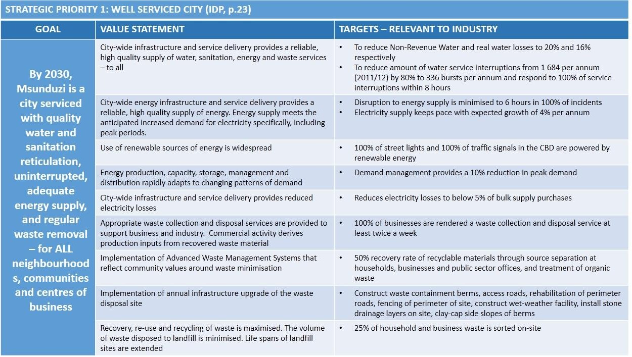

While stormwater upgrades does appear in one project for Ward 11, the IDS considers the upgrade of the stormwater system in the city to cope with the likelihood of increasing storm intensities as a priority. This would include looking at other, more innovative, green ways to handle stormwater.
The Climate Change Policy prepared by the municipality also advocates for this.
      - IDP SP2: An accessible and connected city – IDS Bulk Infrastructure and Catalytic Projects
The table below indicates that the municipality intends to address an integrated public and private transport network, essentially the IRPTN (IDS priority 2 under Integrated Catalytic Projects). The IDP, on page 293, lists the Strategic Infrastructure (SIP2) projects that SANRAL has responsibility for which includes both the N3 bypass route (estimated budget R 10 billion) and the various N3 interchanges (estimated combined budget of over R 1.349 billion -some of those interchanges listed are still to be costed).
In addition, the issue of increasing the speed and accessibility of ICT infrastructure is clearly spelt out in the IDP SP targets below. This corresponds with the IDS priority catalytic projects on improved city- wide ICT and links with the ICT hub and Smart City initiatives and expanding broadband connectivity.

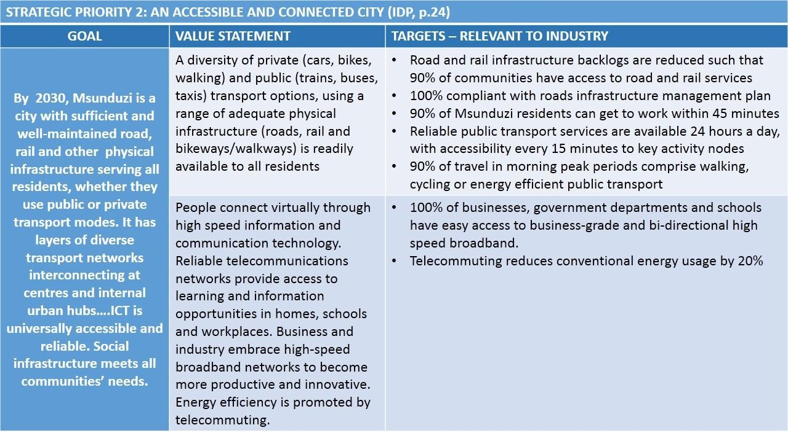

      - IDP SP3: A clean, green city – IDS Protective environmental and social measures
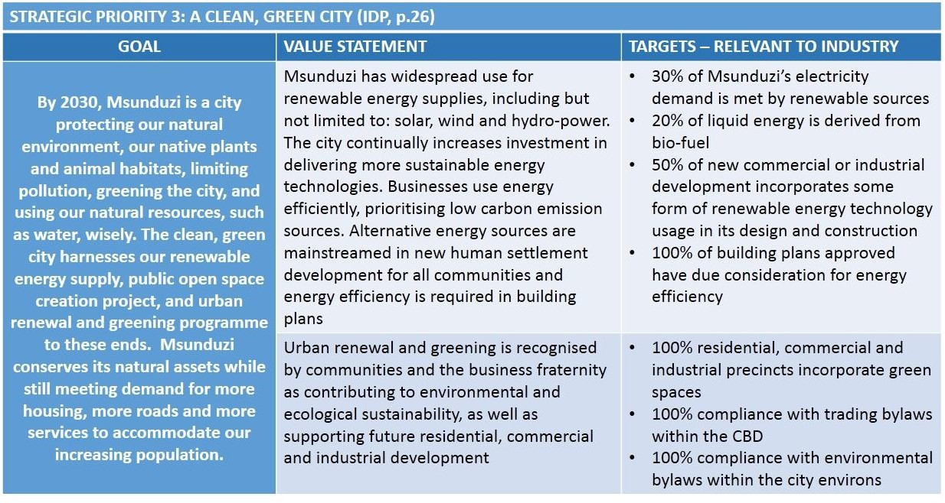
The table below indicates the municipality’s strong commitment to creating a cleaner, greener city by encouraging renewable energy technology, through ensuring future buildings are energy efficient and creating green spaces in business and industrial precincts, as well as compliance with environmental by-laws. The goal assumes that the Strategic Environmental Assessment and the Environmental Management Framework and Climate Change Policy, as well as compliance with NEMA and the EIA regulations will inform the assessment for all future development, as well as working with existing industries and businesses to achieve a carbon neutral city.

There are also some projects mentioned in the IDS industrial sector programme which will contribute to a cleaner, greener city such as project priority number 12 which includes exploring opportunities for biofuels, using exotic and invasive species for furniture manufacturing, moving away from buildings using bricks and sand which create major ecological problems for KZN rivers because of illegal sandmining) and the promotion of climate smart agriculture.
There are some specific aspects of greening the city that are in the IDS but not specifically mentioned in the IDP. These projects are highlighted in 6.2.3.

      - IDP SP4: A friendly safe city – IDS Institutional support and Industrial sectors
This IDP SP relates mainly to the IDS suite of projects under institutional support. In the Industrial Sector Programme of IDS, albeit not within the top ten priorities, the need to install CCTV cameras in industrial areas is mentioned, which is taken care of in the IDP targets.
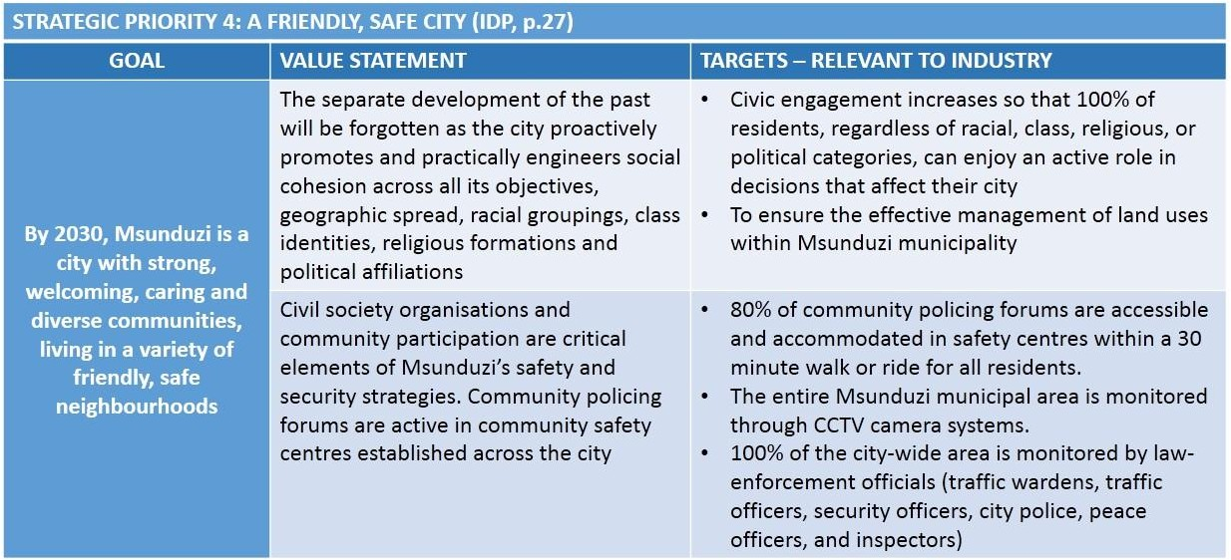
This IDP SP broadly points to increased engagement of the city with residents and business. The IDS lists specific projects important to industry which provide the detail to this ‘engagement” (section 6.2.3)

      - IDP SP5: An economically prosperous city – IDS Industrial Sectors programme
This IDP SP sets out the broad goal of a flourishing economy while setting specific targets for reduction of unemployment, particularly unemployment among youth, and focuses also on the need for training and building skills among all residents to meet the needs of a strong and resilient economy. It also mentions incentive packages to attract businesses in order to assist with job creation.
The top priority project in the IDS is to implement the 2017 incentives policy of the municipality, including ensuring that the incentives policy is fair to existing industries and businesses and not just new entrants.

There are a number of projects in the IDS industrial sectors programme which encourage skills training and entrepreneurship in general, but particularly for the youth with specific sectors highlighted such as automotive, leather and agricultural.
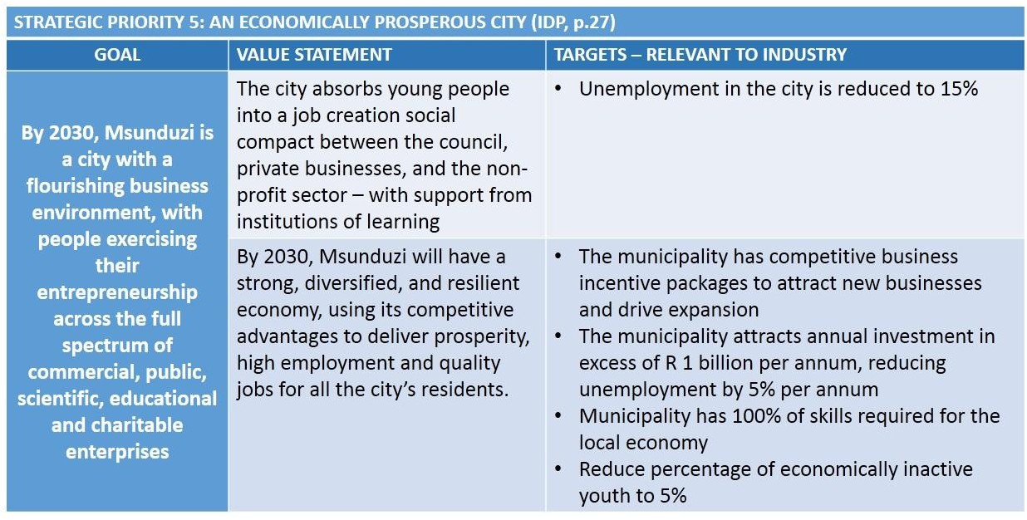

Section 6.2.3 lists more specific projects which fall within this IDP strategic priority, but are not specifically mentioned in the IDP projects. Some of them do tie in with LED strategy projects.

      - IDP SP6: Financially viable and well governed city
There are no specific IDS programmes that relate to this IDP SP.
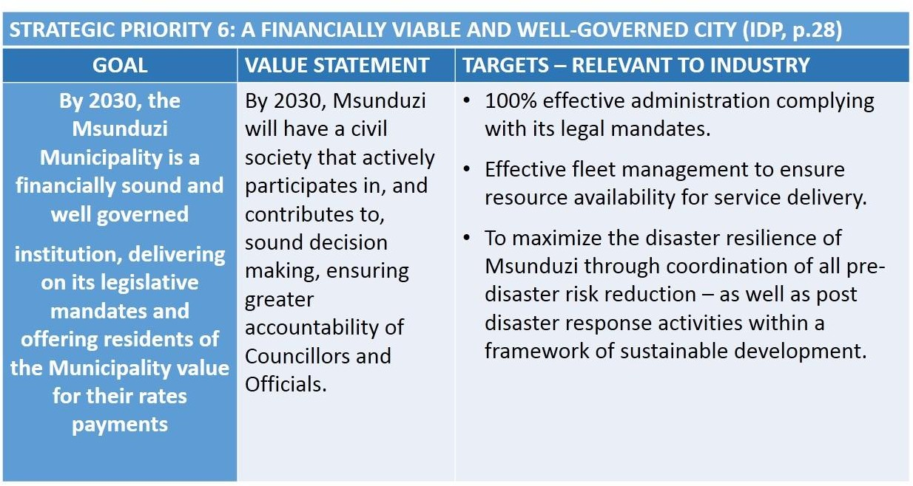

However, a number of projects under, for example, ensuring protective environmental measures, do relate to the target of 100% compliance of the administration to its legal mandates (e.g. applying the SEA and EMF as well as the Climate Change Policy to the assessment of development applications). The target of minimising disaster resilience relates to the bulk infrastructure IDP project of upgrading the stormwater infrastructure in the city.

    - Industrial Strategy priority projects to be included in the IDP Review 2018/19
The following are projects which do not appear in the fourth generation IDP 2016/17 to 2021/22. They are therefore listed for inclusion in the next review. It should be noted that budget estimates were not available for all projects, so figures are included only when available.
It should also be noted that many of these ‘projects’ are administrative / operational based on liaising or lobbying with other organisations and departments over specific issues, or fast tracking particular tasks such as amendment of the land use Scheme. While they may not be capital projects that fit more easily into the IDP project list, they nevertheless have just as an important role in order to stimulate and support the industrial sector. The capital projects have largely already been included in the IDP (see section 6.2.2).
Key to the table:
- Orange shaded projects are not in the IDP (2016/17-2021/22) and need to be included in the IDP review (2018/19).
- The yellow shaded projects are those that, wholly or in part, already appear in the IDP (2016/17-2021/22).

MIDS  priority | Project description | Funding /  responsibility | Budget estimate
1 | SPATIAL AND LAND SUPPORT
1.1 | Short term release of 60.7 ha of land for industrial  development | Municipality | None  internal operational
1.2 | Amend the current Town Planning Scheme to reflect the new integrated zones proposed in the SDF, namely: Industrial zone (cumulative industrial zone); Logistics and business parks ;  Agri-business and commercial | Municipality | None internal operational
1.3 | Promotion of Ibhubhesi Light Industrial Park so that it  achieves full capacity in terms of sale of land | Municipality | Promotional material  TBC
1.4 | Investigate why some already zoned industrial land is not being used; this includes land which has been invaded or is  vacant | Municipality | None internal operational
1.5 | Rezone land which is vacant because it has no attraction for  industry and seek alternatives elsewhere | Municipality | None  internal operational
1.6 | Business and industrial development opportunities along the  R56 logistics corridor need to be encouraged and properly zoned as per the 2015 SDF | Municipality | None internal operational
1.7 | Identification, preparation, servicing and zoning of additional  municipal land suited to industry aligned to industry needs | Municipality | None  internal operational
1.8 | Identify subsequent land parcels to make up the remainder of the land identified in the SDF as required for industry in the medium to long term (the recommendation is 50ha per year  – although current growth is about 5 to 7 ha a year.) | Municipality | None internal operational
1.9 | Determine strategy, with relevant municipal departments, for  resolving the freeing up of industrial land where it has been | Municipality | None  internal operational

MIDS  priority | Project description | Funding /  responsibility | Budget estimate
invaded, particularly if it has good potential for industry, and/or may present problems to communities due to industrial impacts (pollution, noise, heavy traffic, poor access
to schools etc)
2 | BULK INFRASTRUCTURAL SUPPORT
2.1 | Liaise with SANRAL regarding expediting decision on location of by-pass route (following due EIA process) Establish a standing forum to meet every quarter as well to monitor  progress and address obstacles | Municipality SANRAL | None – liaison function SANRAL for implementation of bypass
2.2 | Determine water demands in order to liaise with DWAS re securing sufficient water supply for current and future needs (dams); Ensure City has sufficient storage capacity (water towers and bulk reticulation); Protection of water sources from pollutants through planning and environmental controls; Non-revenue water reduction projects: ensure regular  monitoring and maintenance prevents water loss | Municipality DWAS  Mngeni Water | None  Liaison and advocacy function
2.3 | Stormwater upgrades: This is critical in order to be able to cope with the likelihood of increasing, and higher intensity storm events due to climate change, as well as to prevent damage to road infrastructure through inadequate stormwater  management. | Municipality | TBC
2.4 | Upgrade of infrastructure to facilitate Technology Hub as per  the Airport Precinct Plan | Municipality  DoT | TBC
2.5 | To ensure retention of existing industries and capacity to attract new industry undertake the following: electrical infrastructure upgrade; Resolve staffing and capacity issues in the electricity department to ensure sufficient capacity to manage and operate electricity grid; Ensure appropriate maintenance and repair on electrical facilities and networks –  sub-stations etc. | Municipality | See IDP
2.6 | Where possible, partner with industry to ensure key electrical  installations are maintained and updated | Municipality  Chamber | TBC
2.7 | Upgrading of routes – rail and road, to ensure that proposed corridor linkages in the Urban Network Strategy are  maintained and can meet transport demand | Municipality DOT | TBC
2.8 | Funding is to be secured to improve the road connection between the N3 (Market Road) and the Airport, and further towards the Mason’s Mill area, in unison with N3 market road interchange upgrade by SANRAL. Progress to be reported to  Council on a quarterly basis. | Municipality | TBC
2.9 | Continued support of current initiative to investigate green  energy options at landfill site | Municipality | TBC – re service  provider study
2.10 | Northeast: upgraded of the Northdale / Greytown Road, plus  additional access to the Willowton industrial area; | Municipality | TBC
3 | INTEGRATED CATALYTIC PROJECTS
3.5 | Actively support and encourage the 8 interchanges related to the City from the N3 – liaise with SANRAL, provide input and monitor progress. Secure funding from National Agencies for the upgrade of roads linking to the new intersection, based on  a municipal priority model | SANRAL | See IDP
3.23 | Monitor progress on the IRPTN project; IRPTN important to enable staff for industries to travel between work and home  efficiently and at reasonable cost | Municipality | None – monitoring function
3.3 | Integrate the currently disconnected industrial and logistics activities as well as marginalised rural production centres surrounding the corridor that are currently isolated from the  main logistics system | Municipality | TBC
3.4 and 3.5 | Align stakeholders behind a common plan for the SIP2 corridor and create capacity for industrial development ahead  of demand | Municipality | None Operational

MIDS  priority | Project description | Funding /  responsibility | Budget estimate
3.6 | Identify specific industrial park(s) or new areas for a Hub - Msunduzi can assist in this process through partnerships with ICT providers and ensuring a dedicated programme to facilitate and fast track ICT provision by streamlining approval  and implementation processes under its control. | Municipality | None Operational
3.7 | Assess the efforts of other cities to establish Smart Cities and  bring back lessons learned | Municipality | None – operational /  liaison
3.8 | Accelerate and synchronise infrastructure rollout associated with the N3/SIP2 corridor; this ties in with the alignment of stakeholders behind a common plan for the corridor, effectively recommending an implementation strategy for  that plan | Municipality DOT | TBC
3.9 | Develop mixed use industrial zone with logistical ties along the new industrial extension along Gladys Manzi road to both  airport and N3 | Municipality | TBC
3.10 | Encourage, support and expand the development of  broadband connectivity as per the related projects in the IDP | Municipality | TBC
4 | INDUSTRIAL SECTORS PROGRAMME
4.1 | Implement the 2017 incentives policy of the municipality (once approved by Council) to ensure that the incentives are fair to both existing industries as well as new entrants. The policy lists: Industrial incentives; Broadening participation incentives; Technology and human resources for industry;  Trade, export and investment incentives | Municipality | TBC
4.2 | Liaise with the Aluminium Beneficiation Initiative (Hulamin and South32) to determine where it may be possible for the municipality to assist with their industrial growth plans and identify specific interventions that the municipality or other  government agencies may assist with | Municipality ABI | None  Liaison / operational
4.3 | Municipality, in conjunction with the Chamber, to assist in  marketing the proposed Hub to the automotive industry | Municipality  Chamber | Promotional material  TBC
4.4 | Develop a business aftercare programme for new and existing  businesses that have been established for less than 3 years | Municipality  Chamber | TBC
4.5 | Secure sites in Edendale for the proposed Leather Hub | Municipality | TBC
4.6 | Review incentives provided for new entrants vs existing industries and ensure that the incentives policy are fair to  both | Municipality | None Administrative
4.7 | Municipality to become part of the existing liaison between EDTEA, DTI and IDC and the leather cluster industries so that they have better understanding of the industry and its  requirements in terms of municipal services and support | Municipality | None  Liaison / operational
4.8 | Liaise with EDTEA to expedite the development of an  automotive hub in terms of land / location | Municipality  EDTEA | None  Liaison / operational
4.9 | Consider establishment of an SEZ with a focus on the aluminium / metal industry – this may be in the form of designating a physical SEZ, or a virtual SEZ. Work with EDTEA  and /or DTI on this initiative | Municipality EDTEA  DTI | Feasibility study TBC
4.10 | Provide support to youth through municipal capacity building  programmes to train them in the automotive industry | Municipality  Private sector | TBC
4.31* | Explore possibility of bringing in natural gas as an energy source to the City, particularly for the aluminium industry as Hulamin have been considering this as an alternative energy  source for part of their needs | Municipality Dept of Energy | Feasibility study TBC
* This has been included as although it did not rank in the top 10 priority with the application of the prioritisation model, it is considered to be an important project for the city in general and for one of its prominent, and oldest industries.
5 | PROTECTIVE ENVIRONMENTAL AND SOCIAL MEASURES
5.1 | All development applications to take into consideration the  EMF management zones | Municipality | None  Operational
5.2 | Zoning (management area overlay) of 30m precautionary  buffer areas around protected areas and sensitive | Municipality | None  Operational

MIDS  priority | Project description | Funding /  responsibility | Budget estimate
environmental zones identified in the EMF and Ecological infrastructure Plan to ensure that industrial zones do not
cause environmental harm
5.3 | Develop partnerships with industry to strive towards carbon  neutral city | Municipality  Chamber | None  Cooperation
5.4 | Review municipal tariff structures w.r.t penalties as well as incentives to help ensure environmental compliance and the costing of externalities : This should be based on the principle of “polluter pays”; Intention is to encourage industries to mitigate all emissions and effluent from their production  processes | Municipality | None Operational
5.5 | Ensure, as part of the development application processes, that all laws and regulations, especially pertaining to the EIA process, are considered in the decision making process and complied with thereafter, particularly where approvals are  given based on conditions. | Municipality | None Operational
5.6 | Biomass (energy from waste, forestry biomass); Biogas (anaerobic, methane, abattoirs); Solar or wind farms (renewable energy generation) to be investigated for  alternative energy supply | Municipality Industry/private sector | TBC  Feasibility studies
5.7 | Implementation of Climate Change Policy where industry and municipality take cognisance of mitigation strategies and  adaptation strategies | Municipality Private sector | Multiple public and private sector projects
5.8 | Measure industrial development applications against  provisions of the SEA and the adopted EMF | Municipality | None  Operational
5.9 | Work with the DEA and DMR in controlling illegal sand mining  and quarrying | Municipality | None  Operational
5.10 | Industrialists to install mitigating technologies to prevent  pollution and become carbon neutral | Industry | Private sector project  technology upgrades
6 | INSTITUTIONAL SUPPORT
6.1 | Re-establish regular monthly or bi-monthly meetings  between the Chamber and the municipality | Municipality  Chamber | None  Operational
6.2 | Work with municipal Economic Policy and Advisory Committee to review various aspects of industrial development, including incentives, municipal tariff structures  for industry | Municipality | None Operational
6.3 | Organise into sectoral clusters so that the clusters can more effectively lobby and interact with municipality and with  provincial EDTEA | Municipality EDTEA | None Operational
6.4 | Host industrial cluster quarterly engagements so that the industry take their stumbling blocks to the City as this must be  implemented across industrial management areas | Municipality EDTEA | None Operational
6.5 | Build capacity in Business Unit to be able to streamline  applications | Municipality | None  Operational
6.6 | Develop pamphlet: Include incentives available for existing and potential industries; Marketing of the City for industries with comparative advantage and promotion of possible downstream / value-added industries. Link to TIKZN  investment initiatives | Municipality | Promotional material TBC
6.7 | Establishment of a rapid delivery agency within appropriate business unit to assist potential investors (links in with SDF  and LED strategy) | Municipality | None Operational
6.8 | Appoint service provider to assist with the design and establishment of an industrial health dashboard for the City; this will include the tracking of industrial land (capacity and demand), monitoring key requirements for industrial applicants, monitoring progress on planned industrial  hubs/parks etc | Municipality | TBC

  - Implementation structure

There was a specific request from one of the stakeholder workshops, that a project champion be identified, within the municipality, to drive the implementation of the Strategy.
It is proposed that a rapid delivery agency be established, under the auspices of the LED Manager, but overall falling under the General Manager: Sustainable Development and Municipal Entities. This agency should form a “one-stop-shop”, ensuring that the requisite departments within the municipality and relevant provincial and national departments or agencies, are brought in to comment on, and/or provide approvals for, the development application processes for the various approvals that industry and business require. This is not intended to shortcut much needed protective measures, but rather to streamline the process and make it more efficient.
This is being done to a certain extent by some departments within the municipality where, for instance, planning applications come before a committee comprising all the relevant people who are needed to comment on or provide regulatory input on a development.
The proposed structure is illustrated below:
Figure 23: Proposed implementation structure for Industrial Development Strategy

- ALIGNMENT OF POLICIES AND PLANS

This Industrial Strategy has reviewed a range of existing laws, policies and plans in order to establish which of these - national, provincial, district or municipal level - apply to industrial development in Msunduzi. Thus, to a great extent, this plan is aligned with the recommendations and plans from the following:
- NDP : National Development Plan
- IPAP: Industrial Policy Action Plan
- SIP2: Durban-Gauteng Corridor Infrastructure Plan
- PDGS / PGDP : Provincial Growth and Development Strategy / Plan
- PSEDS: Provincial Spatial Economic Development Strategy
- LED Strategy (2017): Msunduzi Local Economic Development Strategy
- Climate Smart Policy for Msunduzi
- uMgungundlovu District Comparative Advantages Study
- uMgungundlovu District Water Services Development Plan
The importance of industrial development in Msunduzi is well recognised in both the national and provincial planning as well local municipal planning. Table 11 below summarises the catalytic projects identified by the various strategic documents. Whilst the number of catalytic projects are substantial in number, the fact that the various strategic documents are not carefully aligned, needs attention. The IDP and the SDF should have alignment with the other strategic documents across all projects.
Table 11: Schedule of catalytic projects, based on national, provincial and municipal strategic documents

Catalytic projects | NDP | PGDS | PSEDS | SIP 2 Study | IDP/SDF
Common projects
Upgrading of the Durban-Gauteng Freight Corridor |  | 
Unique projects
Electrical infrastructure update |  | Electrical infrastructure update
Freeway node development |  | Freeway node development |  | Freeway node development | Freeway node development
Hilton/Mondi |  | Hilton/Mondi
IRPTN |  | IRPTN
PMB Airport upgrade |  | PMB Airport upgrade |  | PMB Airport upgrade | PMB Airport upgrade
Pietermaritzburg By-pass |  | Pietermaritzburg By-pass |  | Pietermaritzburg By-pass
Techno Hub |  | Techno Hub |  | Techno Hub

Catalytic projects | NDP | PGDS | PSEDS | SIP 2 Study | IDP/SDF
Msunduzi CBD revitalisation |  |  | Msunduzi CBD revitalisation | CBD  regeneration
Large scale conference centre |  |  | Large scale conference centre
Edendale Corridor |  |  | Edendale Corridor
Edendale Town Centre |  |  | Edendale Town Centre | Edendale regeneration
Flight school |  |  | Flight school
Masons Mill development |  |  |  | Masons Mill development
Mkondeni Industrial Revitalisation |  |  |  | Mkondeni Industrial Revitalisation
South Eastern Development Integration Zone |  |  |  | South Eastern Development Integration Zone
Mixed use precinct between N3 and R56 |  |  |  |  | Mixed use precinct between N3 and R56
Development of Logistics platform
Dedicated large scale truck stops
High speed train between Durban and Johannesburg
Rapid release of land for Industrial development |  |  |  |  | Rapid release of land for Industrial development

- PROJECT PRIORITISATION

  - Introduction

The Industrial Development Strategy is intended to be broad in nature, highlighting the strategic goals and objectives on which the municipality should focus in order to create an investor friendly environment.
The projects that have emerged from this investigation, however, range from the broad and strategic down to quite particular, locally focused projects. They have been grouped under six strategic programmes:
- Ensure there is sufficient land for industrial growth in Msunduzi in the short, medium and long term
- Ensure that there is sufficient capacity in terms of bulk infrastructure to meet both current and future demands: energy, water, road access, waste removal.
- Implement the catalytic projects that are currently planned or, if in the process of being implemented, monitor progress
- Provide support to the various industrial sectors in the municipality
- Ensure there are sufficient environmental and social protections in place to minimise, preferably prevent, negative impacts from industry on surrounding natural environment and neighbouring communities; and to mitigate climate change
- Provide institutional support and improve communication between the public and private sector with respect to industrial development.

  - Prioritisation model

Altogether 108 projects were identified within the six main strategic programmes. Many of these projects had already been identified in the LED Strategy or in the investigation done on the development of the Airport Precinct and Techno Hub. Projects were also brought in from the nationally driven SIP2 corridor. Cognisance therefore had to be taken of existing and already planned projects that have a direct or indirect bearing on industrial development as well as to identify new projects.
With the list being so long, it was important to find a way to prioritise the projects as simply as possible. The prioritisation tool that was used was based on¹⁴:

- PMOGuru – Project Portfolio and Agile PMO Consultants; http://www.pmoguru.com/project-prioritisation-prioritise- projects/

  - determining the key indicators for the projects which would help decide whether they matched up to those indicators and to what level;
  - deciding on how to categorise the levels within each indicator;
  - assigning a percentage weight to each of the indicators to guide the prioritisation; and,
  - listing all the projects and giving each project an assessment value based on the above. This key building blocks for the model are shown in the table below:
Table 12: Project prioritisation model - determinants

 |  | Benefits |  |  | Complexity
 |  | Contribution to Strategy | Implementation period | Job creation | Financial requirements | Implementation risks
Weight |  | 25% | 25% | 15% | 25% | 10%
Point Allocation | 1 | Low contribution to Strategy | > 5 Years | Low contribution | > R 5 million | High implementation risks
 | 2 | Medium contribution to Strategy | 3 to 5 Years | Medium contribution | R 2 to 4 million | Medium implementation risks
 | 3 | High contribution to Strategy | 1 to 2 Years | High contribution | R 1 to 2 million | Low implementation risks
 | 4 | Critical contribution to Strategy | > 1 Year | Very High Contribution | <R 1 million | Insignificant implementation risks

The projects were listed in the left hand column and then each was given a value or point allocation based on a broad assessment of what that project contributed to the overall strategy, when it was likely to be implemented, whether the project was a job generator, how much it was likely to cost, and what level of risk was involved in undertaking implementation.
The model then, incorporating the weighting, calculated those values and produced a figure with the value 100 indicating the highest priority.
A snapshot of the model is shown below, with the projects listed at left, and the prioritisation values shown in the right hand column.

With such a varied range of projects, and at such different levels of complexity, it is inevitable that inconsistencies will creep in. Sometimes it is difficult to assign, for example, a value to the implementation risk when it is difficult to compare one type of implementation risk with another type of risk across projects that differ widely in terms of scale or cost. It should be noted that some “projects” are more reminders to the municipality to elevate the importance of, for instance, specific processes. An example is the “project” to ensure adherence to the provisions of the SDF and EMF when considering applications. This should be embedded in existing application and decision-making processes, but needs to be clearly stated given the critical importance of environmental factors in mitigating the negative impacts of climate change. The final prioritisation list must, therefore, only be seen as a useful guide. Some of the projects which emerged in the top ten made sense; there are however, others which should be higher priority but have a value of less than 70.
Figure 24: Snapshot of prioritisation table
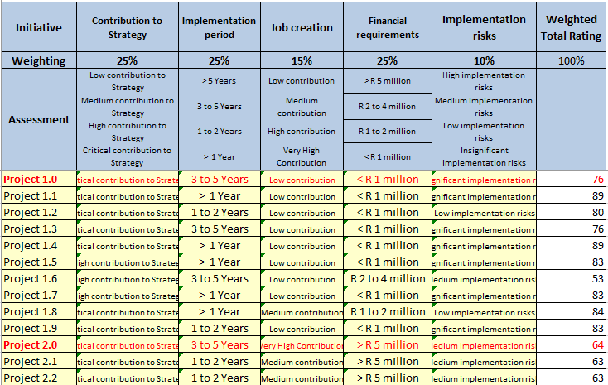

  - Results

The results that emerged from the model are shown in Annexure C. Annexure C1 shows all the projects and the values assigned to each project as per the assessment above, derived from the determinants shown in Table 12. Annexure C2 is the same table, this time divided into the main strategic programmes (spatial and land; bulk infrastructure, catalytic projects, industrial sectors, environmental and social measures and institutional support), illustrating what each of those values mean and how those values have been calculated (applying the weighting), producing the ranking shown in the right hand column. Finally, Annexure C3 is a simplified version which summarises the priority ranking per each of the programmes mentioned above.

Those projects shown in red are the main strategic programmes; they were included more as a matter of interest in the ranking calculations, more to see how the six programmes would rank compared with each other.
Some project rankings may seem counter-intuitive; relatively small projects may have received a higher ranking than some major catalytic projects. This could be a result of them being relatively easy and quick to do, at little to no cost, and therefore are more achievable in the short term.
In summary, the top three priorities within each programme that have emerged are as follows:
- Spatial and land support: ensure that there is sufficient land for industrial growth in Msunduzi in the short, medium, and long term
  - The highest ranked project is the short term release of 60.7 ha of land for industrial use
  - This is followed by the need to reflect the new integrated zones proposed in the SDF
  - The next priority is to market the Ibhubesi light industrial park so that it reaches its full capacity
- Bulk infrastructural support: ensure that there is sufficient capacity in the bulk infrastructure to meet both current and future demands: energy, water, road access, waste removal
  - The highest ranked project, largely because it only requires liaison, can be done immediately and has no cost attached to it, is to talk to SANRAL to try and expedite the decision on the location of the by-pass route. As long as there is no conclusion to the planning of the by-pass route, uncertainty will persist.
  - The next ranked project concerns liaising with the Department of Water Affairs over securing an adequate supply of water for current and future needs. This includes protection of water sources from pollutants.
  - Stormwater upgrades receive the next ranking to prevent damage to infrastructure with anticipated increase in the number and intensity of severe weather events with climate change. This is a critical pro-active measure which will prevent greater cost to the municipality later on.
It is important to note the relatively low ranking (5) of securing a stable energy supply. This was an aspect that all industrialists at the stakeholder meeting agreed was a top priority. This ranking probably comes from the high cost and high implementation risk, given the current challenges facing Eskom. Nonetheless, a stable energy supply remains a critical project.
- Integrated catalytic projects: implement catalytic projects that are planned, and where they are already underway, monitor progress
  - Top priority, which ties in with the bulk infrastructural priority, is liaison with SANRAL over the 8 planned interchanges from the N3.
  - The next priority is the IRPTN project: to monitor progress and ensure effective implementation. This has a bearing on being able to ensure that it is easier for workers to commute between their homes and places of work.
  - The third priority is to integrate the spatially separated industrial and logistics activities across the city into the proposed main logistics system linked to the SIP2 corridor along the N3.
- Industrial sectors: provide support to industrial sectors

  - The top priority is to implement the 2017 industrial incentives policy
  - The Aluminium Beneficiation Initiative (ABI) is ranked as the next priority: to liaise with Hulamin and South32 to determine how the municipality may assist with their growth plans
  - The marketing of the proposed automotive hub to the auto industry is ranked third.
- Protective environmental and social measures: ensure there are sufficient environmental and social protections in place to minimise, preferably prevent, negative impacts from industry on surrounding natural environment and on neighbouring communities, and to mitigate the negative effects of climate change.
  - The top priority concerns ensuring that the planning of any industrial zones takes into account the EMF zoning. This should be part of the normal assessment process for both changes of land use as well as for industrial development applications. This ranking merely serves to emphasise the importance of taking environmental constraints into account when locating industries.
  - Ensuring the zoning of precautionary 30 m buffer areas around sensitive environments and protected areas is the next priority. This is a follow on from the first priority; the EMF should specify such a buffer.
  - The third priority is to develop partnerships with industry to strive towards a carbon neutral city. This is a critical strategic decision to take – to assess all current and future industries for their impact on climate change. This should be written into the municipal by-laws – that all industries must at least comply with international standards.
- Institutional support: provide institutional support and improve communication between public and private sectors with respect to industrial development
  - The top priority is to re-establish regular meetings between the municipality and the Chamber. This ranking is supported by the discussions held with the Chamber at a stakeholder workshop.
  - The next priority ties in with the industrial support priority: working with the Economic Policy and Advisory Committee to review various aspects of industrial development, including industrial incentives and municipal tariff structures for industry.
  - EDTEA have been promoting the next ranked ‘project’, that of organising into sectoral clusters so that industry can more effectively interact with both EDTEA and the municipality.
The development of the investor booklet is only ranked at 6; and yet it is important that it be produced as soon as possible in order to market the municipality, and in order to help publicise the number one ranking of municipal incentives.¹⁵

- Much has been said about incentives throughout the document , however, some degree of caution needs to be exercised that this drive to offer incentives does not become “smokestack chasing”. See the following links.

The prioritisation tool is not perfect; it is a guideline and there may be reason to increase the ranking of some projects where it is logical to do so. For example, ensuring regular liaison between the municipality and the Chamber is has top ranking for institutional support, but identifying a champion and the establishment of a rapid delivery agency unit should also be a priority.

  - Link with the Integrated Development Plan (IDP)

This Industrial Development Strategy is not prepared in isolation from other initiatives and plans of the municipality as shown in section 7: Alignment of Plans. In this section, the IDP column from section 7 is examined in a little more detail to specify which of the above projects within the six strategic industrial development programmes are already in the IDP, and which should be included in the 2018/19 IDP.
The information displayed below is drawn from the IDP 2015/17 – 2021/2022. The figures shown are the estimated budgets.
Figure 25: Catalytic Projects from the IDP 2016/17-2021/22

Pietermaritzburg Airport Upgrade | This is a short term project that will see the extension of the existing runway, together with the terminal buildings. This will allow for larger aeroplanes to make use of the airport, thereby attracting additional operators and increasing the amount of feet through the airport. | R 0.5 billion
Integrated Rapid Public Transport System | This project is a short to medium-term project which will see the roll-out of reliable and efficient public transport between key points in the city, thereby reducing residents’ commuting times. | R 3.2 billion
Fibre optic Cable network | This is a short to medium-term project that will see the development of a leading-edge technology fibre optic telecommunications network leading to increased connectivity and usage, decreased costs and stimulating growth and development | R 0.5 billion
Electrical infrastructure upgrade | This is a short to medium term project that will see the rehabilitation and upgrading of the municipality’s electrical infrastructure | R 0.9 billion
City-wide CCTV system | Camera surveillance of areas within the Msunduzi Municipality so as to encourage a crime-free environment | R 0.5 billion
Freeway node development | This is a medium term project that involves the upgrade of key freeway interchanges within the municipality so as to ensure more efficient movement of traffic, as well as unlocking strategically located adjacent land for the development | R 1 bilion
Non-revenue water reduction project | This is a medium to long-term project that will simultaneously increase revenue and reduce water losses. The reduction of water losses will ultimately reduce the demand on our source (dams) which will have a catalytic benefit to the catchment | R 0.5 billion

http://articles.chicagotribune.com/1989-04-11/news/8904030161_1_foreign-plants-foreign-investment-new-plants ; http://alphalaunch.com/blog/2009/05/11/green-smokestack-chasing/

- MONITORING AND EVALUATION

  - Defining monitoring and evaluation

Monitoring is the ongoing internal collection and analysis of information about a project or programme. A decision has to be taken about which key information needs to be collected to provide an effective indication as to whether the project will achieve its objectives. There needs to be a realistic understanding of what information is readily available, how often it can be updated and what its accuracy is.
Evaluation then takes that project information and assesses it against milestones and the overall objectives of the project. Again, a decision has to be taken on which are the most important indicators that need to be assessed and how often.

  - Key indicators for monitoring and evaluation

It is recommended that the following information needs to be collected on a continual basis in order to provide sufficient material for evaluating whether the municipality and its partner stakeholders are achieving their objectives in terms of the expansion of the industrial sector.
Table 13: Recommended monitoring indicators

 | Indicator | Detail | Frequency | Source
1 | Industrial land available | - Current Industrial land – zoned and fully serviced  - The degree to which zoned land has been developed to the maximum permitted by the planning scheme  - Occupancy of current industrial land – where and how much zoned and serviced land is vacant  - Current industrial land zoned, but NOT serviced – assumption that this is vacant  - Current industrial land that is zoned and serviced but invaded (not being used for industry)  - Current industrial land zoned, not serviced, but invaded (being used for residential or other purposes)  - Identification of future industrial land for zoning  All of this information mapped and quantified | Quarterly updates | Planning / land section
2 | Bulk infrastructure  (Municipal) | - Bulk electricity lines – mapped and spare capacity available  - Bulk water storage: mapped, capacity and spare capacity available  - Sanitation: bulk reticulation mapped and spare capacity available  - Roads: Road network to industrial areas – traffic and capacity monitoring, as well as | Annual updates | Infrastructure Services – LM and DM  Eskom

 | Indicator | Detail | Frequency | Source
 |  | design standards to cope with any changes in traffic loads due to industrial needs
3 | Strategic Infrastructure  SIP2 corridor | - Freight flows  - Communication / liaison with SIP2 coordinator (Transnet) and other SIP2 stakeholders  - Status of freight corridor upgrades (N3)  - Status of Pmb interchanges plans and implementation programme  - Status of planning and implementation of logistics Hub in Msunduzi  - Status of planning and implementation of truck stops related to SIP2 corridor in Msunduzi | At least 6 monthly meetings or liaison with key SIP2 drivers  Maintain up to date information on status of implementation of various SIP2 projects | Transnet SANRAL KZN DoT  KZN DEDTEA  Office of the Premier
4 | Key institutional structures | - Establishment of project champion in the form of an Industrial Incentive Business Unit (rapid delivery agency) within the Economic Development section of the municipality  - Chamber of Commerce and Economic Development driver from Municipality hold regular meetings | Once-off establishment | Municipality – Department of Sustainable Development and Municipal Entities
5 | Key institutional programmes | - Streamlined decision making process in place to integrate and facilitate approval across multiple processes | Once-off establishment | Municipality – Dept of Sustainable Dev and Municipal Entities (SDME)  Dept of Infra- structure Svces
6 | Catalytic projects | - Status of catalytic projects in terms of: planning, construction, operations | Six monthly | Municipality  SDME & Infra- structure Svces
7 | Number of industries | - Data base of industrial businesses; categorised into heavy, medium and light industry, include date of establishment | Establish initial data base  Ongoing updates | Municipality SDME  Chamber
8 | Downstream opportunities | - Downstream industrial / business opportunities created from industrial investment | Establish initial data base  Ongoing updates | Municipality SDME  Chamber
9 | Employment | - Employment statistics in the industrial sector | Updated with Census  If possible, more frequent updates depending on data available from other  sources, or from | StatsSA  Markit and other private sector data/ stats info

 | Indicator | Detail | Frequency | Source
 |  |  | local industry sources
10 | Income levels | - Income statistics – general | Updated with census | StatsSA, Markit etc
11 | Green standards in place | - Industries / Municipality have monitoring tools in place to test air, soil and water quality – as per national standards and, where relevant, local standards set by municipal by-laws (have to be same as, or higher standard than national) | Use existing testing undertaken by relevant Depts.  This testing should be synchronised if possible  Conduct testing after any specific pollution incident | DEDTEA DWAS  Municipality
12 | Industrial environment attractive | - Street cleanliness within industrial parks and industrial areas  - Street trees: planting and maintenance  - Attractive street landscaping  - Green stormwater mitigation  - Adequate on-site parking (staff and customers) so that loading of heavy vehicles does not occur on streets | Regular cleaning as per municipal schedule plus additional cleaning when necessary by industries themselves.  Including maintenance of landscaped and planted areas (watering, weeding etc) | Municipality  Industrial park associations

It would be useful to keep separate tables for monitoring employment and income levels generated by each of the industrial sectors as an additional measure of the success of the sector. This can be gleaned from StatsSA although it may be useful to set up a joint Municipal / Chamber survey mechanism to monitor jobs created / lost in the industrial sector within the municipal area.

  - Evaluation tools

The evaluation of progress on the Strategy requires evaluating the information collected through the monitoring process, as well checking key information for conformity with that provided by the census and StatsSA as well as any other relevant market or economic surveys that provide key indicators at regional and municipal level.
The table below provides some key indicators and statistical tools that are commonly used to measure economic activity in a country or region. Therefore the frequency of being able to update and evaluate has been dependent on external sources of information, rather than internal research/ surveys.

Table 14: Statistical evaluation tools

 | Tool | Definition | INDICATORS / INFO REQUIRED and COMMENT
1 | GDP | Gross Domestic Product is a monetary measure of the market value of all final goods and services produced in a period of time. Used to determine the economic performance of a country or region. | - The monetary value of goods and services bought by the final user  - Info produced by StatsSA
2 | HDI | Human Development Index (HDI) is a statistical tool used to measure a country's overall achievement in its social and economic dimensions of a country which are based on the health of people, their level of education attainment and their standard of living.  (see figure below) | - Composite statistic comprising:  - A long and healthy life: Life expectancy at birth  - Education levels: mean years of schooling and expected years of schooling  - A decent standard of living: GNI (gross national income) per capita (using PPP Purchasing Power Parity)  - This is a more realistic measurement than GDP as it takes into account externalities (e.g. quality of life, and not just gross income. Under GDP a country or region can seem very wealthy, but the distribution of that wealth may be very skewed. The HDI will show a more realistic picture of the health of both people and by association, the environment (life expectancy will decrease in unhealthy environments – air or water pollution for example)
3 | Tress Index | An evaluation tool to measure the level of concentration – or diversification – within an economic region. | - Sectoral contribution to GVA  - Adding values cumulatively then indexing them  - 0 value: all sectors in economic region contribute equally to GVA. This is a totally diversified economy which will be more resilient if faced with economic shocks.  - 100 value: only one economic sector makes up entire GVA of the region. Very dependent on one sector and therefore vulnerable to changes – no resilience built into local economy  Current value (as at 2016) is 47.  Recommend that Tress Index values of between 30 and 50 be considered optimum.
4 | Carvalho Classification | This looks at employment growth relative to growth in the overall economy at a local or regional level. | - Provides a multi-dimensional indication of the suitability of sectors in relation to the tools and instruments to use in the development of these sectors (depends on one assumption – that reasonably comparable regions will be used)

 | Tool | Definition | INDICATORS / INFO REQUIRED and COMMENT
- The benchmark employment sector can be SA as a whole, or KZN province that the municipality is compared to.
- It does provide valuable insights into the strengths and weaknesses experienced in the local economy, indicating development potential and prospects. Are the sectors leading, or lagging, are they driving the economy or are they vulnerable or expanding sectors.
5 | Location quotient | An indication of the comparative advantage of different economic sectors within an economic region | - Sectoral productivity in economic region compared with other regions and/or with the Province  - Production statistics per sector  - Employment statistics per sector  - Percentage contribution of a sector to GGP or total employment in a specific economy/percentage contribution of the same sector to the aggregate economy  - Location quotient smaller than 1 shows that an economy is at a comparative disadvantage in terms of that sector compared with other areas  - A location quotient larger than 1 indicates a comparative advantage for that sector compared with other areas

Figure 26: The principle underlying the Human Development Index
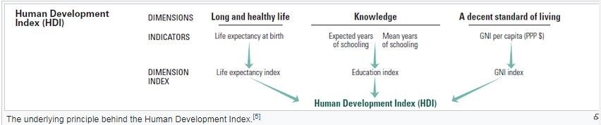
Source: Wikipedia

The monitoring and evaluation report (Phase 7) sets out recommended templates for monitoring information e.g.:

Table 15: Recommended template table for monitoring of industrial land and occupancy rates

 | Ha
 | Short term |  |  |  |  | Medium Term |  |  |  |  | Long term
 | 2018 | 2019 | 2020 | 2021 | 2022 | 2023 | 2024 | 2025 | 2026 | 2027 | 2028 | 2029 | 2030 | 2031 | 2032
Total :
Industrial land
Occupancy of industrial land
% occupancy
Per industrial park / area
Leather Hub ha
Leather hub
Occupancy%
Etc.

  - Institutional requirements

For the industrial strategy to be carried through from the short to long term, there needs to be strong institutional structures in place to champion the strategy and to drive the various projects identified.
The table below gives an indication of institutions that will do this. Note that some of these organisations or committees are already in place; some have apparently been started but are now defunct or not operating as they should.
Table 16: Institutional structures to assist with monitoring and evaluation

INSTITUTION | DESCRIPTION
Project champion | Require an identified project champion to drive the strategy. Should be from within  the Sustainable Development and Municipal Entities directorate. This can be a person or a small committee (e.g. could be the rapid delivery agency, a unit within the municipality). This champion would manage the establishment and maintenance of the industrial health dashboard.
Rapid delivery agency  – one-stop shop | There is already some form of this in the planning department with their Planning  Advisory Committee which has been operating for 18 months with the intention of bringing relevant stakeholders together to consider applications in order to speed up decision-making processes. This can be expanded upon to include other departments (municipal and provincial) who have a responsibility for some aspect of the decision making process for the full range of applications / approvals that a prospective industrialist will need. Where necessary, the applicant can come before

 | the committee to clarify aspects of their application and receive information as to its status.
Pmb Chamber and  municipal liaison | This relates directly to re-establishing regular liaison between the Chamber and the  Municipality. Meetings should be held at least on a quarterly basis, if not monthly, in order to ensure that there is a good working relationship and understanding of each other’s circumstances on an ongoing basis.
Industrial clusters  (Leather / Wood products / Metal products, automotive etc.) | Some clusters are already in place. Additional industry clusters should be  established with the assistance of DEDTEA to enable them to take advantage of collective industry information and requirements
SMME Coordinating  Committee | There is an SMME section within the Chamber. This needs to be strengthened and  included in the liaison with the municipality. This institution can drive innovation in the small business / emerging industrial sector to see what advantages can be taken for downstream activities, use of business and industrial hives, and working with ADA on possible agri-processing projects.

  - Industrial Health Dashboard

All of the above monitoring and evaluation tools should be brought together into an interactive, web- based industrial health dashboard where both authorities and the private sector (current industrialists and potential investors) can go and check various key indicators and information. This would include links to specific documents such as: the investor booklet, the municipal incentives policy; maps of the industrial areas etc.
While this report makes suggestions as to what should be measured and evaluated, and therefore form part of the industrial health dashboard, the municipality, together with the Chamber, should work together and decide what can be realistically monitored and what will give them, and potential investors, the kind of information they need.
The dashboard should also include, for relevant factors, a quick assessment reference to see whether targets have been reached and where objectives are falling behind. This can be done in the form of a colour coded chart which gives a snapshot of progress:

Completed / target achieved | In process and meeting deadlines | In process but behind schedule | No progress / blockage

It is recommended that the municipality and the Chamber liaise over what aspects should form part of the dashboard and draw up a terms of reference to enable a service provider to set up the web- based dashboard, ensuring that it is simple, user friendly and provides the information all stakeholders and potential stakeholders need.

Figure 27: Industrial health dashboard

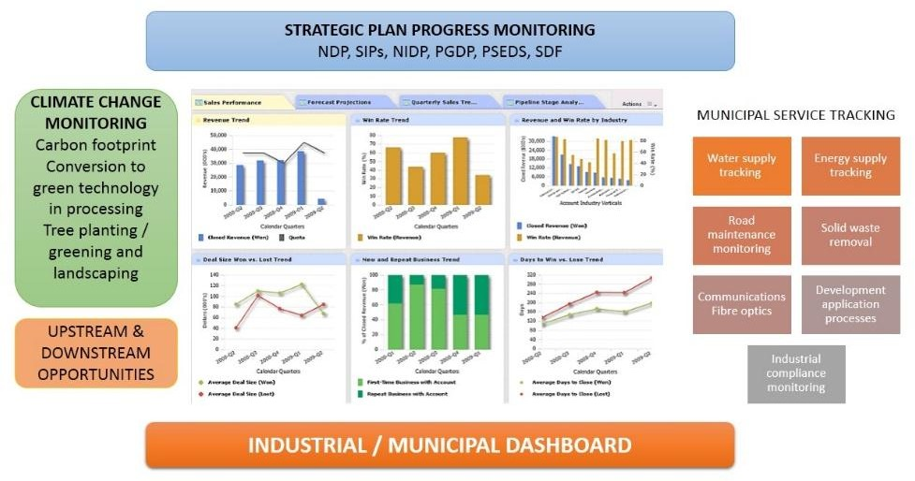

- CONCLUSION

Msunduzi Municipality, through its LED strategy and work undertaken on various catalytic projects, has already travelled a considerable way along the road towards coordinating and promoting industrial development in the city and surrounds.
This Industrial Strategy attempts to bring that work together into one document, focussing on the industrial sector of the municipal economy, providing more detailed analysis and recommendations on what the municipality needs to focus on in the short to medium term, within six broad programmes, to promote appropriate industrial development that both takes cognisance of comparative strengths, as well as acknowledges the critical importance of moving towards greener technologies and greener systems that will help mitigate the effects of climate change.
The municipality, together with the Chamber, should start to engage with the concepts set out in Industry 4.0 – the 4th Industrial Revolution. This suggests a different kind of growth, one that is not ‘business as usual’ based on striving for continual growth of the GDP. The municipality and the business and industry stakeholders need to recognise the changing world; one that requires different kinds of job creation strategies, and one that does not rely on the huge industries and businesses of the past to drive the economy. Innovative solutions need to be found to decrease income and wage gaps and provide for the poor, while providing dignified work for as many people as possible. These solutions must recognise the global warming crisis and seek to ensure that business, industry and society at large, do not continue to fuel the factors that are driving climate change.
The analysis revealed some positive aspects to build on: the fact that there is industrial land available; there is a Chamber of Business which the municipality can work in partnership with; there are various projects in the pipeline such as the airport upgrade. Hulamin also provides significant opportunity for downstream beneficiation. There are also exciting new ideas with respect to agricultural processing and the involvement of youth in aquaculture enterprises. There is therefore, already a move amongst existing industry stakeholders to encourage emerging, smaller-scale businesses linked to the industrial value chain.
As to be expected, this is tempered by some challenges that need to be overcome such as stabilising the electricity supply and making it more reliable for industry, as well as creating a more conducive environment for investors through improved street cleaning and repair and maintenance to city infrastructure. Overall, the outlook is positive: the location of Msunduzi on the SIP2 corridor means that it is poised to take advantage of this key national strategic project and this Industrial Strategy will help give direction to the municipality to respond to this initiative.

- REFERENCES

Department of Agriculture, Forestry and Fisheries, 2016, Economic Review of South African Agriculture

Department of Minerals and Energy, 2006, Operating Mines and Quarries and Mineral Processing Plants in the Republic of South Africa, 2006, Directorate Mineral Economics

DTI, date unknown, National Industrial Policy Framework

DTI, 2016, South African Leather Research Institute: A technical feasibility, December 2016 EDTEA, 2014, Leather Hub analysis
IHS Markit Regional eXplorer version 1160, 2016

Institute of Natural Resources, 2017, Draft Environmental Management Framework for the uMgungundlovu District Municipality, EMF Report, May 2017

Iyer Urban Design Studio cc, 2015, Msunduzi Municipality SDF Review, 13th February 2015 KZN Provincial Growth and Development Plan, 20
KZN Provincial Spatial Economic Development Strategy

McKenzie, R., Siqalaba, ZN, and Wegelin, WA, 2013, The State of Non-Revenue Water in South Africa (2012) in, The Water Wheel, Vol 12, No.1, January/February 2013

Meyer, D.F., (c.2013), Local Government’s Role in the creation of an Enabling Developmental Environment, School of Economics, Dept of Public Management, North West University

Msunduzi Municipality, 2016, Draft Integrated Development Plan for the 2016-17 to 2020-21 Financial Years

Msunduzi LED Division, 2014, Msunduzi Local Economic Development Strategic Plan, December 2014 Msunduzi Municipality, 2015, Integrated Development Plan
Msunduzi Municipality, 2017, Annual Budget of Msunduzi Municipality KZN225: 2017/18 to 2019/20 Medium Term Revenue and Expenditure Forecasts

Msunduzi Municipality, date unknown, Water Services By-Laws of the Msunduzi Municipality as Water Services Authority

Msunduzi Urban Network Strategy, 2014

Marcewicz Redman Partnership and RHDHV (Pty) Ltd., 2016, Shenstone City: Draft Concept and Block Plan, 10 June 2016

Msunduzi Municipality, 2014, Msunduzi Local Municipality Integrated Waste Management Plan 2014- 18

Msunduzi Municipality, 2014, Climate Change Policy for Msunduzi Municipality, November 2014

Msunduzi Municipality Environmental Management Unit, 2016, Climate Change Adaptation and Mitigation Strategy, May 2016

Pat Luckin; 2015, Presentation on SMMEs

PMOGuru, Project Portfolio and Agile PMO Consultants; http://www.pmoguru.com/project- prioritisation-prioritise-projects/
Royal HaskoningDHV, 2013, Technical Note: Bulk Water and Sewerage Services, Msunduzi Central Area and CBD Extension Node Local Area Plan

SRK Consulting, 2010, Msunduzi Municipality – Finak Draft Strategic Environmental Assessment, May 2010

SRK Consulting, 2010, Msunduzi Final Draft Environmental Management Framework, May 2010

Msunduzi Municipality, 2016. Airport Precinct Plan: Final Report Airport Precinct and Management Plan for the Pietermaritzburg Airport and surrounds. Prepared by The Markewicz Redman Partnership in association with Royal HaskoningDHV (Pty) Ltd and Glen Robbins,

RSA, National Development Plan

RSA, State of the Nation Address, 9th February 2017 RSA, Industrial Policy Action Plan
Sivest, 2017, Review of the Msunduzi Local Economic Development Strategy, Phases 4, 5 and 6 (Draft), June 2017

StatisticsSA, 2017,

StatisticsSA, 2014

uMgungundlovu District Municipality, 2012, District Comparative Advantage Report, August 2012

ANNEXURE A

ANNEXURE A: DETAILED MAPS OF INDUSTRIAL AREAS

Figure 28: Ashburton Industrial Area
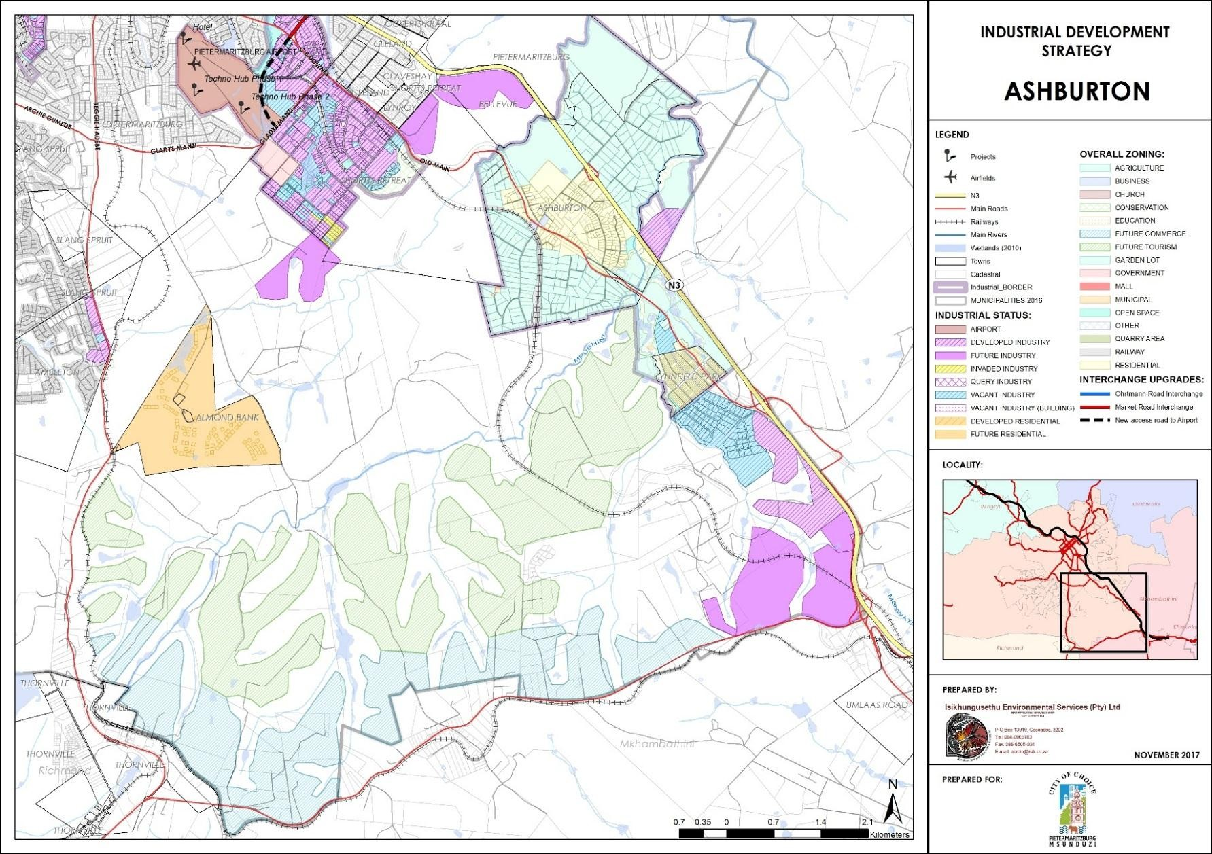

Figure 29: Mkondeni Industrial Area
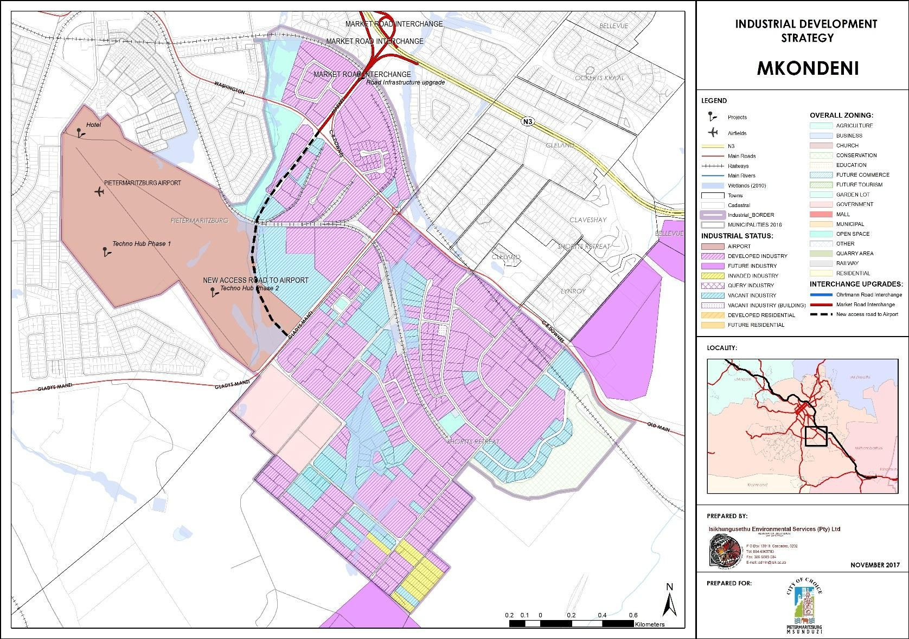

Figure 30: Edendale Industrial Area
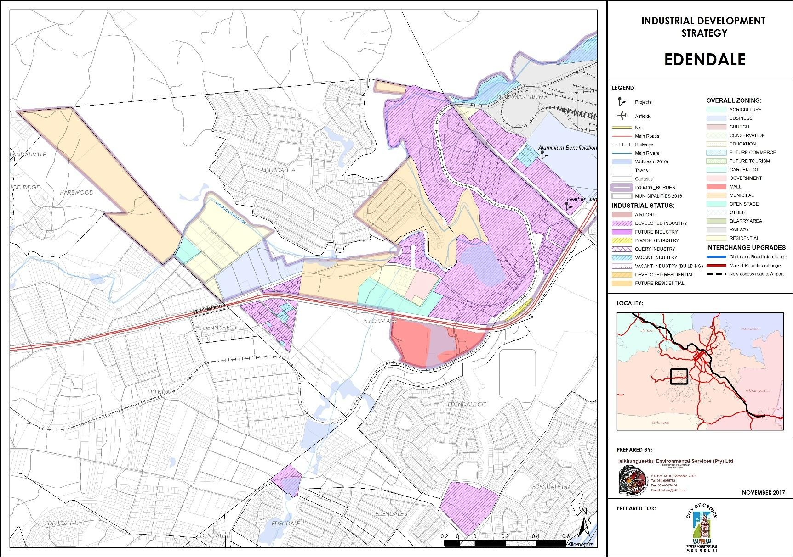

Figure 31: Masons Mill Industrial Area
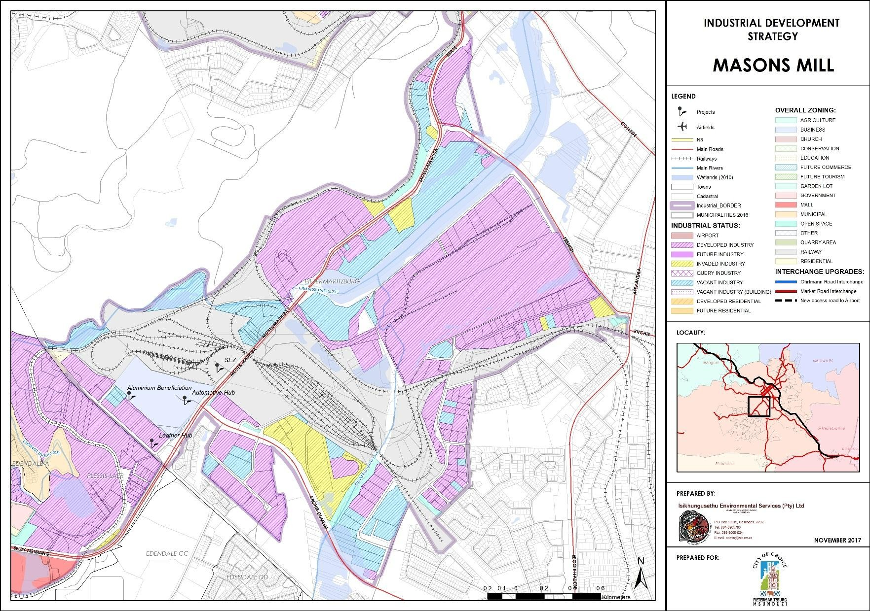

Figure 32: Industrial areas in the CBD
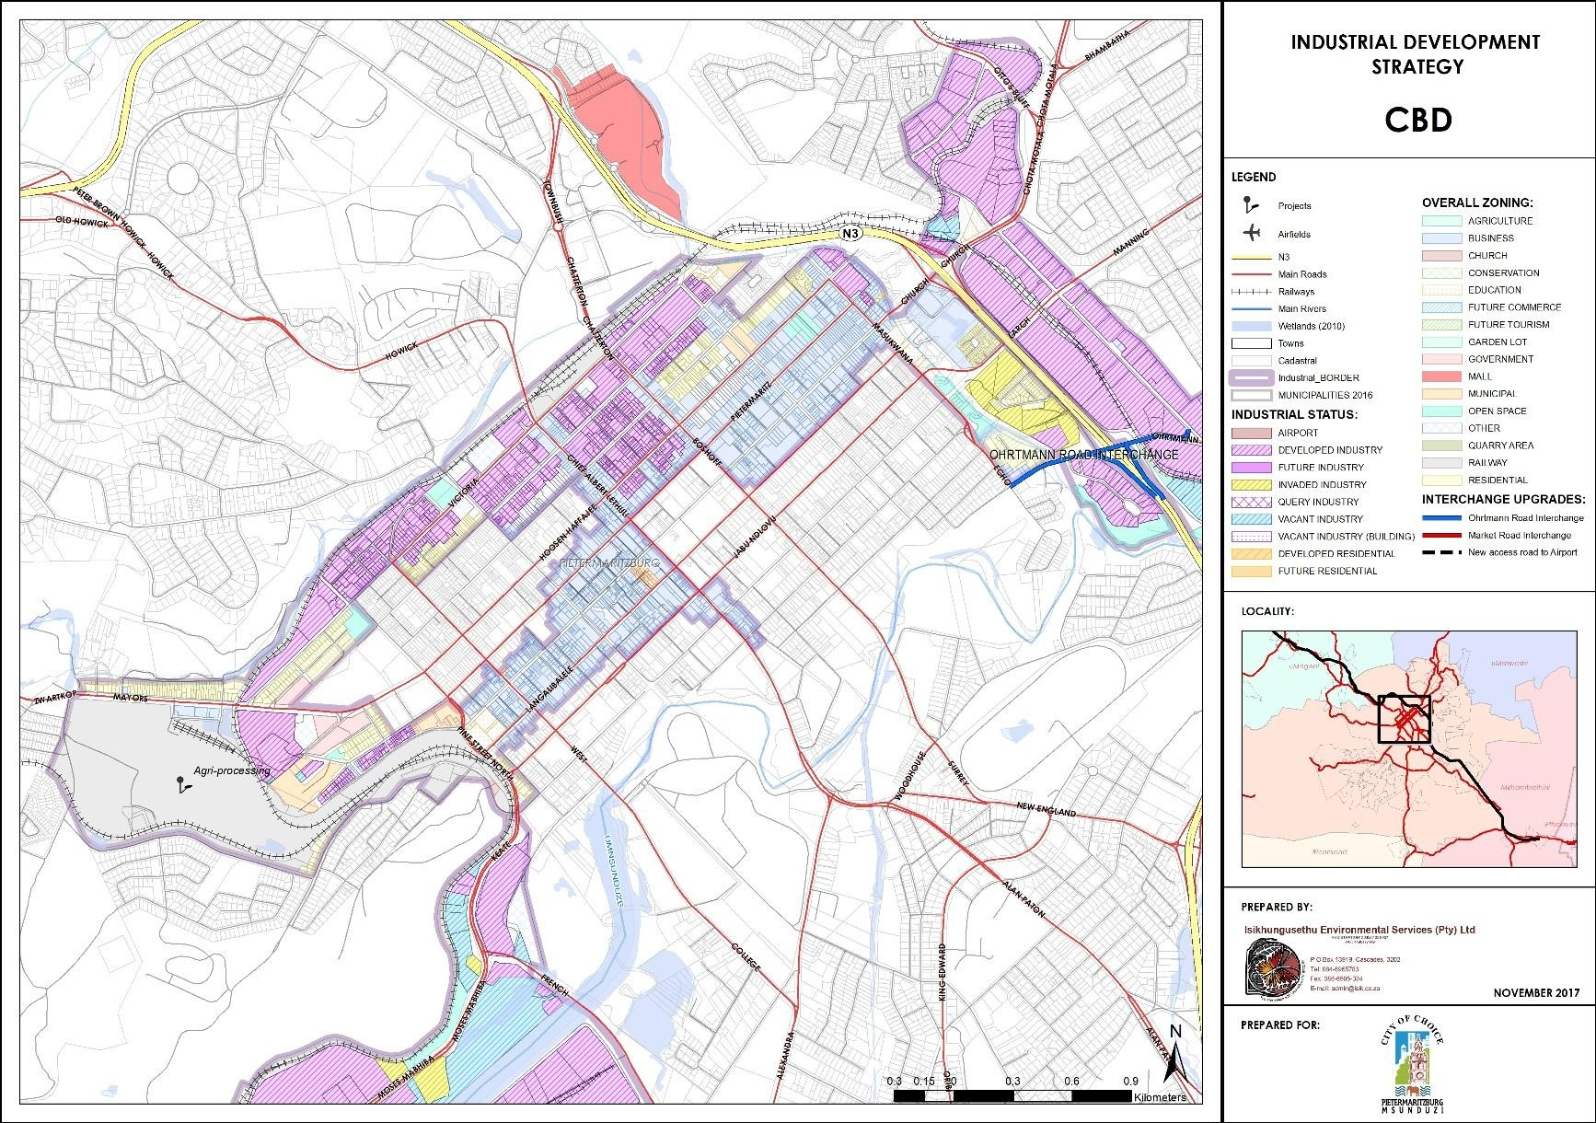

Figure 33: Industrial zoning in the Northern Area
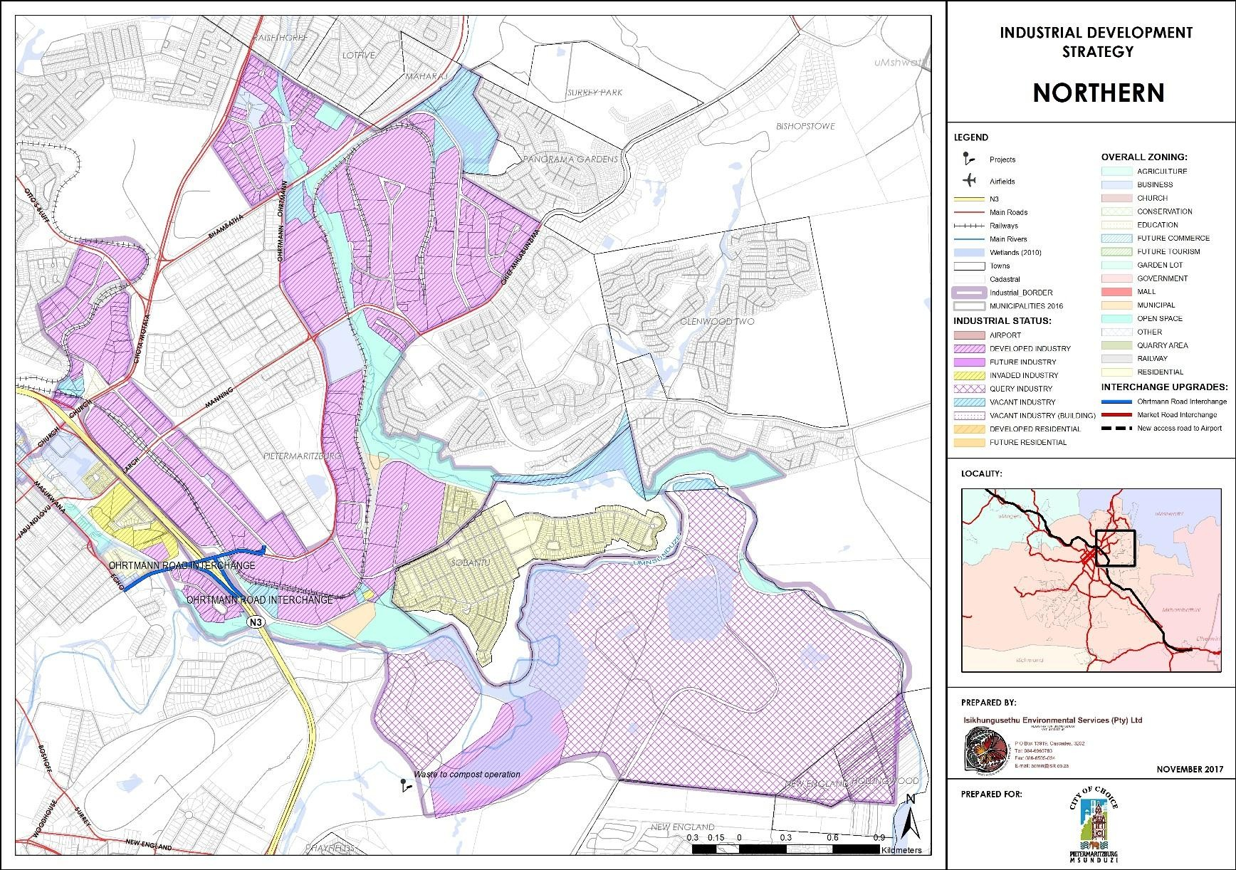

Figure 34: Msunduzi - Industrial land ownership
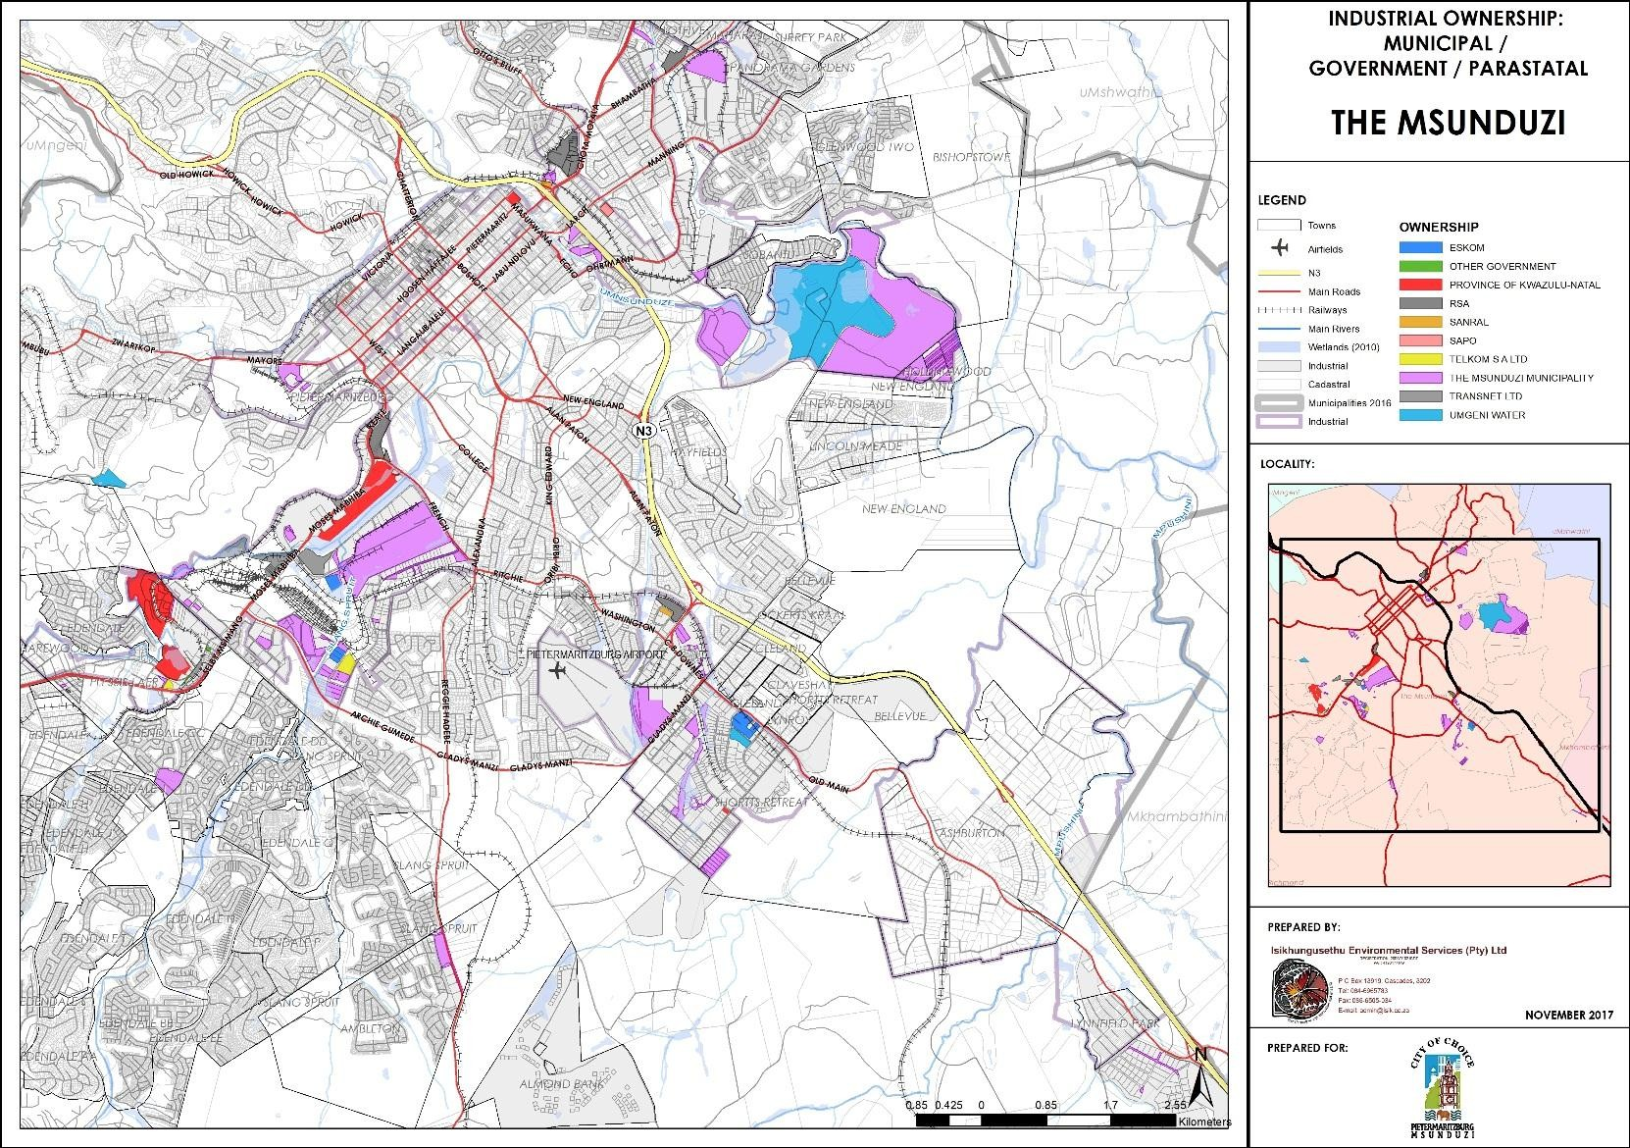

ANNEXURE B

ANNEXURE B: AIRPORT PRECINCT AND TECHNO HUB IMPLEMENTATION SCHEDULE

Table 17: Airport Precinct and Techno Hub Implementation Schedule

Project name | Project Description | Source of funding | Phase 1 | Phase 2 | Phase 3 | Total
 |  |  | 2017 - 2022 | 2023 - 2028 | 2029+
Airport Infrastructure
New Airport Access Loop Road off Washington Road | New Airport Terminal Access loop road off Washington Road opposite Pilot Road in Scottsville Extension to improve direct access to the Airport. | Provincial |  | 42 000 000 |  | 42 000 000
Expansion of Landside Infrastructure | New parking and entrance access roads off the proposed new Airport Access Loop Road | Provincial | 15 000 000 |  |  | 15 000 000
Sub-total |  |  | 15 000 000 | 42 000 000 |  | 57 000 000
Regional Road Infrastructure
Market Road Ext through to Gladys Mansi | Extension of Market Road across the obsolete railway servitude through to Gladys Mansi Road to improve access to the N3 form the precinct and to improve access to the Airport. This portion of Road to be designed to operate independently of the connection with the proposed new Airport access loop road off Washington Road but also to be able to work as a cohesive system when the two roads are constructed. | Municipal & Provincial |  | 21 000 000 |  | 21 000 000
Market Road Interchange Upgrade | Upgrade of the existing interchange to provide improved access to the N3 for the Airport as well as for the precinct as a whole and including the Mkondeni and Short Retreat Industrial areas. | SANRAL |  | 500 000 000 |  | 500 000 000
Sub-total |  |  |  | 521 000 000 |  | 521 000 000
City Transportation Infrastructure
First Phase IRPTN Route Oribi Road | As per IRPTN proposals | Municipal | 2 000 000 |  |  | 2 000 000
Phase 3 IRPTN Route Washington / Gladys Mansi | As per IRPTN proposals | Municipal | 4 000 000 |  |  | 4 000 000
Washington Road | Upgrade capacity on Washington Road between Gladys Manzi and Market Roads | Municipal | 11 200 000 |  |  | 11 200 000
CB Downes / Gladys Manzi Intersection | Upgrade capacity of signalised intersection of Washington / Gladys Manzi Roads | Municipal | 5 000 000 |  |  | 5 000 000
Washington / Oribi intersection | Upgrade capacity of signalised intersection of Washington / Oribi Roads | Municipal |  | 5 000 000 |  | 5 000 000

Project name | Project Description | Source of funding | Phase 1 | Phase 2 | Phase 3 | Total
 |  |  | 2017 - 2022 | 2023 - 2028 | 2029+
Oribi / Powell intersection | Install signalised intersection to Techno Hub | Municipal |  | 3 000 000 |  | 3 000 000
Oribi / Stubbs intersection | Install signalised intersection to Techno Hub | Municipal |  | 3 000 000 |  | 3 000 000
Oribi / Pharazyn intersection | Install signals | Municipal |  | 2 000 000 |  | 2 000 000
Sub-total |  |  | 22 200 000 | 13 000 000 |  | 35 200 000
Local Infrastructure
Pharazyn Road Extension | Extension of Pharazyn Road to connect with Andries Pretorius Road to improve accessibility to the precinct from the west and to service the vacant portion of land between the Bisley Primary School and Bisley residential area. | Municipal |  | 6 300 000 |  | 6 300 000
Phase One Techno Hub Infrastructure | Consists of establishing a first phase of serviced land to take to the market place | Provincial | 20 000 000 |  |  | 20 000 000
Phase Two Techno Hub Infrastructure | Consists of establishing a second phase of serviced land to take to the market place | Municipal |  |  | 200 000  000 | 200 000 000
Sub-total |  |  | 20000000 | 6 300 000 | 200 000  000 | 226 300 000
Water / Sanitation / Stormwater / Energy /
ICT Infrastructure
Additional Reservoir Capacity at Bisley | Upgrading of existing Bisley Reservoir | Municipal and Private |  |  | 22 000 000 | 22 000 000
Additional Water Pipeline | Additional capacity form upgraded Bisley Reservoir to Precinct | Municipal and Private |  |  | 5 250 000 | 5 250 000
Relocation of Existing Water Mains around the Airport | Relocation of existing water mains around the Airport Sub Precinct | Municipal and Private |  | 7 000 000 |  | 7 000 000
Connection to Blackborough Interceptor Sewer | Connection of proposed new industrial development in Mkondeni into Blackborough interceptor sewer | Municipal and Private |  | 1 000 000 |  | 1 000 000
Connection to Foxhill Interceptor Sewer | Connection of proposed new Techno Hub into Foxhill interceptor sewer | Municipal and Private |  | 1 000 000 |  | 1 000 000
Storm Water Master Plan | Storm Water Management Master Plan based on sustainable practices should be prepared which identifies and articulates the requirements for the macro and micro systems that need to be constructed within the Precinct | Municipal | 1 000 000 |  |  | 1 000 000

Project name | Project Description | Source of funding | Phase 1 | Phase 2 | Phase 3 | Total
2017 - 2022 |  |  |  | 2023 - 2028 | 2029+
Energy Master Plan | Energy supply and management Master Plan to identify and plan for alternative green energy systems that can support the conventional energy supply system within the Precinct | Municipal | 1 000 000 |  |  | 1 000 000
ICT Strategy Plan | An ICT strategy for the Precinct which integrates Municipality’s current endeavours and policy development. | Municipal | 1 000 000 |  |  | 1 000 000
Sub-total |  |  | 3 000 000 | 9000000 | 27 250 000 | 39 250 000
Regulatory improvements
Rezonings | Ad-hoc rezoning of properties to enable or incentivise development | Municipal | 500 000 | 500 000 |  | 1 000 000
“Special Zone” for the Techno Hub Precinct | Rezone Techno Hub properties to enable or incentivise development | Municipal | 1 000 000 |  |  | 1 000 000
Sub-total |  |  | 1 500 000 | 500 000 |  | 2 000 000
Operation and Management
CID Mkondeni | Establishment of a City Improvement District to improve the management and operation of the Industrial district | Municipal and Private | 1 000 000 | 1 000 000 | 1 000 000 | 3 000 000
Techno Hub Sub Precinct | Establishment of an area based agency to ensure the management and operation of the Techno Hub Sub Precinct | Municipal and Private | 1 000 000 | 1 000 000 | 1 000 000 | 3 000 000
Sub-total |  |  | 2 000 000 | 2 000 000 | 2 000 000 | 6 000 000
Tehno Hub development
Phase One | Consists of developing the research zone, student zone, testing and development zones, engineering and data zones, business support and start-up zones, single tenanted buildings, the convention, life and body zones as well as some landscaping. | Private |  | 100 000 000 |  | 100 000 000
Phase Two | Consists of the development of the single and multi – tenanted buildings, remainder of parking and landscaping. | Private |  |  | 100 000  000 | 100 000 000
Sub-total |  |  |  | 100 000 000 | 100 000  000 | 200 000 000

Project name | Project Description | Source of funding | Phase 1 | Phase 2 | Phase 3 | Total
 |  |  | 2017 - 2022 | 2023 - 2028 | 2029+
Industrial Development
Gladys Manzi Estate | stablish new sustainable industrial estate off Gladys Mansi and Market Road Extension as a pilot within the Municipality to be developed according to best practice “green “principles | Private |  |  | 150 000  000 | 150 000 000
Infill on Vacant Lots | Promote the development of infill sites within Mkondeni Estate | Private |  |  | 50 000 | 50 000
Sub-total |  |  |  |  | 150 050  000 | 150 050 000
Airport development
Terminal Building Upgrade | Proposal and costs as per Airport Master Plan 2014 | Mixed |  |  | 110 000  000 | 110 000 000
New Hangar Buildings | New Hangers (20 000m 2 ) for General Aviation requirements to increase capacity for accommodating this industry and to be located in accordance with the Airport Master plan | Private | 20 000 000 | 40 000 000 |  | 60 000 000
Sub-total |  |  | 20 000 000 | 40 000 000 | 110 000  000 | 170 000 000
Grand Total |  |  | 82 200 000 | 733 300 000 | 439 250  000 | 1 254 750 000
Source: Adapted from Msunduzi Municipality, 2016. Airport Precinct Plan: Final Report Airport Precinct and Management Plan for the Pietermaritzburg Airport and surrounds. Prepared by The Markewicz Redman Partnership in association with Royal HaskoningDHV (Pty) Ltd and Glen Robbins, p 59, 61 – 62, 64, 66 – 67, 69, 71, 73 & 75.

ANNEXURE C

ANNEXURE C: PROJECT PRIORITISATION TABLES

The tables below are shown in three parts:
Annexure C.1: Assignment of priorities to each project
This sets out, in one continuous table, the priorities which were assigned to each of the projects derived from the strategy tables. This was then entered into the model which then calculated an overall value based on the weighting given to each factor. (See table below which provides the basis of the model).
Annexure C2: Results
This set of tables gives the results of the prioritisation in terms of the model per key strategy area: Spatial and land, Infrastructure, catalytic projects, industrial sectors, environmental and social; and institutional. In this table, the projects are kept in the same order as in the strategy tables and therefore the same order as Annex C1. The details of the prioritisation remain in the columns: contribution to strategy, time period, job creation, financial requirements and implementation risk.
Annexure C3: Ranked projects
This set of tables tanks the projects per key strategy area: Spatial and land, Infrastructure, catalytic projects, industrial sectors, environmental and social; and institutional. The detail of the prioritisation has been removed so the tables just give the ranking, project number, project description and the value that was calculated in terms of the model.

The basis of the model:

 |  | Benefits |  |  | Complexity
 |  | Contribution to Strategy | Implementation period | Job creation | Financial requirements | Implementation risks
Weight |  | 25% | 25% | 15% | 25% | 10%
Point Allocation | 1 | Low contribution to Strategy | > 5 Years | Low contribution | > R 5 million | High implementation risks
 | 2 | Medium contribution to Strategy | 3 to 5 Years | Medium contribution | R 2 to 4 million | Medium implementation risks
 | 3 | High contribution to Strategy | 1 to 2 Years | High contribution | R 1 to 2 million | Low implementation risks
 | 4 | Critical contribution to Strategy | > 1 Year | Very High Contribution | <R 1 million | Insignificant implementation risks

ANNEXURE C1: ASSIGNMENT OF PRIORITIES

Project Prioritisation tables: The project prioritisation model used is from PMOGuru: http://www.pmoguru.com/project-prioritisation-prioritise-projects/

 | GOAL | # | PROJECTS | Contribution to strategy | Implementation period | Job creation | Financial requirements | Implementation risks
1 | To ensure that there is sufficient land for industrial growth in Msunduzi in the short- medium and long term | 1.0 | To ensure that there is sufficient land for industrial growth in Msunduzi in the short- medium and long term | 4 | 2 | 1 | 4 | 4
1 | Land release for industrial development | 1.1 | Short term release of 60.7 ha of land | 4 | 4 | 1 | 4 | 4
1 | Land release for industrial development | 1.2 | Identification, preparation, servicing and zoning of additional municipal land suited to  industry aligned to industry needs | 4 | 3 | 1 | 4 | 3
1 | Land release for industrial development | 1.3 | Identify subsequent land parcels to make up the remainder of the land identified in the SDF as required for industry in the medium to long term (the recommendation is 50ha per year – although current growth is about 5 to 7 ha a  year) | 4 | 2 | 1 | 4 | 4
1 | Zone land appropriately for industrial land use | 1.4 | Amend the current Town Planning Scheme to reflect the new integrated zones proposed in the SDF, namely: Industrial zone (cumulative industrial zone); Logistics and business parks ; Agri-business and commercial | 4 | 4 | 1 | 4 | 4
1 | Resolve issue of currently zoned industrial land which is not being used for industrial purposes | 1.5 | Investigate why some already zoned industrial land is not being used; this includes land which has been invaded or is vacant | 3 | 4 | 1 | 4 | 4
1 | Resolve issue of currently zoned industrial land which is not being used for industrial purposes | 1.6 | Determine strategy, with relevant municipal departments, for resolving the freeing up of industrial land where it has been invaded, particularly if it has good potential for industry, and/or may present problems to communities due to industrial impacts (pollution, noise, heavy traffic, poor access to schools etc) | 3 | 2 | 1 | 2 | 2

 | GOAL | # | PROJECTS | Contribution to strategy | Implementation period | Job creation | Financial requirements | Implementation risks
1 | Resolve issue of currently zoned industrial land which is not being used for industrial purposes | 1.7 | Rezone land which is vacant because it has no attraction for industry and seek alternatives elsewhere | 3 | 4 | 1 | 4 | 4
1 | Identify possible land for industrial parks / SEZ / industrial Hubs | 1.8 | Ibhubesi Light Industrial Park: promote the park so reach full capacity ito sale of land | 4 | 4 | 2 | 3 | 3
1 | Identify possible land for industrial parks / SEZ / industrial Hubs | 1.9 | Business and industrial development opportunities along the R56 logistics corridor need to be encouraged and properly zoned as  per the 2015 SDF | 4 | 3 | 1 | 4 | 4
2 | Ensure that there is sufficient capacity in terms of bulk infrastructure to meet both current and future demands: energy, water, road access, waste removal | 2.0 | Ensure that there is sufficient capacity in terms of bulk infrastructure to meet both current and future demands: energy, water, road access, waste removal Overall goal | 4 | 2 | 4 | 1 | 2
2 | Stabilise and secure energy supply | 2.1 | To ensure retention of existing industries and capacity to attract new industry undertake the following: electrical infrastructure upgrade; Resolve staffing and capacity issues in the electricity department to ensure sufficient capacity to manage and operate electricity grid; Ensure appropriate maintenance and repair on electrical facilities and networks – sub-stations etc | 4 | 3 | 2 | 1 | 2
2 | Stabilise and secure energy supply | 2.2 | Where possible, partner with industry to ensure key electrical installations are maintained and updated | 4 | 3 | 2 | 1 | 2
2 | Secure water supply: ensure sufficient water storage for existing and potential industrial bulk water users | 2.3 | Determine water demands in order to liaise with DWAS re securing sufficient water supply for current and future needs (dams); Ensure City has sufficient storage capacity (water towers and bulk reticulation); Protection of water sources through planning and environmental controls – from pollutant sources; Non-revenue water reduction projects: ensure regular monitoring and  maintenance prevents water loss | 4 | 4 | 4 | 1 | 3

 | GOAL | # | PROJECTS | Contribution to strategy | Implementation period | Job creation | Financial requirements | Implementation risks
2 | Implementation of Urban Network Strategy | 2.4 | Upgrading of routes – rail and road, to ensure that proposed corridor linkages in the Urban Network Strategy are maintained and can meet transport demand | 3 | 2 | 4 | 1 | 3
2 | Pietermaritzburg bypass route to be decided and put into planning phase | 2.5 | Liaise with SANRAL regarding expediting decision on location of by-pass route (following due EIA process). Establish a standing forum to meet every quarter as well  to monitor progress and address obstacles | 3 | 4 | 1 | 4 | 4
2 | Upgrade of entry routes into Pmb | 2.6 | Central: upgrade of the existing interchanges; | 2 | 1 | 4 | 1 | 2
2 | Upgrade of entry routes into Pmb | 2.7 | Northeast: upgraded of the Northdale / Greytown Road, plus additional access to the Willowton industrial area; | 3 | 1 | 4 | 1 | 2
2 | Upgrade of entry routes into Pmb | 2.8 | Southwest: upgrade of the Richmond Road and Edendale Road, plus additional access to Mason’s Mill area further extend the small industrial node of Thornville | 3 | 1 | 4 | 1 | 2
2 | Upgrade of entry routes into Pmb | 2.9 | The current N3 can then turn into a Metropolitan trunk road, with higher local capacity, collecting traffic and bring this to the N3 at Umlaas Road and near Howick respectively. | 2 | 1 | 3 | 1 | 2
2 | Upgrade of entry routes into Pmb | 2.10 | Funding is to be secured to improve the road connection between the N3 (Market Road) and the Airport, and further towards the Mason’s Mill area, in unison with N3 market road interchange upgrade by SANRAL..  Progress to be reported to Council on a  quarterly basis. | 4 | 2 | 2 | 1 | 2
2 | Solid waste / landfill upgrade | 2.11 | Continued support of current initiative to investigate green energy options at landfill site | 3 | 2 | 1 | 2 | 2

 | GOAL | # | PROJECTS | Contribution to strategy | Implementation period | Job creation | Financial requirements | Implementation risks
2 | Stormwater upgrades | 2.12 | This is critical in order to be able to cope with the likelihood of increasing, and higher intensity storm events due to climate change, as well as to prevent damage to road infrastructure through inadequate stormwater management. | 4 | 3 | 3 | 1 | 2
2 | Technology Hub Infrastructure (IDP capital projects) | 2.13 | Upgrade of infrastructure to facilitate Technology Hub as per the Airport Precinct Plan | 3 | 3 | 4 | 1 | 2
3 | Implement catalytic projects that are currently planned or, if in the process of being implemented, monitor progress | 3.0 | Implement catalytic projects that are currently planned or, if in the process of being implemented, monitor progress | 4 | 2 | 4 | 1 | 3
3 | Launch the Agricultural and logistics platform | 3.1 | Development of logistics platform (packaging, loading, transport) (envisioned) | 3 | 2 | 3 | 2 | 2
3 | Launch the Agricultural and logistics  platform | 3.2 | Dedicated large scale truck stops (envisioned) | 3 | 2 | 3 | 2 | 2
3 | Launch the Agricultural and logistics platform | 3.3 | High speed train between Durban and Johannesburg (planned) | 2 | 1 | 4 | 1 | 2
3 | Launch the Agricultural and logistics platform | 3.4 | Further expansion of Pietermaritzburg airport (planned) | 3 | 2 | 3 | 1 | 2
3 | Expedite the proposed N3 upgrades | 3.5 | Actively support and encourage the 8 interchanges related to the City from the N3 – liaise with SANRAL, provide input and monitor progress. Secure funding from National Agencies for the upgrade of roads linking to the new intersection, based on a municipal  priority model | 4 | 4 | 1 | 4 | 4
3 | Expedite the proposed N3 upgrades | 3.6 | The SIP 2 corridor plans must be integrated into the Municipal IDP and Precinct Plan with  detailed implementation plans | 4 | 2 | 1 | 2 | 3

 | GOAL | # | PROJECTS | Contribution to strategy | Implementation period | Job creation | Financial requirements | Implementation risks
3 | Develop the Airport Precinct and Techno- Hub | 3.7 | Airport precinct and Management Plan: continue with planning and implementation. Refer to implementation table under section 7 for further details which are set out under the following headings: Airport infrastructure; Regional road infrastructure; City transportation infrastructure; Local infrastructure; Water/sanitation/stormwater/energy / ICT infrastructure; Regulatory improvements; Operation and management issues – e.g. a City Improvement District; Techno Hub- development; Airport development | 4 | 1 | 4 | 1 | 2
3 | Upgrade of the Oribi Airport as part of the Airport Precinct development | 3.8 | Improving and extending scheduled passenger parking, hangers, fuel storage, car hire and improved retail (5 to 10 years). To be followed by runway enhancement and core aviation services. | 4 | 1 | 4 | 1 | 3
3 | Development of Phase 1 of the Techno Hub: Infrastructure and Aeronautical excellence phase development in joint curriculum programme with DUT | 3.9 | Access from the N3, via the Market Road intersection, bulk service extension and upgrading, phase 1 of the Industrial Hub internal infrastructure development and construction of Phase 1 development (5 to 10 years). Link with Msunduzi ICT plan. This phase is to consist of a research zone, student zone, testing and development zones, data zones, business support and start-up zones and convention centre. | 4 | 1 | 4 | 1 | 2
3 | Development of Phase 1 of the Techno Hub: Infrastructure and Aeronautical excellence phase development in joint curriculum programme with DUT | 3.10 | Improving bulk services and associated infrastructure. Development of single and multi-tenanted buildings, the remainder of the parking and landscaping. | 4 | 1 | 4 | 1 | 3
3 | Develop the mixed use industrial zone between the N3 and the R56 | 3.11 | Develop mixed use industrial zone along the new industrial extension along Gladys Manzi  Road with logistical ties to both airport and N3 | 4 | 2 | 1 | 3 | 3
3 | Launch the ICT Hub and Smart City concept | 3.12 | Appointment of service provider for 5 year programme to implement the ICT Hub and Msunduzi Smart City requirements | 4 | 2 | 3 | 1 | 2

 | GOAL | # | PROJECTS | Contribution to strategy | Implementation period | Job creation | Financial requirements | Implementation risks
3 | Launch the ICT Hub and Smart City concept | 3.13 | Develop a fibre optic cable network for the City – communications upgrade | 3 | 2 | 3 | 1 | 2
3 | Launch the ICT Hub and Smart City concept | 3.14 | Assess the efforts of other cities to establish Smart Cities and bring back lessons learned | 3 | 3 | 1 | 4 | 3
3 | Launch the ICT Hub and Smart City concept | 3.15 | Identify specific industrial park(s) or new areas for a Hub - Msunduzi can assist in this process through partnerships with ICT providers and ensuring a dedicated programme to facilitate and fast track ICT provision by streamlining approval and implementation processes under its control. | 4 | 3 | 1 | 4 | 3
3 | Launch the ICT Hub and Smart City concept | 3.16 | Encourage, support and expand the development of broadband connectivity as per the related projects in the IDP | 3 | 2 | 1 | 4 | 3
3 | Launch the ICT Hub and Smart City concept | 3.17 | Investigate the use of existing municipal infrastructure (e.g. communication poles) or municipal servitudes for the provision of additional wireless networks by external providers and draw up service agreements with those providers in order to reduce authorisation times | 3 | 2 | 1 | 3 | 3
3 | Launch the ICT Hub and Smart City concept | 3.18 | Assess the benefit to the municipality’s own internal communication and processes with improved city-wide ICT | 3 | 3 | 1 | 3 | 3
3 | Launch the ICT Hub and Smart City concept | 3.19 | Link upgrading the ICT network through the Hub to increased preventative / public security systems – assisting in improving investor confidence (Safe City initiative) | 4 | 3 | 2 | 1 | 2
3 | Launch the ICT Hub and Smart City concept | 3.20 | The systematic development of improved ICT infrastructure provides an opportunity for the establishment of associated ICT industries in itself. | 3 | 3 | 1 | 3 | 2

 | GOAL | # | PROJECTS | Contribution to strategy | Implementation period | Job creation | Financial requirements | Implementation risks
3 | Launch the ICT Hub and Smart City concept | 3.21 | Link this ICT Hub initiative to education and providing ICT services to the developmental sectors of a disadvantaged community such learners, community organizations, job seekers, micro to small business, etc. (e.g. youth development and capacity building through municipal funding programmes) | 3 | 3 | 1 | 3 | 3
3 | Integrated Rapid Public Transport Network  – implement | 3.22 | Continue with the implementation of the IRPTN | 3 | 2 | 3 | 1 | 3
3 | Integrated Rapid Public Transport Network  – implement | 3.23 | Monitor progress on the IRPTN project; IRPTN important to enable staff for industries to travel between work and home efficiently and at reasonable cost | 4 | 4 | 1 | 4 | 4
3 | SIP2 Durban-Free State-Gauteng Logistics and industrial Corridor | 3.24 | Integrate the currently disconnected industrial and logistics activities as well as marginalised rural production centres surrounding the corridor that are currently isolated from the main logistics system | 4 | 3 | 2 | 4 | 4
3 | SIP2 Durban-Free State-Gauteng Logistics and industrial Corridor | 3.25 | Create capacity ahead of demand | 4 | 3 | 2 | 4 | 3
3 | SIP2 Durban-Free State-Gauteng Logistics and industrial Corridor | 3.26 | Create better access to the corridor | 4 | 2 | 1 | 1 | 2
3 | SIP2 Durban-Free State-Gauteng Logistics and industrial Corridor | 3.27 | Develop a programme to align stakeholders behind a common plan for the corridor | 4 | 3 | 1 | 4 | 4
3 | SIP2 Durban-Free State-Gauteng Logistics and industrial Corridor | 3.28 | Accelerate and synchronise infrastructure rollout associated with the corridor. This ties in with the alignment of stakeholders behind a common plan for the corridor, effectively recommending an implementation strategy for  that plan | 4 | 3 | 1 | 3 | 4
3 | SIP2 Durban-Free State-Gauteng Logistics and industrial Corridor | 3.29 | Focus on upgrading and developing the main industrial areas linked to the SIP2 corridor: Mkondeni, Willowton, Pentrich and Masons Mill. | 4 | 3 | 1 | 1 | 3
4 | Provide support to industrial sectors | 4.0 | Provide support to industrial sectors | 4 | 4 | 1 | 2 | 4

 | GOAL | # | PROJECTS | Contribution to strategy | Implementation period | Job creation | Financial requirements | Implementation risks
4 | Retention of existing industries | 4.1 | Upgrade of operating environment in industrial areas (streets, street cleaning, aesthetics): Have Urban Management Zone teams across security, street cleaning, looking after the roads and fixing potholes; Report bad buildings, by-law contraventions, land use issues, ageing infrastructure such as bursting of old pipes, shortage of electricity to the municipality | 4 | 2 | 2 | 1 | 2
4 | Retention of existing industries | 4.2 | Strengthening of Urban Management Zone within industrial areas | 4 | 2 | 1 | 2 | 3
4 | Retention of existing industries | 4.3 | Have urban management teams reporting on a quarterly basis to an Industrial Area Clusters about progress. | 4 | 3 | 1 | 3 | 3
4 | Retention of existing industries | 4.4 | Install CCTV cameras for additional security in industrial areas | 3 | 2 | 2 | 1 | 2
4 | Retention of existing industries | 4.5 | Review incentives provided for new entrants vs existing industries and ensure that the incentives policy are fair to both | 4 | 4 | 1 | 4 | 4
4 | Promotion / attraction of new entrants into the industrial sector | 4.6 | Implement the 2017 incentives policy of the municipality (once approved by Council) to ensure that the incentives are fair to both existing industries as well as new entrants. The policy lists: Industrial incentives; Broadening participation incentives; Technology and human resources for industry; Trade, export and investment incentives | 4 | 4 | 3 | 4 | 4
4 | Promotion / attraction of new entrants into the industrial sector | 4.7 | Develop a business aftercare programme for new and existing businesses that have been established for less than 3 years | 4 | 4 | 2 | 4 | 4
4 | Provide support to the proposed Leather Hub | 4.8 | Secure sites in Edendale for the proposed Leather Hub | 4 | 4 | 2 | 4 | 4

 | GOAL | # | PROJECTS | Contribution to strategy | Implementation period | Job creation | Financial requirements | Implementation risks
4 | Provide support to the proposed Leather Hub | 4.9 | Municipality to become part of the existing liaison between EDTEA, DTI and IDC and the leather cluster industries so that they have better understanding of the industry and its requirements in terms of municipal services and support | 4 | 4 | 1 | 4 | 4
4 | Provide support to the proposed Leather Hub | 4.10 | Municipality to assist in liaising with the Department of Agriculture over support to small farmers regarding their livestock and the storing and transport of hides for processing | 4 | 3 | 2 | 3 | 4
4 | Provide support to the proposed Leather Hub | 4.11 | Where the LED section has funding for apprenticeships or youth study grants, encourage them to consider a career in the agricultural / leather / shoe-making and high- end leather goods sector. | 3 | 3 | 1 | 4 | 4
4 | Provide support to the aluminium industry | 4.12 | Liaise with the Aluminium Beneficiation Initiative (Hulamin and South32) to determine where it may be possible for the municipality to assist with their industrial growth plans and identify specific interventions that the municipality or other government agencies may assist with | 4 | 4 | 3 | 4 | 4
4 | Provide support to the aluminium industry | 4.13 | Consider establishment of an SEZ with a focus on the aluminium / metal industry – this may be in the form of designating a physical SEZ, or a virtual SEZ. Work with EDTEA and /or DTI on this initiative | 4 | 3 | 3 | 3 | 4
4 | Provide support to the aluminium industry | 4.14 | Aluminium/metal industry agglomeration to be marketed and be linked to existing Dube Tradeport SEZ as it is not far from King Shaka Airport | 4 | 3 | 2 | 3 | 4
4 | Provide support to the aluminium industry | 4.15 | Provide marketing support to the ABI initiative through the municipal / Chamber advertising and marketing initiatives. | 4 | 3 | 2 | 3 | 4

 | GOAL | # | PROJECTS | Contribution to strategy | Implementation period | Job creation | Financial requirements | Implementation risks
4 | Provide support to the aluminium industry | 4.16 | Explore possibility of bringing in natural gas as an energy source to the City, particularly for the aluminium industry as Hulamin have been considering this as an alternative energy source for part of their needs. | 4 | 2 | 3 | 1 | 2
4 | Provide support to the aluminium industry | 4.17 | Linking to the above point: continue engagements with Transnet on the alternative use of the old Durban-Johannesburg Pipeline (DJP) to transport natural gas to the City. A Feasibility study was initiated by Hulamin and PMB Chamber of Business. | 4 | 2 | 2 | 1 | 3
4 | Provide support to the Automotive Hub | 4.18 | Locate suitable land for an automotive service hub, in consultation with the industry representatives and/or the Chamber – preferably in the Masons Mill area | 4 | 4 | 3 | 1 | 3
4 | Provide support to the Automotive Hub | 4.19 | Liaise with EDTEA to expedite the development of an automotive hub in terms of land / location | 4 | 4 | 1 | 4 | 4
4 | Provide support to the Automotive Hub | 4.20 | Provide support to youth through municipal capacity building programmes to train them in the automotive industry | 3 | 3 | 3 | 4 | 4
4 | Provide support to the Automotive Hub | 4.21 | Municipality, in conjunction with the Chamber, to assist in marketing the proposed Hub to the automotive industry | 4 | 4 | 3 | 4 | 4
4 | Provide support to the Automotive Hub | 4.22 | Liaise with metal and other recycling plants to link into the automotive service hub | 3 | 3 | 2 | 3 | 3
4 | Agri –industry / processing development | 4.23 | Review the forward and backward linkages and determine all areas for possible beneficiation or value-add that can be viably developed in Msunduzi; liaise with ADA and KZN Dept of Agric as well as Chamber to market these potential linkages | 1 | 3 | 2 | 4 | 4

 | GOAL | # | PROJECTS | Contribution to strategy | Implementation period | Job creation | Financial requirements | Implementation risks
4 | Agri –industry / processing development | 4.24 | Establish a programme of social engagement with the surrounding rural communities to determine what they need and the extent to which they can contribute ideas to, or are interested in ideas around the increase in agricultural production and beneficiation in the area. This should be done in conjunction with eh Agricultural Development Agency (ADA) | 3 | 3 | 3 | 4 | 4
4 | Agri –industry / processing development | 4.25 | Promote Climate Smart Agriculture in conjunction with the Department and the ADA as a critical component to reducing the carbon footprint of the production of agricultural goods | 3 | 2 | 3 | 4 | 4
4 | Agri –industry / processing development | 4.26 | Draw up information booklet on agricultural opportunities and agric-related application processes in conjunction with the ADA | 3 | 3 | 2 | 4 | 4
4 | Agri –industry / processing development | 4.27 | Development of an agri-processing plant at Mkondeni Market (revival of previous youth project) | 3 | 3 | 2 | 3 | 3
4 | Agri –industry / processing development | 4.28 | Protection of high potential land from urban, peri-urban and rural settlement sprawl to secure sufficient land for agricultural enterprises that can feed into agri-processing industries in the City | 2 | 2 | 1 | 3 | 3
4 | Agri –industry / processing development | 4.29 | Explore aquaculture opportunities - revival of project at the old Blackridge Reservoir. Liaise with EDTEA over this project | 4 | 3 | 2 | 3 | 3
4 | Agri –industry / processing development | 4.30 | Assess potential for hydroponics | 4 | 3 | 2 | 3 | 3
4 | Agri –industry / processing development | 4.31 | Continue current exploration of making compost from garden waste delivered to garden waste depots and the landfill site | 2 | 2 | 2 | 3 | 3
4 | Agri –industry / processing development | 4.32 | Explore possibility of establishing a feedlot and abattoir | 2 | 2 | 2 | 2 | 3

 | GOAL | # | PROJECTS | Contribution to strategy | Implementation period | Job creation | Financial requirements | Implementation risks
4 | Agri –industry / processing development | 4.33 | Explore alternative for energy production from agricultural products - Biofuels | 2 | 2 | 2 | 1 | 3
4 | Establish manufacturing hives for emerging and small-scale manufacturers in Msunduzi | 4.34 | Identify land for hives | 2 | 3 | 2 | 3 | 3
4 | Establish manufacturing hives for emerging and small-scale manufacturers in Msunduzi | 4.35 | Establish hive (buildings, infrastructure) | 2 | 3 | 2 | 3 | 3
4 | Establish manufacturing hives for emerging and small-scale manufacturers in Msunduzi | 4.36 | Identify and promote opportunities for SMMES in existing manufacturing activities | 3 | 3 | 2 | 2 | 4
4 | Establish manufacturing hives for emerging and small-scale manufacturers in Msunduzi | 4.37 | Potential projects including making use of abandoned buildings, refurbishing them and working with youth on refurbishment as well as potential SMME occupancy | 3 | 3 | 1 | 2 | 3
4 | Forestry and timber industry to be enhanced | 4.38 | Explore opportunities in the following sectors: Biofuels from the high volumes of waste in plantations and sawmills; Dissolving pulp industry – a green alternative to non- renewables. This is a key programme in the IPAP.; Furniture production – from exotic plantation and use of timber from clearing invasive trees (e.g. water hyacinth can be used to produce a type of cane furniture); Housing construction (moving away from bricks and mortar which require building sand which is becoming a major ecological / environmental problem for our rivers in KZN) | 4 | 3 | 4 | 2 | 4
4 | Train coach manufacturing at Masons Mill | 4.39 | Encourage the manufacture of coaches and rail components at Mason’s Mill and link this to Prasa’s refurbishment plan | 2 | 2 | 3 | 1 | 2
5 | To ensure that there are sufficient environmental and social protections in place to minimise, preferably prevent, negative impacts from industry on surrounding natural environment and neighbouring communities; and to mitigate  climate change | 5.0 | To ensure that there are sufficient environmental and social protections in place to minimise, preferably prevent, negative impacts from industry on surrounding natural environment and neighbouring communities; and to mitigate climate change | 4 | 4 | 3 | 3 | 4

 | GOAL | # | PROJECTS | Contribution to strategy | Implementation period | Job creation | Financial requirements | Implementation risks
5 | Implementation of the SEA and the EMF | 5.1 | Measure industrial development applications against provisions of the SEA and the adopted EMF | 3 | 4 | 1 | 4 | 4
5 | Implementation of the SEA and the EMF | 5.2 | All development applications to take into consideration the EMF management zones | 4 | 4 | 1 | 4 | 4
5 | Establish, through zoning (management areas) buffer zones around sensitive areas | 5.3 | Zoning (management area overlay) of 30m precautionary buffer areas around protected areas and sensitive environmental zones identified in the EMF and Ecological infrastructure Plan to ensure that industrial zones do not cause environmental harm | 4 | 4 | 1 | 4 | 4
5 | Climate Change Policy | 5.4 | Implementation of Climate Change Policy where industry and municipality take cognisance of mitigation strategies and adaptation strategies | 4 | 4 | 3 | 2 | 4
5 | Climate Change Policy | 5.5 | Develop partnerships with industry to strive towards carbon neutral city | 4 | 4 | 1 | 4 | 4
5 | Climate Change Policy | 5.6 | Industrialists to install mitigating technologies to prevent pollution and become carbon neutral | 4 | 3 | 2 | 2 | 4
5 | Review municipal tariff structures to help ensure environmental compliance | 5.7 | Review municipal tariff structures w.r.t penalties as well as incentives to help ensure environmental compliance and the costing of externalities : This should be based on the principle of “polluter pays”; Intention is to encourage industries to mitigate all emissions and effluent from their production processes | 4 | 4 | 1 | 4 | 4
5 | Explore green energy options for Msunduzi | 5.8 | Biomass (energy from waste, forestry biomass); Biogas (anaerobic, methane, abattoirs); Solar or wind farms (renewable energy generation) | 4 | 4 | 4 | 2 | 4
5 | Mining and quarry – sandwinning operations to be monitored | 5.9 | Work with the DEA and DMR in controlling illegal sand mining and quarrying | 2 | 4 | 1 | 4 | 4

 | GOAL | # | PROJECTS | Contribution to strategy | Implementation period | Job creation | Financial requirements | Implementation risks
5 | Compliance with National and provincial legislation and local by-laws and policy | 5.10 | Ensure, as part of the development application processes, that all laws and regulations, especially pertaining to the EIA process, are considered in the decision making process and complied with thereafter, particularly where approvals are given based on conditions. | 4 | 4 | 1 | 4 | 4
6 | Provide institutional support and improve communication between public and private sector with respect to industrial  development | 6.0 | Provide institutional support and improve communication between public and private sector with respect to industrial development | 4 | 4 | 1 | 4 | 4
6 | Liaison and communication with the Pmb Chamber of Business | 6.1 | Re-establish regular monthly or bi-monthly meetings between the Chamber and the municipality | 4 | 4 | 1 | 4 | 4
6 | Rapid delivery agency | 6.2 | Establishment of a rapid delivery agency within appropriate business unit to assist potential investors (links in with SDF and LED strategy) | 4 | 3 | 2 | 4 | 4
6 | Work with Economic Policy and Advisory committee | 6.3 | Work with municipal Economic Policy and Advisory Committee to review various aspects of industrial development, including incentives, municipal tariff structures for industry, | 4 | 4 | 1 | 4 | 4
6 | Organise industrial clusters | 6.4 | Organise into sectoral clusters so that the clusters can more effectively lobby and interact with municipality and with provincial EDTEA | 4 | 4 | 1 | 4 | 4
6 | Organise industrial clusters | 6.5 | Host industrial cluster quarterly engagements so that the industry take their stumbling blocks to the City as this must be implemented across industrial management areas | 4 | 4 | 1 | 4 | 4

 | GOAL | # | PROJECTS | Contribution to strategy | Implementation period | Job creation | Financial requirements | Implementation risks
6 | Establishment of Industrial Health Dashboard | 6.6 | Appoint service provider to assist with the design and establishment of an industrial health dashboard for the City; this will include the tracking of industrial land (capacity and demand), monitoring key requirements for industrial applicants, monitoring progress on planned industrial hubs/parks etc | 4 | 3 | 2 | 4 | 4
1 | Streamline application process for industrial land applicants | 6.7 | Build capacity in Business Unit to be able to streamline applications | 4 | 4 | 1 | 4 | 4
6 | Develop booklet /pamphlet with relevant information to attract / assist / inform investors and current industries | 6.8 | Develop pamphlet: Include incentives available for existing and potential industries; Marketing of the City for industries with comparative advantage and promotion of possible downstream / value-added industries. Link to TIKZN investment initiatives. | 4 | 4 | 1 | 4 | 4

ANNEXURE C2: RESULTS PER STRATEGIC PROGRAMME

1. SPATIAL AND LAND SUPPORT
PROJECT # | PROJECT DESCRIPTION | CONTRIBUTION TO STRATEGY | TIME PERIOD | JOB CREATION | FINANCIAL REQUIREMENTS | IMPLEMENTATION RISKS | CALCULATED  VALUE
Project 1.0 | To ensure that there is sufficient land for industrial growth in Msunduzi in the short- medium and long term | Critical contribution to Strategy | 3 to 5 Years | Low contribution | < R 1 million | Insignificant implementation risks | 76.25
Project 1.1 | Short term release of 60.7 ha of land | Critical contribution to  Strategy | > 1 Year | Low contribution | < R 1 million | Insignificant implementation risks | 88.75
Project 1.2 | Identification of additional municipal land suited to industry | Critical contribution to  Strategy | 1 to 2 Years | Low contribution | < R 1 million | Low implementation risks | 80.00

1. SPATIAL AND LAND SUPPORT
PROJECT # | PROJECT DESCRIPTION | CONTRIBUTION TO STRATEGY | TIME PERIOD | JOB CREATION | FINANCIAL REQUIREMENTS | IMPLEMENTATION RISKS | CALCULATED  VALUE
Project 1.3 | Identify subsequent land parcels to make up the remainder of the land identified in the SDF as required for industry in the medium to long term (the recommendation is 50ha per year –  although current growth is about 5 to 7 ha a year). | Critical contribution to Strategy | 3 to 5 Years | Low contribution | < R 1 million | Insignificant implementation risks | 76.25
Project 1.4 | Amend the current Town Planning Scheme to reflect the new integrated zones proposed in the SDF, namely: Industrial zone (cumulative industrial zone); Logistics and business parks ; Agri-  business and commercial | Critical contribution to Strategy | > 1 Year | Low contribution | < R 1 million | Insignificant implementation risks | 88.75
Project 1.5 | Investigate why some already zoned industrial land is not being used; this includes land which has been invaded or is vacant | High contribution to Strategy | > 1 Year | Low contribution | < R 1 million | Insignificant implementation risks | 82.50
Project 1.6 | Determine strategy, with relevant municipal departments, for resolving the freeing up of industrial land where it has been invaded, particularly if it has good potential for industry, and/or may present problems to communities due to industrial impacts  (pollution, noise, heavy traffic, poor access to schools etc) | High contribution to Strategy | 3 to 5 Years | Low contribution | R 2 to 4 million | Medium implementation risks | 52.50
Project 1.7 | Rezone land which is vacant because it has no attraction for industry and seek alternatives elsewhere | High contribution to Strategy | > 1 Year | Low contribution | < R 1 million | Insignificant implementation risks | 82.50
Project 1.8 | Ibhubesi Light Industrial Park: promote the park so reach full capacity in terms of sale of land | Critical contribution to  Strategy | > 1 Year | Medium contribution | R 1 to 2 million | Low implementation risks | 83.75
Project 1.9 | Business and industrial development opportunities along the R56 logistics corridor need to be encouraged and properly zoned as per the 2015 SDF | Critical contribution to Strategy | 1 to 2 Years | Low contribution | < R 1 million | Insignificant implementation risks | 82.50

2. BULK INFRASTRUCTURAL SUPPORT
PROJECT # | PROJECT DESCRIPTION | CONTRIBUTION TO STRATEGY | TIME PERIOD | JOB CREATION | FINANCIAL REQUIREMENTS | IMPLEMENTATION RISKS | CALCULATED  VALUE
Project 2.0 | Ensure that there is sufficient capacity in terms of bulk infrastructure to meet both current and future demands: energy, water, road access, waste removal | Critical contribution to Strategy | 3 to 5 Years | Very High Contribution | > R 5 million | Medium implementation risks | 63.75
Project 2.1 | To ensure retention of existing industries and capacity to attract new industry undertake the following: electrical infrastructure upgrade; Resolve staffing and capacity issues in the electricity department to ensure sufficient capacity to manage and operate electricity grid; Ensure appropriate maintenance and repair on electrical facilities and  networks – sub-stations etc | Critical contribution to Strategy | 1 to 2 Years | Medium contribution | > R 5 million | Medium implementation risks | 62.50
Project 2.2 | Where possible, partner with industry to ensure key electrical installations are maintained and updated | Critical contribution to Strategy | 1 to 2 Years | Medium contribution | > R 5 million | Medium implementation risks | 62.50
Project 2.3 | Determine water demands in order to liaise with DWAS re securing sufficient water supply for current and future needs (dams); Ensure City has sufficient storage capacity (water towers and bulk reticulation); Protection of water sources through planning and environmental controls – from pollutant sources; Non-revenue water reduction  projects: ensure regular monitoring and maintenance prevents water loss | Critical contribution to Strategy | > 1 Year | Very High Contribution | > R 5 million | Low implementation risks | 78.75
Project 2.4 | Upgrading of routes – rail and road, to ensure that proposed corridor linkages in the Urban Network Strategy are maintained and can meet  transport demand | High contribution to  Strategy | 3 to 5 Years | Very High Contribution | > R 5 million | Low implementation  risks | 60.00
Project 2.5 | Liaise with SANRAL regarding expediting decision on location of by-pass route (following due EIA process) (establish a standing forum to meet  every quarter as well to monitor progress and address obstacles) | High contribution to  Strategy | > 1 Year | Low contribution | < R 1 million | Insignificant implementation  risks | 82.50
Project 2.6 | Central: upgrade of the existing interchanges; | Medium contribution to  Strategy | > 5  Years | Very High Contribution | > R 5 million | Medium implementation  risks | 45.00
Project 2.7 | Northeast: upgraded of the Northdale / Greytown Road, plus additional access to the Willowton industrial area; | High contribution to  Strategy | > 5  Years | Very High Contribution | > R 5 million | Medium implementation  risks | 51.25

2. BULK INFRASTRUCTURAL SUPPORT
PROJECT # | PROJECT DESCRIPTION | CONTRIBUTION TO STRATEGY | TIME PERIOD | JOB CREATION | FINANCIAL REQUIREMENTS | IMPLEMENTATION RISKS | CALCULATED  VALUE
Project 2.8 | Southwest: upgrade of the Richmond Road and Edendale Road, plus additional access to Mason’s Mill area further extend the small industrial node of Thornville | High contribution to Strategy | > 5  Years | Very High Contribution | > R 5 million | Medium implementation risks | 51.25
Project 2.9 | Msunduzi should establish a Task team to investigate and undertake the relevant studies to determine the impact of the intended by-pass on business and establish innovative strategies to mitigate the impact  on business and develop new opportunities due to the new transport configuration | Medium contribution to Strategy | > 5  Years | High contribution | > R 5 million | Medium implementation risks | 41.25
Project 2.10 | Funding is to be secured to improve the road connection between the N3 (Market Road) and the Airport, and further towards the Mason’s Mill area, in unison with N3 market road interchange upgrade by SANRAL.. Progress to be reported to Council on a quarterly basis. | Critical contribution to Strategy | 3 to 5 Years | Medium contribution | > R 5 million | Medium implementation risks | 56.25
Project 2.11 | Continued support of current initiative to investigate green energy options at landfill site | High contribution to  Strategy | 3 to 5 Years | Low contribution | R 2 to 4 million | Medium implementation  risks | 52.50
Project 2.12 | Stormwater infrastructure upgrade: This is critical in order to be able to cope with the likelihood of increasing, and higher intensity storm events due to climate change, as well as to prevent damage to road  infrastructure through inadequate stormwater management. | Critical contribution to Strategy | 1 to 2 Years | High contribution | > R 5 million | Medium implementation risks | 66.25
Project 2.13 | Upgrade of infrastructure to facilitate Technology Hub as per the Airport Precinct Plan | High  contribution to Strategy | 1 to 2 Years | Very High Contribution | > R 5 million | Medium  implementation risks | 63.75

3. INTEGRATED CATALYTIC PROJECTS
PROJECT # | PROJECT DESCRIPTION | CONTRIBUTION TO STRATEGY | TIME PERIOD | JOB CREATION | FINANCIAL REQUIREMENTS | IMPLEMENTATION RISKS | CALCULATED  VALUE
Project 3.0 | Implement catalytic projects that are currently planned or, if in the process of being implemented, monitor progress | Critical contribution to  Strategy | 3 to 5 Years | Very High Contribution | > R 5 million | Low implementation  risks | 66.25
Project 3.1 | Development of logistics platform (packaging, loading, transport) (envisioned) | High contribution to  Strategy | 3 to 5 Years | High contribution | R 2 to 4 million | Medium implementation  risks | 60.00
Project 3.2 | Dedicated large scale truck stops (envisioned) | High contribution to  Strategy | 3 to 5 Years | High contribution | R 2 to 4 million | Medium implementation  risks | 60.00
Project 3.3 | High speed train between Durban and Johannesburg (planned) | Medium contribution to  Strategy | > 5  Years | Very High Contribution | > R 5 million | Medium implementation  risks | 45.00
Project 3.4 | Further expansion of Pietermaritzburg airport (planned) | High contribution to  Strategy | 3 to 5 Years | High contribution | > R 5 million | Medium implementation  risks | 53.75
Project 3.5 | Actively support and encourage the 8 interchanges related to the City from the N3 – liaise with SANRAL, provide input and monitor progress. Secure funding from National Agencies for the upgrade of roads linking  to the new intersection, based on a municipal priority model | Critical contribution to Strategy | > 1 Year | Low contribution | < R 1 million | Insignificant implementation risks | 88.75
Project 3.6 | The SIP 2 corridor plans must be integrated into the Municipal IDP and Precinct Plan with detailed implementation plans | Critical contribution to  Strategy | 3 to 5 Years | Low contribution | R 2 to 4 million | Low implementation  risks | 61.25
Project 3.7 | Airport precinct and Management Plan: continue with planning and implementation. Refer to implementation table under section 7 for further details which are set out under the following headings: Airport infrastructure; Regional road infrastructure; City transportation infrastructure; Local infrastructure; Water/sanitation/stormwater/energy / ICT infrastructure; Regulatory improvements; Operation and management issues – e.g. a City Improvement District; Techno Hub-development; Airport  development | Critical contribution to Strategy | > 5  Years | Very High Contribution | > R 5 million | Medium implementation risks | 57.50
Project 3.8 | Improving and extending scheduled passenger parking, hangers, fuel storage, car hire and improved retail (5 to 10 years). To be followed by runway enhancement and core aviation services. | Critical contribution to Strategy | > 5  Years | Very High Contribution | > R 5 million | Low implementation risks | 60.00

3. INTEGRATED CATALYTIC PROJECTS
PROJECT # | PROJECT DESCRIPTION | CONTRIBUTION TO STRATEGY | TIME PERIOD | JOB CREATION | FINANCIAL REQUIREMENTS | IMPLEMENTATION RISKS | CALCULATED  VALUE
Project 3.9 | Access from the N3, via the Market Road intersection, bulk service extension and upgrading, phase 1 of the Industrial Hub internal infrastructure development and construction of Phase 1 development (5 to 10 years). Link with Msunduzi ICT plan. This phase is to consist of a research zone, student zone, testing and development zones, data zones, business support and start-up zones and convention centre. | Critical contribution to Strategy | > 5  Years | Very High Contribution | > R 5 million | Medium implementation risks | 57.50
Project 3.10 | Improving bulk services and associated infrastructure. Development of single and multi-tenanted buildings, the remainder of the parking and  landscaping. | Critical contribution to  Strategy | > 5  Years | Very High Contribution | > R 5 million | Low implementation  risks | 60.00
Project 3.11 | Develop mixed use industrial zone with logistical ties, along the new industrial extension along Gladys Manzi Road to both airport and N3 | Critical contribution to  Strategy | 3 to 5 Years | Low contribution | R 1 to 2 million | Low implementation  risks | 67.50
Project 3.12 | Appointment of service provider for 5 year programme to implement the ICT Hub and Msunduzi Smart City requirements | Critical contribution to  Strategy | 3 to 5 Years | High contribution | > R 5 million | Medium implementation  risks | 60.00
Project 3.13 | Develop a fibre optic cable network for the City – communications upgrade | High  contribution to Strategy | 3 to 5 Years | High contribution | > R 5 million | Medium  implementation risks | 53.75
Project 3.14 | Assess the efforts of other cities to establish Smart Cities and bring back lessons learned | High contribution to  Strategy | 1 to 2 Years | Low contribution | < R 1 million | Low implementation  risks | 73.75
Project 3.15 | Identify specific industrial park(s) or new areas for a Hub - Msunduzi can assist in this process through partnerships with ICT providers and ensuring a dedicated programme to facilitate and fast track ICT provision by streamlining approval and implementation processes  under its control. | Critical contribution to Strategy | 1 to 2 Years | Low contribution | < R 1 million | Low implementation risks | 80.00
Project 3.16 | Encourage, support and expand the development of broadband connectivity as per the related projects in the IDP | High contribution to  Strategy | 3 to 5 Years | Low contribution | < R 1 million | Low implementation  risks | 67.50
Project 3.17 | Investigate the use of existing municipal infrastructure (e.g. communication poles) or municipal servitudes for the provision of additional wireless networks by external providers and draw up service agreements with those providers in order to reduce authorisation times | High contribution to Strategy | 3 to 5 Years | Low contribution | R 1 to 2 million | Low implementation risks | 61.25

3. INTEGRATED CATALYTIC PROJECTS
PROJECT # | PROJECT DESCRIPTION | CONTRIBUTION TO STRATEGY | TIME PERIOD | JOB CREATION | FINANCIAL REQUIREMENTS | IMPLEMENTATION RISKS | CALCULATED  VALUE
Project 3.18 | Assess the benefit to the municipality’s own internal communication and processes with improved city-wide ICT | High contribution to  Strategy | 1 to 2 Years | Low contribution | R 1 to 2 million | Low implementation  risks | 67.50
Project 3.19 | Link upgrading the ICT network through the Hub to increased preventative / public security systems – assisting in improving investor confidence (Safe City initiative) | Critical contribution to Strategy | 1 to 2 Years | Medium contribution | > R 5 million | Medium implementation risks | 62.50
Project 3.20 | The systematic development of improved ICT infrastructure provides an opportunity for the establishment of associated ICT industries in  itself. | High contribution to  Strategy | 1 to 2 Years | Low contribution | R 1 to 2 million | Medium implementation  risks | 65.00
Project 3.21 | Link this ICT Hub initiative to education and providing ICT services to the developmental sectors of a disadvantaged community such learners, community organizations, job seekers, micro to small business, etc. (e.g. youth development and capacity building through  municipal funding programmes) | High contribution to Strategy | 1 to 2 Years | Low contribution | R 1 to 2 million | Low implementation risks | 67.50
Project 3.22 | Continue with the implementation of the IRPTN | High contribution to  Strategy | 3 to 5 Years | High contribution | > R 5 million | Low implementation  risks | 56.25
Project 3.23 | Monitor progress on the IRPTN project; IRPTN important to enable staff for industries to travel between work and home efficiently and at  reasonable cost | Critical contribution to  Strategy | > 1 Year | Low contribution | < R 1 million | Insignificant implementation  risks | 88.75
Project 3.24 | Integrate the currently disconnected industrial and logistics activities as well as marginalised rural production centres surrounding the corridor that are currently isolated from the main logistics system | Critical contribution to Strategy | 1 to 2 Years | Medium contribution | < R 1 million | Insignificant implementation risks | 86.25
Project 3.25 | Create capacity ahead of demand | Critical contribution to  Strategy | 1 to 2 Years | Medium contribution | < R 1 million | Low implementation  risks | 83.75
Project 3.26 | Create better access to the corridor | Critical contribution to  Strategy | 3 to 5 Years | Low contribution | > R 5 million | Medium implementation  risks | 52.50
Project 3.27 | Develop a programme to align stakeholders behind a common plan for the corridor | Critical contribution to  Strategy | 1 to 2 Years | Low contribution | < R 1 million | Insignificant implementation  risks | 82.50

3. INTEGRATED CATALYTIC PROJECTS
PROJECT # | PROJECT DESCRIPTION | CONTRIBUTION TO STRATEGY | TIME PERIOD | JOB CREATION | FINANCIAL REQUIREMENTS | IMPLEMENTATION RISKS | CALCULATED  VALUE
Project 3.28 | Accelerate and synchronise infrastructure rollout associated with the corridor; this ties in with the alignment of stakeholders behind a common plan for the corridor, effectively recommending an  implementation strategy for that plan | Critical contribution to Strategy | 1 to 2 Years | Low contribution | R 2 to 4 million | Insignificant implementation risks | 70.00
Project 3.29 | Focus on upgrading and developing the main industrial areas linked to the SIP2 corridor: Mkondeni, Willowton, Pentrich and Masons Mill. | Critical contribution to Strategy | 1 to 2 Years | Low contribution | > R 5 million | Low implementation risks | 61.25

4. INDUSTRIAL SECTORS
PROJECT # | PROJECT DESCRIPTION | CONTRIBUTION TO STRATEGY | TIME PERIOD | JOB CREATION | FINANCIAL REQUIREMENTS | IMPLEMENTATION RISKS | CALCULATED  VALUE
Project 4.0 | Provide support to industrial sectors | Critical contribution to  Strategy | > 1 Year | Low contribution | R 2 to 4 million | Insignificant implementation risks | 76.25
Project 4.1 | Upgrade of operating environment in industrial areas (streets, street cleaning, aesthetics): Have Urban Management Zone teams across security, street cleaning, looking after the roads and fixing potholes; Report bad buildings, by- law contraventions, land use issues, ageing infrastructure such as bursting of old pipes, shortage of electricity to the municipality | Critical contribution to Strategy | 3 to 5 Years | Medium contribution | > R 5 million | Medium implementation risks | 56.25
Project 4.2 | Strengthening of Urban Management Zone within industrial areas | Critical contribution to Strategy | 3 to 5 Years | Low contribution | R 2 to 4 million | Low implementation risks | 61.25
Project 4.3 | Have urban management teams reporting on a quarterly basis to an Industrial Area Clusters about progress. | Critical contribution to Strategy | 1 to 2 Years | Low contribution | R 1 to 2 million | Low implementation risks | 73.75
Project 4.4 | Install CCTV cameras for additional security in industrial areas | High contribution to Strategy | 3 to 5 Years | Medium contribution | > R 5 million | Medium implementation risks | 50.00
Project 4.5 | Review incentives provided for new entrants vs existing industries and ensure that the incentives policy are fair to both | Critical contribution to Strategy | > 1 Year | Low contribution | < R 1 million | Insignificant implementation risks | 88.75
Project 4.6 | Implement the 2017 incentives policy of the municipality (once approved by Council) to ensure that the incentives are fair to both existing industries as well as new entrants. The policy lists: Industrial incentives; Broadening participation incentives; Technology and human resources for industry; Trade, export and investment incentives | Critical contribution to Strategy | > 1 Year | High contribution | < R 1 million | Insignificant implementation risks | 96.25
Project 4.7 | Develop a business aftercare programme for new and existing businesses that have been established for less than 3 years | Critical contribution to Strategy | > 1 Year | Medium contribution | < R 1 million | Insignificant implementation risks | 92.50
Project 4.8 | Secure sites in Edendale for the proposed Leather Hub | Critical contribution to  Strategy | > 1 Year | Medium contribution | < R 1 million | Insignificant implementation risks | 92.50

4. INDUSTRIAL SECTORS
PROJECT # | PROJECT DESCRIPTION | CONTRIBUTION TO STRATEGY | TIME PERIOD | JOB CREATION | FINANCIAL REQUIREMENTS | IMPLEMENTATION RISKS | CALCULATED  VALUE
Project 4.9 | Municipality to become part of the existing liaison between EDTEA, DTI and IDC and the leather cluster industries so that they have better understanding of the industry and its requirements in terms of municipal services and support | Critical contribution to Strategy | > 1 Year | Low contribution | < R 1 million | Insignificant implementation risks | 88.75
Project 4.10 | Municipality to assist in liaising with the Department of Agriculture over support to small farmers regarding their livestock and the storing and transport of hides for processing | Critical contribution to Strategy | 1 to 2 Years | Medium contribution | R 1 to 2 million | Insignificant implementation risks | 80.00
Project 4.11 | Where the LED section has funding for apprenticeships or youth study grants, encourage them to consider a career in the agricultural / leather / shoe-making and high-end leather goods sector. | High contribution to Strategy | 1 to 2 Years | Low contribution | < R 1 million | Insignificant implementation risks | 76.25
Project 4.12 | Liaise with the Aluminium Beneficiation Initiative (Hulamin and South32) to determine where it may be possible for the municipality to assist with their industrial growth plans and identify specific interventions that the municipality or other government agencies may assist with | Critical contribution to Strategy | > 1 Year | High contribution | < R 1 million | Insignificant implementation risks | 96.25
Project 4.13 | Consider establishment of an SEZ with a focus on the aluminium / metal industry – this may be in the form of designating a physical SEZ, or a virtual SEZ. Work with EDTEA and /or DTI on this initiative | Critical contribution to Strategy | 1 to 2 Years | High contribution | R 1 to 2 million | Insignificant implementation risks | 83.75
Project 4.14 | Aluminium/metal industry agglomeration to be marketed and be linked to existing Dube Tradeport SEZ as it is not far from King Shaka Airport | Critical contribution to Strategy | 1 to 2 Years | Medium contribution | R 1 to 2 million | Insignificant implementation risks | 80.00
Project 4.15 | Provide marketing support to the ABI initiative through the municipal / Chamber advertising and marketing initiatives. | Critical contribution to Strategy | 1 to 2 Years | Medium contribution | R 1 to 2 million | Insignificant implementation risks | 80.00
Project 4.16 | Explore possibility of bringing in natural gas as an energy source to the City, particularly for the aluminium industry as Hulamin have been considering this as an alternative energy source for part of their needs. | Critical contribution to Strategy | 3 to 5 Years | High contribution | > R 5 million | Medium implementation risks | 60.00
Project 4.17 | Linking to the above point: continue engagements with Transnet on the alternative use of the old Durban-Johannesburg Pipeline (DJP) to transport natural gas to the City. A Feasibility study was initiated by Hulamin and PMB  Chamber of Business. | Critical contribution to Strategy | 3 to 5 Years | Medium contribution | > R 5 million | Low implementation risks | 58.75

4. INDUSTRIAL SECTORS
PROJECT # | PROJECT DESCRIPTION | CONTRIBUTION TO STRATEGY | TIME PERIOD | JOB CREATION | FINANCIAL REQUIREMENTS | IMPLEMENTATION RISKS | CALCULATED  VALUE
Project 4.18 | Locate suitable land for an automotive service hub, in consultation with the industry representatives and/or the Chamber – preferably in the Masons Mill area | Critical contribution to Strategy | > 1 Year | High contribution | > R 5 million | Low implementation risks | 75.00
Project 4.19 | Liaise with EDTEA to expedite the development of an automotive hub in terms of land / location | Critical contribution to  Strategy | > 1 Year | Low contribution | < R 1 million | Insignificant implementation risks | 88.75
Project 4.20 | Provide support to youth through municipal capacity building programmes to train them in the automotive industry | High contribution to Strategy | 1 to 2 Years | High contribution | < R 1 million | Insignificant implementation risks | 83.75
Project 4.21 | Municipality, in conjunction with the Chamber, to assist in marketing the proposed Hub to the automotive industry | Critical contribution to  Strategy | > 1 Year | High contribution | < R 1 million | Insignificant implementation risks | 96.25
Project 4.22 | Liaise with metal and other recycling plants to link into the automotive service hub | High contribution to Strategy | 1 to 2 Years | Medium contribution | R 1 to 2 million | Low implementation risks | 71.25
Project 4.23 | Review the forward and backward linkages and determine all areas for possible beneficiation or value-add that can be viably developed in Msunduzi; liaise with ADA and KZN Dept of Agric as well as Chamber to market these potential linkages | Low contribution to Strategy | 1 to 2 Years | Medium contribution | < R 1 million | Insignificant implementation risks | 67.50
Project 4.24 | Establish a programme of social engagement with the surrounding rural communities to determine what they need and the extent to which they can contribute ideas to, or are interested in ideas around the increase in agricultural production and beneficiation in the area. This should be done in conjunction with eh Agricultural Development Agency (ADA) | High contribution to Strategy | 1 to 2 Years | High contribution | < R 1 million | Insignificant implementation risks | 83.75
Project 4.25 | Promote Climate Smart Agriculture in conjunction with the Department and the ADA as a critical component to reducing the carbon footprint of the production of agricultural goods | High contribution to Strategy | 3 to 5 Years | High contribution | < R 1 million | Insignificant implementation risks | 77.50
Project 4.26 | Draw up information booklet on agricultural opportunities and agric-related application processes in conjunction with the ADA | High contribution to Strategy | 1 to 2 Years | Medium contribution | < R 1 million | Insignificant implementation risks | 80.00
Project 4.27 | Development of an agri-processing plant at Mkondeni Market (revival of previous youth project) | High contribution to Strategy | 1 to 2 Years | Medium contribution | R 1 to 2 million | Low implementation risks | 71.25

4. INDUSTRIAL SECTORS
PROJECT # | PROJECT DESCRIPTION | CONTRIBUTION TO STRATEGY | TIME PERIOD | JOB CREATION | FINANCIAL REQUIREMENTS | IMPLEMENTATION RISKS | CALCULATED  VALUE
Project 4.28 | Protection of high potential land from urban, peri-urban and rural settlement sprawl to secure sufficient land for agricultural enterprises that can feed into agri-processing industries in the City | Medium contribution to Strategy | 3 to 5 Years | Low contribution | R 1 to 2 million | Low implementation risks | 55.00
Project 4.29 | Explore aquaculture opportunities - revival of project at the old Blackridge Reservoir. Liaise with EDTEA over this project | Critical contribution to Strategy | 1 to 2 Years | Medium contribution | R 1 to 2 million | Low implementation risks | 77.50
Project 4.30 | Assess potential for hydroponics | Critical contribution to  Strategy | 1 to 2 Years | Medium contribution | R 1 to 2 million | Low implementation risks | 77.50
Project 4.31 | Continue current exploration of making compost from garden waste delivered to garden waste depots and the landfill site | Medium contribution to Strategy | 3 to 5 Years | Medium contribution | R 1 to 2 million | Low implementation risks | 58.75
Project 4.32 | Explore possibility of establishing a feedlot and abattoir | Medium contribution to Strategy | 3 to 5 Years | Medium contribution | R 2 to 4 million | Low implementation risks | 52.50
Project 4.33 | Explore alternative for energy production from agricultural products - Biofuels | Medium contribution to Strategy | 3 to 5 Years | Medium contribution | > R 5 million | Low implementation risks | 46.25
Project 4.34 | Identify land for hives | Medium contribution to  Strategy | 1 to 2 Years | Medium contribution | R 1 to 2 million | Low implementation risks | 65.00
Project 4.35 | Establish hive (buildings, infrastructure) | Medium contribution to  Strategy | 1 to 2 Years | Medium contribution | R 1 to 2 million | Low implementation risks | 65.00
Project 4.36 | Identify and promote opportunities for SMMES in existing manufacturing activities | High contribution to Strategy | 1 to 2 Years | Medium contribution | R 2 to 4 million | Insignificant implementation risks | 67.50
Project 4.37 | Potential projects including making use of abandoned buildings, refurbishing them and working with youth on refurbishment as well as potential SMME occupancy | High contribution to Strategy | 1 to 2 Years | Low contribution | R 2 to 4 million | Low implementation risks | 61.25

4. INDUSTRIAL SECTORS
PROJECT # | PROJECT DESCRIPTION | CONTRIBUTION TO STRATEGY | TIME PERIOD | JOB CREATION | FINANCIAL REQUIREMENTS | IMPLEMENTATION RISKS | CALCULATED  VALUE
Project 4.38 | Explore opportunities in the following sectors: Biofuels from the high volumes of waste in plantations and sawmills; Dissolving pulp industry – a green alternative to non-renewables. This is a key programme in the IPAP.; Furniture production – from exotic plantation and use of timber from clearing invasive trees (e.g. water hyacinth can be used to produce a type of cane furniture); Housing construction (moving away from bricks and mortar which require building sand which is becoming a major ecological / environmental problem for our rivers in KZN) | Critical contribution to Strategy | 1 to 2 Years | Very High Contribution | R 2 to 4 million | Insignificant implementation risks | 81.25
Project 4.39 | Encourage the manufacture of coaches and rail components at Mason’s Mill and link this to Prasa’s refurbishment plan | Medium contribution to Strategy | 3 to 5 Years | High contribution | > R 5 million | Medium implementation risks | 47.50

5. PROTECTIVE ENVIRONMENTAL AND SOCIAL MEASURES
PROJECT # | PROJECT DESCRIPTION | CONTRIBUTION TO STRATEGY | TIME PERIOD | JOB CREATION | FINANCIAL REQUIREMENTS | IMPLEMENTATION RISKS | CALCULATED  VALUE
Project 5.0 | To ensure that there are sufficient environmental and social protections in place to minimise, preferably prevent, negative impacts from industry on surrounding natural environment and neighbouring communities; and to mitigate climate change | Critical contribution to Strategy | > 1 Year | High contribution | R 1 to 2 million | Insignificant implementation risks | 90
Project 5.1 | Measure industrial development applications against provisions of the SEA and the adopted EMF | High contribution to Strategy | > 1 Year | Low contribution | < R 1 million | Insignificant implementation  risks | 82.5
Project 5.2 | All development applications to take into consideration the EMF management zones | Critical contribution to Strategy | > 1 Year | Low contribution | < R 1 million | Insignificant implementation risks | 88.75
Project 5.3 | Zoning (management area overlay) of 30m precautionary buffer areas around protected areas and sensitive environmental zones identified in the EMF and Ecological infrastructure Plan to ensure that industrial zones do not cause environmental harm | Critical contribution to Strategy | > 1 Year | Low contribution | < R 1 million | Insignificant implementation risks | 88.75
Project 5.4 | Implementation of Climate Change Policy where industry and municipality take cognisance of mitigation strategies and adaptation strategies | Critical contribution to Strategy | > 1 Year | High contribution | R 2 to 4 million | Insignificant implementation risks | 83.75
Project 5.5 | Develop partnerships with industry to strive towards carbon neutral city | Critical contribution to Strategy | > 1 Year | Low contribution | < R 1 million | Insignificant implementation risks | 88.75
Project 5.6 | Industrialists to install mitigating technologies to prevent pollution and become carbon neutral | Critical contribution to Strategy | 1 to 2 Years | Medium contribution | R 2 to 4 million | Insignificant implementation risks | 73.75
Project 5.7 | Review municipal tariff structures w.r.t penalties as well as incentives to help ensure environmental compliance and the costing of externalities : This should be based on the principle of “polluter pays”; Intention is to encourage industries to mitigate all emissions and effluent from their production processes | Critical contribution to Strategy | > 1 Year | Low contribution | < R 1 million | Insignificant implementation risks | 88.75
Project 5.8 | Biomass (energy from waste, forestry biomass); Biogas (anaerobic, methane, abattoirs); Solar or wind farms (renewable energy generation) | Critical contribution to  Strategy | > 1 Year | Very High Contribution | R 2 to 4 million | Insignificant implementation  risks | 87.5
Project 5.9 | Work with the DEA and DMR in controlling illegal sand mining and quarrying | Medium contribution to Strategy | > 1 Year | Low contribution | < R 1 million | Insignificant implementation risks | 76.25

5. PROTECTIVE ENVIRONMENTAL AND SOCIAL MEASURES
PROJECT # | PROJECT DESCRIPTION | CONTRIBUTION TO STRATEGY | TIME PERIOD | JOB CREATION | FINANCIAL REQUIREMENTS | IMPLEMENTATION RISKS | CALCULATED  VALUE
Project 5.10 | Ensure, as part of the development application processes, that all laws and regulations, especially pertaining to the EIA process, are considered in the decision making process and complied with thereafter, particularly where approvals are given based on conditions. | Critical contribution to Strategy | > 1 Year | Low contribution | < R 1 million | Insignificant implementation risks | 88.75

6. INSTITUTIONAL SUPPORT
PROJECT # | PROJECT DESCRIPTION | CONTRIBUTION TO STRATEGY | TIME PERIOD | JOB CREATION | FINANCIAL REQUIREMENTS | IMPLEMENTATION RISKS | CALCULATED  VALUE
Project 6.0 | Provide institutional support and improve communication between public and private sector with respect to industrial development | Critical contribution to Strategy | > 1 Year | Low contribution | < R 1 million | Insignificant implementation risks | 88.75
Project 6.1 | Re-establish regular monthly or bi-monthly meetings between the Chamber and the municipality | Critical contribution to Strategy | > 1 Year | Low contribution | < R 1 million | Insignificant implementation risks | 88.75
Project 6.2 | Establishment of a rapid delivery agency within appropriate business unit to assist potential investors (links in with SDF and LED strategy) | Critical contribution to Strategy | 1 to 2 Years | Medium contribution | < R 1 million | Insignificant implementation risks | 86.25
Project 6.3 | Work with municipal Economic Policy and Advisory Committee to review various aspects of industrial development, including incentives, municipal tariff structures for industry, | Critical contribution to Strategy | > 1 Year | Low contribution | < R 1 million | Insignificant implementation risks | 88.75
Project 6.4 | Organise into sectoral clusters so that the clusters can more effectively lobby and interact with municipality and with provincial EDTEA | Critical contribution to Strategy | > 1 Year | Low contribution | < R 1 million | Insignificant implementation risks | 88.75
Project 6.5 | Host industrial cluster quarterly engagements so that the industry take their stumbling blocks to the City as this must be implemented across industrial management areas | Critical contribution to Strategy | > 1 Year | Low contribution | < R 1 million | Insignificant implementation risks | 88.75
Project 6.6 | Appoint service provider to assist with the design and establishment of an industrial health dashboard for the City; this will include the tracking of industrial land (capacity and demand), monitoring key requirements for industrial applicants, monitoring progress on planned industrial hubs/parks etc | Critical contribution to Strategy | 1 to 2 Years | Medium contribution | < R 1 million | Insignificant implementation risks | 86.25
Project 6.7 | Build capacity in Business Unit to be able to streamline applications | Critical contribution to Strategy | > 1 Year | Low contribution | < R 1 million | Insignificant implementation risks | 88.75
Project 6.8 | Develop pamphlet: Include incentives available for existing and potential industries; Marketing of the City for industries with comparative advantage and promotion of possible downstream / value-added industries. Link to TIKZN investment initiatives. | Critical contribution to Strategy | > 1 Year | Low contribution | < R 1 million | Insignificant implementation risks | 88.75

ANNEXURE C3: RANKED PROJECTS PER STRATEGIC PROGRAMME

1. SPATIAL AND LAND SUPPORT
RANK | PROJECT # | PROJECT DESCRIPTION | CALCULATED VALUE
Project 1.0 |  | To ensure that there is sufficient land for industrial growth in Msunduzi in the short- medium and long term | 76.25
1 | Project 1.1 | Short term release of 60.7 ha of land | 88.75
2 | Project 1.4 | Amend the current Town Planning Scheme to reflect the new integrated zones proposed in the SDF, namely: Industrial zone (cumulative industrial zone); Logistics and business parks ; Agri-business and commercial | 88.75
3 | Project 1.8 | Ibhubesi Light Industrial Park: promote the park so reach full capacity in terms of sale of land | 83.75
4 | Project 1.5 | Investigate why some already zoned industrial land is not being used; this includes land which has been invaded or is vacant | 82.50
5 | Project 1.7 | Rezone land which is vacant because it has no attraction for industry and seek alternatives elsewhere | 82.50
6 | Project 1.9 | Business and industrial development opportunities along the R56 logistics corridor need to be encouraged and properly zoned as per the 2015 SDF | 82.50
7 | Project 1.2 | Identification of additional municipal land suited to industry | 80.00
8 | Project 1.3 | Identify subsequent land parcels to make up the remainder of the land identified in the SDF as required for industry in the medium to long term (the recommendation is 50ha per year – although current  growth is about 5 to 7 ha a year) | 76.25
9 | Project 1.6 | Determine strategy, with relevant municipal departments, for resolving the freeing up of industrial land where it has been invaded, particularly if it has good potential for industry, and/or may present problems to communities due to industrial impacts (pollution, noise, heavy traffic, poor access to schools etc) | 52.50

2. BULK INFRASTRUCTURAL SUPPORT
RANK | PROJECT # | PROJECT DESCRIPTION | CALCULATED  VALUE
Project 2.0 |  | Ensure that there is sufficient capacity in terms of bulk infrastructure to meet both current and future demands: energy, water, road access, waste removal | 63.75
1 | Project 2.5 | Liaise with SANRAL regarding expediting decision on location of by-pass route (following due EIA process) (establish a standing forum to meet every quarter as well to monitor progress and address  obstacles) | 82.50
2 | Project 2.3 | Determine water demands in order to liaise with DWAS re securing sufficient water supply for current and future needs (dams); Ensure City has sufficient storage capacity (water towers and bulk reticulation); Protection of water sources from pollutants through planning and environmental controls; Non-revenue water reduction projects: ensure regular monitoring and maintenance prevents water loss | 78.75
3 | Project 2.12 | Stormwater upgrades: This is critical in order to be able to cope with the likelihood of increasing, and higher intensity storm events due to climate change, as well as to prevent damage to road infrastructure through inadequate stormwater management. | 66.25
4 | Project 2.13 | Upgrade of infrastructure to facilitate Technology Hub as per the Airport Precinct Plan | 63.75
5 | Project 2.1 | To ensure retention of existing industries and capacity to attract new industry undertake the following: electrical infrastructure upgrade; Resolve staffing and capacity issues in the electricity department to ensure sufficient capacity to manage and operate electricity grid; Ensure appropriate maintenance and repair on electrical facilities and networks – sub-stations etc | 62.50

2. BULK INFRASTRUCTURAL SUPPORT
RANK | PROJECT # | PROJECT DESCRIPTION | CALCULATED  VALUE
6 | Project 2.2 | Where possible, partner with industry to ensure key electrical installations are maintained and updated | 62.50
7 | Project 2.4 | Upgrading of routes – rail and road, to ensure that proposed corridor linkages in the Urban Network Strategy are maintained and can meet transport demand | 60.00
8 | Project 2.10 | Funding is to be secured to improve the road connection between the N3 (Market Road) and the Airport, and further towards the Mason’s Mill area, in unison with N3 market road interchange  upgrade by SANRAL.. Progress to be reported to Council on a quarterly basis. | 56.25
9 | Project 2.11 | Continued support of current initiative to investigate green energy options at landfill site | 52.50
10 | Project 2.7 | Northeast: upgraded of the Northdale / Greytown Road, plus additional access to the Willowton industrial area; | 51.25
11 | Project 2.8 | Southwest: upgrade of the Richmond Road and Edendale Road, plus additional access to Mason’s Mill area further extend the small industrial node of Thornville | 51.25
12 | Project 2.6 | Central: upgrade of the existing interchanges; | 45.00
13 | Project 2.9 | Msunduzi should establish a Task team to investigate and undertake the relevant studies to determine the impact of the intended by-pass on business and establish innovative strategies to mitigate the impact on business and develop new opportunities due to the new transport configuration | 41.25

INTEGRATED CATALYTIC PROJECTS
RANK | PROJECT # | PROJECT DESCRIPTION | CALCULATED  VALUE
 | Project 3.0 | Implement catalytic projects that are currently planned or, if in the process of being implemented, monitor progress | 66.25
1 | Project 3.5 | Actively support and encourage the 8 interchanges related to the City from the N3 – liaise with SANRAL, provide input and monitor progress. Secure funding from National Agencies for the upgrade  of roads linking to the new intersection, based on a municipal priority model | 88.75
2 | Project 3.23 | Monitor progress on the IRPTN project; IRPTN important to enable staff for industries to travel between work and home efficiently and at reasonable cost | 88.75
3 | Project 3.24 | Integrate the currently disconnected industrial and logistics activities as well as marginalised rural production centres surrounding the corridor that are currently isolated from the main logistics system | 86.25
4 | Project 3.25 | Create capacity ahead of demand | 83.75
5 | Project 3.27 | Develop a programme to Align stakeholders behind a common plan for the corridor | 82.50
6 | Project 3.15 | Identify specific industrial park(s) or new areas for a Hub - Msunduzi can assist in this process through partnerships with ICT providers and ensuring a dedicated programme to facilitate and fast track ICT provision by streamlining approval and implementation processes under its control. | 80.00
7 | Project 3.14 | Assess the efforts of other cities to establish Smart Cities and bring back lessons learned | 73.75
8 | Project 3.28 | Accelerate and synchronise infrastructure rollout associated with the corridor; this ties in with the alignment of stakeholders behind a common plan for the corridor, effectively recommending an  implementation strategy for that plan | 70.00
9 | Project 3.11 | Develop mixed use industrial zone with logistical ties, along the new industrial extension along Gladys  Manzi Road to both airport and N3 | 67.50
10 | Project 3.16 | Encourage, support and expand the development of broadband connectivity as per the related  projects in the IDP | 67.50
11 | Project 3.18 | Assess the benefit to the municipality’s own internal communication and processes with improved city-wide ICT | 67.50

INTEGRATED CATALYTIC PROJECTS
RANK | PROJECT # | PROJECT DESCRIPTION | CALCULATED  VALUE
12 | Project 3.21 | Link this ICT Hub initiative to education and providing ICT services to the developmental sectors of a disadvantaged community such learners, community organizations, job seekers, micro to small business, etc. (e.g. youth development and capacity building through municipal funding programmes) | 67.50
13 | Project 3.20 | The systematic development of improved ICT infrastructure provides an opportunity for the establishment of associated ICT industries in itself. | 65.00
14 | Project 3.19 | Link upgrading the ICT network through the Hub to increased preventative / public security systems – assisting in improving investor confidence (Safe City initiative) | 62.50
15 | Project 3.6 | The SIP 2 corridor plans must be integrated into the Municipal IDP and Precinct Plan with detailed implementation plans | 61.25
16 | Project 3.17 | Investigate the use of existing municipal infrastructure (e.g. communication poles) or municipal servitudes for the provision of additional wireless networks by external providers and draw up service agreements with those providers in order to reduce authorisation times | 61.25
17 | Project 3.29 | Focus on upgrading and developing the main industrial areas linked to the SIP2 corridor: Mkondeni, Willowton, Pentrich and Masons Mill. | 61.25
18 | Project 3.1 | Development of logistics platform (packaging, loading, transport) (envisioned) | 60.00
19 | Project 3.2 | Dedicated large scale truck stops (envisioned) | 60.00
20 | Project 3.8 | Improving and extending scheduled passenger parking, hangers, fuel storage, car hire and improved retail (5 to 10 years). To be followed by runway enhancement and core aviation services. | 60.00
21 | Project 3.10 | Improving bulk services and associated infrastructure. Development of single and multi-tenanted buildings, the remainder of the parking and landscaping. | 60.00
22 | Project 3.12 | Appointment of service provider for 5 year programme to implement the ICT Hub and Msunduzi Smart City requirements | 60.00
23 | Project 3.7 | Airport precinct and Management Plan: continue with planning and implementation. Refer to implementation table under section 7 for further details which are set out under the following headings: Airport infrastructure; Regional road infrastructure; City transportation infrastructure; Local infrastructure; Water/sanitation/stormwater/energy / ICT infrastructure; Regulatory improvements; Operation and management issues – e.g. a City Improvement District; Techno Hub-development;  Airport development | 57.50
24 | Project 3.9 | Access from the N3, via the Market Road intersection, bulk service extension and upgrading, phase 1 of the Industrial Hub internal infrastructure development and construction of Phase 1 development (5 to 10 years). Link with Msunduzi ICT plan. This phase is to consist of a research zone, student zone, testing and development zones, data zones, business support and a start-up zone and convention centre. | 57.50
25 | Project 3.22 | Continue with the implementation of the IRPTN | 56.25
26 | Project 3.4 | Further expansion of Pietermaritzburg airport (planned) | 53.75
27 | Project 3.13 | Develop a fibre optic cable network for the City – communications upgrade | 53.75
28 | Project 3.26 | Create better access to the corridor | 52.50
29 | Project 3.3 | High speed train between Durban and Johannesburg (planned) | 45.00

3. INDUSTRIAL SECTORS
RANK | PROJECT # | PROJECT DESCRIPTION | CALCULATED  VALUE
Project 4.0 |  | Provide support to industrial sectors | 76.25
1 | Project 4.6 | Implement the 2017 incentives policy of the municipality (once approved by Council) to ensure that the incentives are fair to both existing industries as well as new entrants. The policy lists: Industrial incentives; Broadening participation incentives; Technology and human resources for industry; Trade, export and investment incentives | 96.25
2 | Project 4.12 | Liaise with the Aluminium Beneficiation Initiative (Hulamin and South32) to determine where it may be possible for the municipality to assist with their industrial growth plans and identify specific interventions that the municipality or other government agencies may assist with | 96.25
3 | Project 4.21 | Municipality, in conjunction with the Chamber, to assist in marketing the proposed Hub to the automotive industry | 96.25
4 | Project 4.7 | Develop a business aftercare programme for new and existing businesses that have been established for less than 3 years | 92.50
5 | Project 4.8 | Secure sites in Edendale for the proposed Leather Hub | 92.50
6 | Project 4.5 | Review incentives provided for new entrants vs existing industries and ensure that the incentives policy are fair to both | 88.75
7 | Project 4.9 | Municipality to become part of the existing liaison between EDTEA, DTI and IDC and the leather cluster industries so that they have better understanding of the industry and its requirements in terms of municipal services and support | 88.75
8 | Project 4.19 | Liaise with EDTEA to expedite the development of an automotive hub in terms of land / location | 88.75
9 | Project 4.13 | Consider establishment of an SEZ with a focus on the aluminium / metal industry – this may be in the form of designating a physical SEZ, or a virtual SEZ. Work with EDTEA and /or DTI on this initiative | 83.75
10 | Project 4.20 | Provide support to youth through municipal capacity building programmes to train them in the automotive industry | 83.75
11 | Project 4.24 | Establish a programme of social engagement with the surrounding rural communities to determine what they need and the extent to which they can contribute ideas to, or are interested in ideas around the increase in agricultural production and beneficiation in the area. This should be done in conjunction with eh Agricultural Development Agency (ADA) | 83.75
12 | Project 4.38 | Explore opportunities in the following sectors: Biofuels from the high volumes of waste in plantations and sawmills; Dissolving pulp industry – a green alternative to non-renewables. This is a key programme in the IPAP.; Furniture production – from exotic plantation and use of timber from clearing invasive trees (e.g. water hyacinth can be used to produce a type of cane furniture); Housing construction (moving away from bricks and mortar which require building sand which is becoming a major ecological / environmental problem for our rivers in KZN) | 81.25
13 | Project 4.10 | Municipality to assist in liaising with the Department of Agriculture over support to small farmers regarding their livestock and the storing and transport of hides for processing | 80.00
14 | Project 4.14 | Aluminium/metal industry agglomeration to be marketed and be linked to existing Dube Tradeport SEZ as it is not far from King Shaka Airport | 80.00
15 | Project 4.15 | Provide marketing support to the ABI initiative through the municipal / Chamber advertising and marketing initiatives. | 80.00
16 | Project 4.26 | Draw up information booklet on agricultural opportunities and agric-related application processes in conjunction with the ADA | 80.00
17 | Project 4.25 | Promote Climate Smart Agriculture in conjunction with the Department and the ADA as a critical component to reducing the carbon footprint of the production of agricultural goods | 77.50

3. INDUSTRIAL SECTORS
RANK | PROJECT # | PROJECT DESCRIPTION | CALCULATED  VALUE
18 | Project 4.29 | Explore aquaculture opportunities - revival of project at the old Blackridge Reservoir. Liaise with EDTEA over this project | 77.50
19 | Project 4.30 | Assess potential for hydroponics | 77.50
20 | Project 4.11 | Where the LED section has funding for apprenticeships or youth study grants, encourage them to consider a career in the agricultural / leather / shoe-making and high-end leather goods sector. | 76.25
21 | Project 4.18 | Locate suitable land for an automotive service hub, in consultation with the industry representatives and/or the Chamber – preferably in the Masons Mill area | 75.00
22 | Project 4.3 | Have urban management teams reporting on a quarterly basis to an Industrial Area Clusters about progress. | 73.75
23 | Project 4.22 | Liaise with metal and other recycling plants to link into the automotive service hub | 71.25
24 | Project 4.27 | Development of an agri-processing plant at Mkondeni Market (revival of previous youth project) | 71.25
25 | Project 4.23 | Review the forward and backward linkages and determine all areas for possible beneficiation or value- add that can be viably developed in Msunduzi; liaise with ADA and KZN Dept of Agric as well as Chamber to market these potential linkages | 67.50
26 | Project 4.36 | Identify and promote opportunities for SMMES in existing manufacturing activities | 67.50
27 | Project 4.34 | Identify land for hives | 65.00
28 | Project 4.35 | Establish hive (buildings, infrastructure) | 65.00
29 | Project 4.2 | Strengthening of Urban Management Zone within industrial areas | 61.25
30 | Project 4.37 | Potential projects including making use of abandoned buildings, refurbishing them and working with youth on refurbishment as well as potential SMME occupancy | 61.25
31 | Project 4.16 | Explore possibility of bringing in natural gas as an energy source to the City, particularly for the aluminium industry as Hulamin have been considering this as an alternative energy source for part of their needs. | 60.00
32 | Project 4.17 | Linking to the above point: continue engagements with Transnet on the alternative use of the old Durban-Johannesburg Pipeline (DJP) to transport natural gas to the City. A Feasibility study was initiated by Hulamin and PMB Chamber of Business. | 58.75
33 | Project 4.31 | Continue current exploration of making compost from garden waste delivered to garden waste depots and the landfill site | 58.75
34 | Project 4.1 | Upgrade of operating environment in industrial areas (streets, street cleaning, aesthetics): Have Urban Management Zone teams across security, street cleaning, looking after the roads and fixing potholes; Report bad buildings, by-law contraventions, land use issues, ageing infrastructure such as bursting of old pipes, shortage of electricity to the municipality | 56.25
35 | Project 4.28 | Protection of high potential land from urban, peri-urban and rural settlement sprawl to secure sufficient land for agricultural enterprises that can feed into agri-processing industries in the City | 55.00
36 | Project 4.32 | Explore possibility of establishing a feedlot and abattoir | 52.50
37 | Project 4.4 | Install CCTV cameras for additional security in industrial areas | 50.00
38 | Project 4.39 | Encourage the manufacture of coaches and rail components at Mason’s Mill and link this to Prasa’s refurbishment plan | 47.50
39 | Project 4.33 | Explore alternative for energy production from agricultural products - Biofuels | 46.25

4. PROTECTIVE ENVIRONMENTAL AND SOCIAL MEASURES
RANK | PROJECT # | PROJECT DESCRIPTION | CALCULATED  VALUE
Project 5.0 |  | To ensure that there are sufficient environmental and social protections in place to minimise, preferably prevent, negative impacts from industry on surrounding natural environment and neighbouring communities; and to mitigate climate change | 90
1 | Project 5.2 | All development applications to take into consideration the EMF management zones | 88.75
2 | Project 5.3 | Zoning (management area overlay) of 30m precautionary buffer areas around protected areas and sensitive environmental zones identified in the EMF and Ecological infrastructure Plan to ensure that industrial zones do not cause environmental harm | 88.75
3 | Project 5.5 | Develop partnerships with industry to strive towards carbon neutral city | 88.75
4 | Project 5.7 | Review municipal tariff structures w.r.t penalties as well as incentives to help ensure environmental compliance and the costing of externalities : This should be based on the principle of “polluter pays”; Intention is to encourage industries to mitigate all emissions and effluent from their production processes | 88.75
5 | Project 5.10 | Ensure, as part of the development application processes, that all laws and regulations, especially pertaining to the EIA process, are considered in the decision making process and complied with thereafter, particularly where approvals are given based on conditions. | 88.75
6 | Project 5.8 | Biomass (energy from waste, forestry biomass); Biogas (anaerobic, methane, abattoirs); Solar or wind farms (renewable energy generation) | 87.5
7 | Project 5.4 | Implementation of Climate Change Policy where industry and municipality take cognisance of mitigation strategies and adaptation strategies | 83.75
8 | Project 5.1 | Measure industrial development applications against provisions of the SEA and the adopted EMF | 82.5
9 | Project 5.9 | Work with the DEA and DMR in controlling illegal sand mining and quarrying | 76.25
10 | Project 5.6 | Industrialists to install mitigating technologies to prevent pollution and become carbon neutral | 73.75

5. INSTITUTIONAL SUPPORT
RANK | PROJECT # | PROJECT DESCRIPTION | CALCULATED  VALUE
 | Project 6.0 | Provide institutional support and improve communication between public and private sector with respect to industrial development | 88.75
1 | Project 6.1 | Re-establish regular monthly or bi-monthly meetings between the Chamber and the municipality | 88.75
2 | Project 6.3 | Work with municipal Economic Policy and Advisory Committee to review various aspects of industrial development, including incentives, municipal tariff structures for industry | 88.75
3 | Project 6.4 | Organise into sectoral clusters so that the clusters can more effectively lobby and interact with municipality and with provincial EDTEA | 88.75
4 | Project 6.5 | Host industrial cluster quarterly engagements so that the industry take their stumbling blocks to the City as this must be implemented across industrial management areas | 88.75
5 | Project 6.7 | Build capacity in Business Unit to be able to streamline applications | 88.75

5. INSTITUTIONAL SUPPORT
RANK | PROJECT # | PROJECT DESCRIPTION | CALCULATED  VALUE
6 | Project 6.8 | Develop pamphlet: Include incentives available for existing and potential industries; Marketing of the City for industries with comparative advantage and promotion of possible downstream / value-added industries. Link to TIKZN investment initiatives. | 88.75
7 | Project 6.2 | Establishment of a rapid delivery agency within appropriate business unit to assist potential investors (links in with SDF and LED strategy) | 86.25
8 | Project 6.6 | Appoint service provider to assist with the design and establishment of an industrial health dashboard for the City; this will include the tracking of industrial land (capacity and demand), monitoring key requirements for industrial applicants, monitoring progress on planned industrial hubs/parks etc | 86.25

